OFLAMERON - technology for learning foreign words http://www.shmeleff.com
Print the tape with the text (text box). The student must correctly divide the tape into fragments and make of them a phrase in French
comment vas-tu - how are you
English
French
commentvas-tu - remove spaces
menvascomt-tu - rearrange the fragments of words
Tape for printing
menvascomt-tu
- tape for print

You need to cut the tape into fragments, and to make a phrase “comment vas-tu”
comment t'appelles tu - what is your name
commentt'appellestu - remove spaces
lestumentcomt'appel - rearrange the fragments of words
Tape for printing
lestumentcomt'appel

You need to cut the tape into fragments, and to make a phrase “comment t'appelles tu”
où est la gare - where is the train station
oùestlagare - remove spaces
laestoùgare - rearrange the fragments of words
Tape for printing
laestoùgare
- tape

You need to cut the tape into fragments, and to make a phrase “où est la gare”
Quel est le plat du jour? - What is today’s special?
quelestleplatdujour - remove spaces
lesquetlejourplatdu - rearrange the fragments of words
Tape for printing
lesquetlejourplatdu

You need to cut the tape into fragments, and to make a phrase “Quel est le plat du jour”

How to learn. Example
sageyerunenvomes
envoyer un message

Quelle heure est-il? - What time is it?
quelleheureest-il - remove spaces
stureellequhee-il - rearrange the fragments of words
Tape for printing
stureellequhee-il
- tape

You need to cut the tape into fragments, and to make a phrase “Quelle heure est-il”
Je ne me sens pas bien - I don't feel good
jenemesenspasbien - remove spaces
pasbinemesjeensen - rearrange the fragments of words
Tape for printing
pasbinemesjeensen

You need to cut the tape into fragments, and to make a phrase “Je ne me sens pas bien”
Je me sens mal - I feel sick
jemesensmal - remove spaces
mesjemalens - rearrange the fragments of words
Tape for printing
mesjemalens
- tape

You need to cut the tape into fragments, and to make a phrase “Je me sens mal”
Je m’appelle - My name is
jem’appelle - remove spaces
lem’apjepel - rearrange the fragments of words
Tape for printing
lem’apjepel

You need to cut the tape into fragments, and to make a phrase “Je m’appelle”
Tu viens d'où ? - Where are you from?
tuviensd'où - remove spaces
d'oùvietuns - rearrange the fragments of words
Tape for printing
d'oùvietuns
- tape

You need to cut the tape into fragments, and to make a phrase “Tu viens d'où”
Je reste un semaine - I am staying for one week
jeresteunsemaine - remove spaces
maesteujernseine - rearrange the fragments of words
Tape for printing
maesteujernseine

You need to cut the tape into fragments, and to make a phrase “Je reste un semaine”
Merci beaucoup - Thank you very much
mercibeaucoup - remove spaces
upcibecomerau - rearrange the fragments of words
Tape for printing
upcibecomerau
- tape

You need to cut the tape into fragments, and to make a phrase “Merci beaucoup”
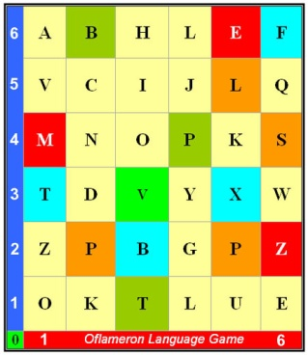 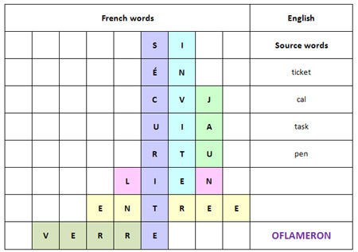 See http://www.shmeleff.com

De rien - You are welcome
derien - remove spaces
enderi - rearrange the fragments of words
Tape for printing
enderi

You need to cut the tape into fragments, and to make a phrase “De rien”
Tu comprends ? - Do you understand?
tucomprends - remove spaces
dsprentucom - rearrange the fragments of words
Tape for printing
dsprentucom

You need to cut the tape into fragments, and to make a phrase “Tu comprends”

How to learn. Example 2
ntapeleapruxi
appeler un taxi

- cut the tape

- make a phrase

You need to cut the tape into fragments, and to make a phrase “appeler un taxi”
Oui, je comprends - Yes, I understand
oui,jecomprends - remove spaces
comproui,jedsen - rearrange the fragments of words
Tape for printing
comproui,jedsen

You need to cut the tape into fragments, and to make a phrase “Oui, je comprends”
Je suis desolé - I am sorry
jesuisdesolé - remove spaces
jedesolésuis - rearrange the fragments of words
Tape for printing
jedesolésuis

You need to cut the tape into fragments, and to make a phrase “Je suis desolé”
© by Valery V Shmeleff http://www.shmeleff.com http://www.oflameron.ru
Blog http://bretell.blogspot.com/

