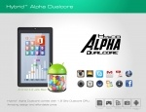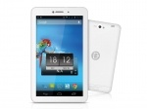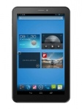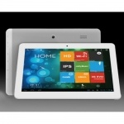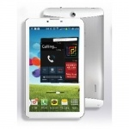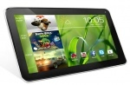

**Contact us**

**Tablets**

**Laptops**

**Home**

**Tablets**

Tablet PC HeroTab Alpha Dual Core Android Jellybean Tablet PC

Rs.6999

[Tablet PC Dany Genius Tab M30](http://www.mobilenmobile.com/buy-1862-tablet_pc-dany_genius_tab_m30-16-pakistan-mobile)Rs.10999

Tablet PC Q100 Q Tab

Rs.12999

[Tablet PC Xpod X10 Dual-core Tablet PC](http://www.mobilenmobile.com/buy-1840-tablet_pc-xpod_x10_dual_core_tablet_pc-16-pakistan-mobile)   
Rs.16699

Tablet PC Xpod G-TAB Dual Core Tablet PC (IPS Display)

Rs.14499

Tablet PC Cherry Jam Dual Core Tablet PC

Rs.7499

Order