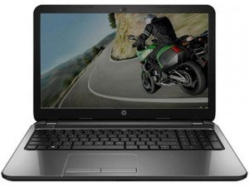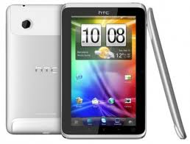[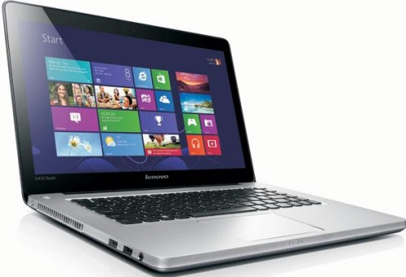](http://www.onlinenewspoint.com/wp-content/uploads/Best-And-Most-Affordable-Laptops-2014-Lenovo-IdeaPad-U410-Touch-500x342.jpg)[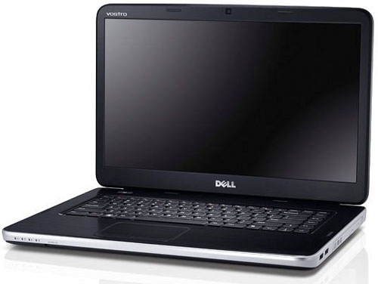](http://hothardware.com/newsimages/Item23543/Dell_Vostro_2520.jpg)[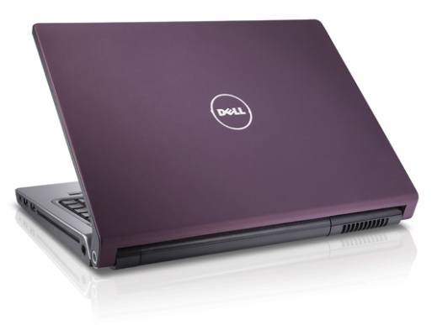](http://www.computershopper.com/shoptalk/dell-studio-15-laptop.jpg)[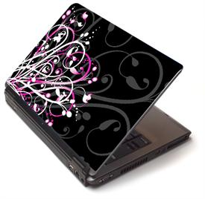](http://www.lifestylo.com/wp-content/uploads/2010/08/pink-piz.jpg)[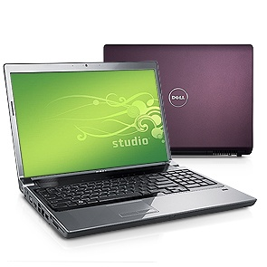](http://www.notebookcheck.net/uploads/tx_nbc2/295_01.jpg)[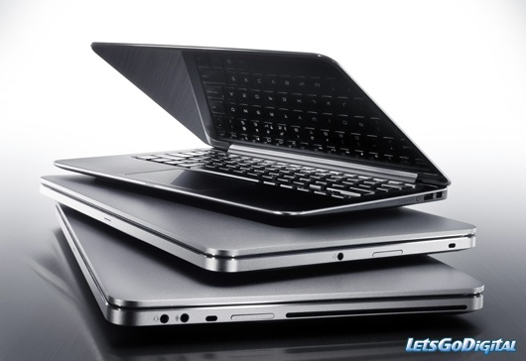](http://www.letsgodigital.org/images/artikelen/199/dell_laptops.jpghttp:/www.letsgodigital.org/images/artikelen/199/dell_laptops.jpg)

**Contact us**

**Tablets**

**Laptops**

**Home**

About us

The name says it all. So if you are looking for a laptop you are the right place.   
Every long journey starts with a first step. So we started on a small scale but with our IT academic background and intrinsic familiarity with computers and peripherals we moved ahead rather fast. Our dealings are always straight, clean and clear. We honor our commitments. We don’t believe in high profits. We aim at high reliability, respect and trust of our clients.  
We offer a whole new world of laptops buying convenience Intel Centrino, Core-Solo, Core-Duo, Core2-Duo Brand new, refurbished or used. And of course the entire major brands – **ACER, APPLE, COMPAQ, DELL, HP, IBM, SONY VAIO, SIEMENS and  TOSHIBA.**

We have data base of available laptops, pocket PCs and Accessories from reputed suppliers around the world. Of course we also deals in associated components like; Laptop Rams, Hard drives, CD/DVD/CDRW/DVDRW ROMs, Drives, Floppy Drives, Adapters, Batteries, Carrying Case and so on

**New products**