]

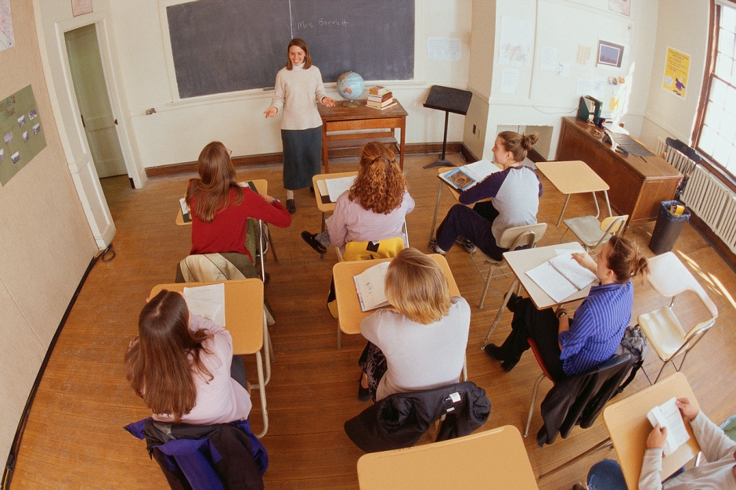

These are my friend of 203 reading the books to gain knowledge. There are 23 of us in the class. We study well together and help each other. There are always laughter, co operation and joy of success working together.

