
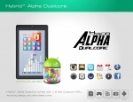
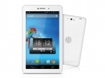
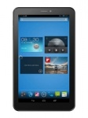
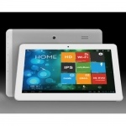
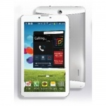
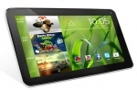
Contact us
Tablets
Laptops
Home
Tablets
Tablet PC HeroTab Alpha Dual Core Android Jellybean Tablet PC
Rs.6999
Tablet PC Dany Genius Tab M30Rs.10999
Tablet PC Q100 Q Tab
Rs.12999
Tablet PC Xpod X10 Dual-core Tablet PC
Rs.16699
Tablet PC Xpod G-TAB Dual Core Tablet PC (IPS Display)
Rs.14499
Tablet PC Cherry Jam Dual Core Tablet PC
Rs.7499
Order

