
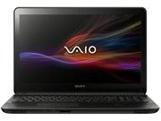
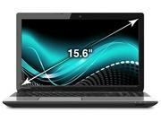

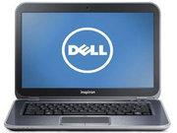
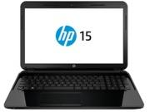
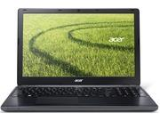
Contact us
Tablets
Laptops
Home

Laptops
Toshiba Satellite L50-A111X
- Intel® Core™ i5
- 2.5GHz
- 1TB
- 4GB
- 15.6 Inches
100,000.000 rs
Sony Vaio Fit SVF15323CXB
- Intel® Core™ i5
- 1.60 Ghz
- 750GB
- 6GB
- 15.5 Inches
- Windows 8.1
94,999 - PKR
Sony Vaio Fit SVF15323CXW
- Intel® Core™ i5
- 1.60 Ghz
- 750GB
- 6GB
- 15.5 Inches
- Windows 8.1
94,999 - PKR
Dell Inspiron 5423
- Intel® Core™ i3
- 1.8 Ghz
- 500GB
- 4GB
- 14.1 Inches
- Windows 8
48,499 - PKR
HP15-D002sx
- Intel Core i3
- 2.4 GHz
- 500 GB
- 2 GB
- 15.6 Inches
- Dos
43,999 - PKR
Acer Aspire E1-572
- Intel® Core™ i5
- 1.6 GHZ
- 750 GB
- 4GB
- 15.6 Inches
- Windows 8
51,999 - PKR
Order

