Nasi Lemak
History

Nasi lemak was mentioned in a book "The Circumstances of Malay Life", written Sir Richard Olof Winstedt in 1909. With roots in Malay culture and Malay cuisine, its name in Malay literally means "oily or fatty rice", but is taken in this context to mean "rich" or "creamy". The name is derived from the cooking process whereby rice is soaked in coconut cream and then the mixture steamed. The rice is normally cooked with pandan leaves that gives it a distinctive flavour.
Traditionally, nasi lemak is served with a hot spicy sauce (sambal), and usually include various garnishes, including fresh cucumber slices, small fried anchovies (ikan bilis), roasted peanuts, and hard-boiled or fried egg. As a more substantial meal, nasi lemakmay also be served with an additional protein dish such as ayam goreng (fried chicken), sambal sotong (cuttlefish in chili), small fried fish, cockles, and on special occasions rendang daging (beef) stewed in coconut milk and spices). Other accompaniments include stir fried water convolvulus (kangkong), and spicy pickled vegetables salad acar. Traditionally most of these accompaniments are spicy in nature.
Nasi lemak is widely eaten in Malaysia and Singapore. More commonly consumed as breakfast in both countries, it is commonly sold at hawker food centres and roadside stalls in Malaysia and Singapore. In Indonesia, nasi lemak is a favourite local breakfast fare; especially in Eastern Sumatra (Riau Islands, Riau and Jambi provinces). In Palembang, it is also a favourite local dish with the name "nasi gemuk". In palembangnese malay, "gemuk" has the same meaning as "lemak". This unique dish often comes wrapped in banana leaves, newspaper or brown paper, or it in some shops served on a plate. However, owing to its popularity there are restaurants which serve it as a noon or evening meal, making it possible for the dish to be eaten all day. Nasi lemak kukus which means "steamed nasi lemak" is another name given to nasi lemak served with steamed rice. In Malaysia, nasi lemak also can be found in a pasar malam (night market) with a variety of dishes.

Recipe: Nasi Lemak

Ingredients:
Coconut Milk Steamed Rice
2 cups of rice
3 screwpine leaves (tie them into a knot as shown above)
Salt to taste
1 small can of coconut milk (5.6 oz size)
Some water
Tamarind Juice
1 cup of water
Tamarind pulp (size of a small ping pong ball)
Sambal Ikan Bilis (Dried anchovies sambal)
1/2 red onion
1 cup ikan bilis (dried anchovies)
1 clove garlic
4 shallots
10 dried chillies
1 teaspoon of belacan (prawn paste)
1/4 teaspoon of salt
1 tablespoon of sugar
Other ingredients
2 hard boiled eggs (cut into half)
3 small fish (sardines or smelt fish)
1 small cucumber (cut into slices and then quartered)

Method:
- Just like making steamed rice, rinse your rice and drain. Add the coconut milk, a pinch of salt, and some water. Add the pandan leaves into the rice and cook your rice.
- Rinse the dried anchovies and drain the water. Fry the anchovies until they turn light brown and put aside.
- Pound the prawn paste together with shallots, garlic, and deseeded dried chilies with a mortar and pestle. You can also grind them with a food processor.
- Slice the red onion into rings.
- Soak the tamarind pulp in water for 15 minutes. Squeeze the tamarind constantly to extract the flavor into the water. Drain the pulp and save the tamarind juice.
- Heat some oil in a pan and fry the spice paste until fragrant.
- Add in the onion rings.
- Add in the ikan bilis and stir well.
- Add tamarind juice, salt, and sugar.
- Simmer on low heat until the gravy thickens. Set aside.
- Clean the small fish, cut them into half and season with salt. Deep fry.
- Cut the cucumber into slices and then quartered into four small pieces.
- Dish up the steamed coconut milk rice and pour some sambal ikan bilis on top of the rice.
- Serve with fried fish, cucumber slices, and hard-boiled eggs.

Nasi kerabu is a Malay rice dish, a type of nasi ulam, in which blue-coloured rice is eaten with dried fish or fried chicken, crackers, pickles and other salads. The blue color of rice resulting from the petals of Clitoria ternatea (butterfly-pea) flowers (kembang telang)used in cooking it.^{[1]} The rice can also be cooked with plain white rice or rice cooked using turmeric. It is often eaten with solok ladaand is also eaten with fried keropok.^{[2]}
Nasi kerabu is very popular in the east coast states of Malaya such as Kelantan and Terengganu, and now can be found throughout Malaysia as well as in southern Thailand where it is known as khāoyam (ข้าวยำ IPA: [kʰâːw jam]).
The dish features in the title of Zan Azlee's book and video Operation Nasi Kerabu: Finding Patani In An Islamic Insurgency.

Herb Rice Salad with Grilled Beef Recipe (Nasi Kerabu Daging Panggang)
Ingredients:
Main ingredients:
1 cup grated coconut
4 cups cooked rice, cooled and flaked
1 lemon grass - white part only, finely sliced
1 torch ginger bud (bunga kantan), finely sliced
4 shallots, thinly sliced
20g young root ginger, finely shredded
10g young galangal root, finely shredded
5g turmeric root, finely shredded
1 tsp salt
½ tsp freshly ground black pepper
1 small piece (200g) tender beef, grilled and finely shredded
For the leafy herb mixture:
5 leaves daun kaduk
5 sprigs daun kesum (stems removed)
1 small bunch daun pegaga
3 sprigs ulam raja
3 sprigs mint (stems removed)
5 leaves daun cekur
2 kaffir lime leaves
1 turmeric leaf (daun kunyit)
Method:
1. Stack the leafy herbs together and roll up tightly, using the larger leaves to wrap the smaller, finer leaves. Using a sharp knife, shred leaves very finely. Set aside.
2. Dry fry grated coconut in a wok over low heat, stirring constantly till the coconut turns a deep golden brown. Cool for 10 minutes, then grind in a mortar and pestle or whiz for a few seconds in an electric chopper to make fine crumbs.
3. Place the cooled rice in a large mixing bowl and add all the remaining ingredients - toasted coconut, shredded herbs, lemon grass, torch ginger, shallots, ginger, galangal, turmeric, salt, pepper and shredded beef. Toss gently until well mixed and serve.

Roti canai (pronunciation tʃanai) or roti cane (pronunciation tʃane) is a type of Indian-influenced flatbread found in Malaysia,Indonesia and Singapore. It is often sold in Mamak stalls in Malaysia; also in Malay, Minangkabau and Aceh restaurants in Indonesia. It is known as roti prata in Southern Malaysia and Singapore, and is similar to the Indian Kerala porotta. It is also found throughout Thailand, where it is called "Ro Tee" and is typically sold by Muslims, most often with street carts, and is usually Halal.
In English and in Chinese, roti canai is sometimes referred to as "flying bread" (飞饼 fēibǐng), a term that evokes the process of tossing and spinning by which it is made. In Chinese, Roti canai is originally called 印度煎饼 "yìn dù jiān bǐng", which means Indian pancake.
Traditionally roti canai is served with dhal (lentil curry) or any type of curry, such as mutton or chicken curry. However, the versatility of roti canai as the staple lends itself to many variations, either savoury or sweet, with a variety of toppings and fillings, which includes eggs, banana, sardines and onion. In Thailand, it is usually served sweet - typical fillings include condensed milk, peanut butter, jam and nutella, without the curry.

Read this before you start
1. Contrary to popular beliefs, Roti Canai does not need or contain a lot of oil.
2. The main objective is to create a super thin dough without tearing that can passed the window pane test. The thinner the dough, the crisper would be the roti when fried.
3. Oil is used liberally only in the final process more as a lubricating agent in the stretching and to prevent the thin dough from sticking together. Hence the misconception that it contains a lot of oil.
1. Basic Dough Recipe (Crisp texture)
600g Plain Flour
300ml Water
1 teaspoon Salt
1 tablespoon Sugar
15ml Oil
1 egg
2. Enriched Dough Recipe (Richer taste, more tender)
600g Plain Flour
270ml Water
80g (1/4 cup) Condensed Milk *
15ml (1 tablespoon) Oil or Melted Butter/Ghee
1 teaspoon. Salt
1 egg
*Condensed Milk (optional)
Replace it with 40mls of water and 1 tablespoon of Sugar, if you omit the 1/4 cup of condensed milk
Making the Dough
1. Mix the wet ingredients together and give them a good whisk.
2. Add in flour and mix well, leave it alone for 20 minutes. *Giving it 20 minutes rest will break down the gluten and when you start to knead, you will get a smooth dough easily. Then knead by hand for about 20 minutes with a 10 minutes rest time in between. ( I used a bred machine for this)
3 .Dust the dough with flour then divide them like a ball , about 100g each. Ensure the bottom is smooth.
4. Coat them with oil or soak them in oil (see below) to prevent drying and again rest them for at least 4 hours and up to 8 hours or overnight.
The resting breaks down the gluten in the flour and makes the dough more pliable and easy to flip. Cover the dough balls with cling wrap to keep the surface from drying out.
(I put the whole container/bowl inside a plastic bag and tied up with a rubber band.)
Soak in oil -I prefer to soak them in some soil to prevent drying. I find the dough is easier to handle after 4 hrs; I need not use any more oil. The same oil may be used to smear the table top and for frying the Roti. Any excess can still be return for general cooking and not wasted.

Satay (/ˈsæteɪ/, /ˈsɑːteɪ/ sah-tay), modern Indonesian and Malay spelling of sate, is a dish of seasoned, skewered and grilled meat, served with a sauce.^{[1]} Satay may consist of diced or sliced chicken, goat, mutton, beef, pork, fish, other meats, or tofu; the more authentic version uses skewers from the midrib of the coconut palm frond, although bamboo skewers are often used. These aregrilled or barbecued over a wood or charcoal fire, then served with various spicy seasonings.
Sate Ponorogo being grilled in a foodstall inSurabaya, East Java,Indonesia
Satay originated in Java, Indonesia.^{[2][3][4]} It is available almost anywhere in Indonesia, where it has become a national dish.^{[5][6]} It is also popular in many other Southeast Asian countries, including Malaysia, Singapore, Brunei, Thailand, the Philippines, as well as inSuriname and the Netherlands, as Indonesia and Suriname are former Dutch colonies.
Satay is a very popular delicacy in Indonesia; the country's diverse ethnic groups' culinary arts (see Indonesian cuisine) have produced a wide variety of satays. In Indonesia, satay can be obtained from a travelling satay vendor, from a street-side tent-restaurant, in an upper-class restaurant, or during traditional celebration feasts. In Malaysia, satay is a popular dish—especially during celebrations—and can be found throughout the country. In Southern Philippines it is known as satti.
Close analogues are yakitori from Japan, shish kebab from Turkey and the Middle East, shashlik from the Caucasus, chuanr fromChina, and sosatie from South Africa. It is listed at number 14 on World's 50 most delicious foods readers' poll complied by CNN Go in 2011.^{[7]}

YOU ARE HERE:Home » Recipes » Malaysian Recipes » Chicken Satay Recipe

NEW RECIPES

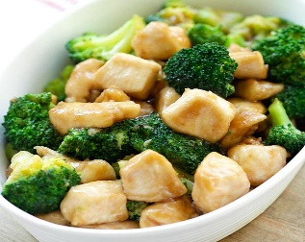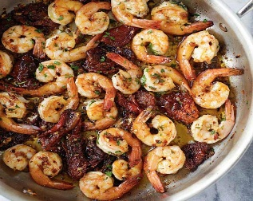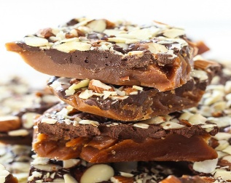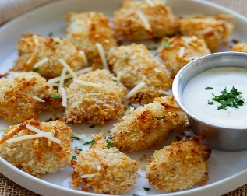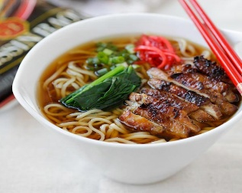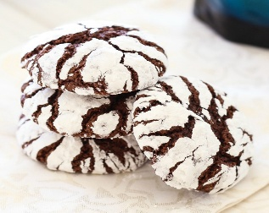

Chicken Satay Recipe
SEPTEMBER 4, 2006 129 Comments33K+
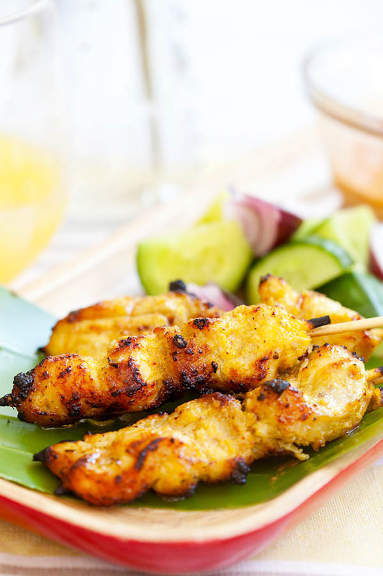


Chicken Satay Recipe
Serves 8-10 people as appetizer | Prep Time: 30 Minutes | Cook Time: 10 Minutes

Ingredients:
4 chicken legs and thighs (preferred) or 4 chicken breasts (boneless and skinless)
Spice Paste:
1 teaspoon coriander powder
2 stalks lemongrass, white parts only
6 shallots, peeled
2 cloves garlic, peeled)
4 tablespoons cooking oil
1 teaspoon chili powder
2 teaspoons turmeric powder
4 teaspoons kecap manis (Indonesian sweet soy sauce)
1 teaspoon oyster sauce
Bamboo skewers, soaked in water for 2 hours to avoid burning)
1 cucumber, cut into small pieces
1 small onion, quartered

Method:
Cut the chicken meat into small cubes. Grind the Spice Paste in a food processor. Add in a little water if needed. Marinate the chicken pieces with the spice paste for 10-12 hours. Thread the meat onto the bamboo skewers and grill for 2-3 minutes on each side. Serve hot with the fresh cucumber pieces and onions.
For the dipping sauce, please follow my satay peanut sauce recipe.

Ingredients:
1 1/2 cup dry roasted peanuts (unsalted)
1 cup water
1 tablespoon sweet soy sauce (Kecap Manis)
1 1/2 tablespoon sugar (palm sugar preferred)
1/8 teaspoon salt
1/4 cup oil
1 heaping tablespoon tamarind pulp (soaked in 1/4 cup water for 15 minutes, squeeze the tamarind pulp for juice and discard the pulp)
Spice Paste:
6-8 dried red chilies (seeded and soaked in warm water)
3 cloves garlic
3 shallots
2 lemon grass (white parts only)
1 inch ginger (galangal preferred)
1 tablespoon coriander powder (optional)

Method:
Crush the peanuts coursely with mortar and pestle or mini food processor and set aside.
Chop the spice paste ingredients and blend until fine. Heat oil and fry the spice paste until aromatic and smell spicy. Add the peanuts, tamarind juice, water, sugar, sweet soy sauce and stir thoroughly. Simmer in low heat while continue stirring for about 3 minutes until the peanut sauce turns smooth. Serve at room temperature with the satay.
Ais kacang, literally meaning "ice beans", also commonly known as ABC (acronym for Air Batu Campur, meaning "mixed ice"), is aMalaysian dessert which is also common in Singapore (where it is called ice kacang) and Brunei.^{[1]}
Traditionally, an ice shaving machine is used to churn out the shaved ice used in the dessert, originally hand cranked but now more often motorized. Many Southeast Asian coffee shops, hawker centres, and food courts offer this dessert.

Ais kacang was originally made of only shaved ice and red beans, though the number and diversity of ingredients has since expanded.^{[2]} Today, ais kacang generally comes in bright colours, and with different fruit cocktails and dressings.
In Malaysia, almost all variants now contain a large serving of attap chee (palm seed), red beans, sweet corn, grass jelly and cubes ofagar agar as common ingredients. Other less-common ingredients include aloe vera, cendol, nata de coco, or ice cream. A final topping of evaporated milk, condensed milk, or coconut milk is drizzled over the mountain of ice along with red rose syrup and sarsi syrup. Some stalls have even introduced novelty toppings such as durian, chocolate syrup and ice cream. There are also versions that shun the multi-coloured syrup and are served with just a drizzling of gula melaka syrup instead.

Ingredients for ice kacang recipe
» finely shaved ice
» rose syrup
» evaporated milk
» cooked red beans
» palm sugar syrup
Toppings for ice kacang
» 1 tin creamed sweet corn
» 75 g jelly
» 80 g finely crushed roasted peanuts
» 45 g palm seed
» sliced bananas
» durian ice cream
Ingredients to make cooked red beans for ais kacang
» 140 g red beans
» 330 ml water
» 95 g sugar
» 3 knotted pandan leaves
Ingredients to make palm sugar syrup for ais kacang
» 180 g palm sugar
» 130 ml water
» 3 knotted pandan leaves
How to cook red beans for ice kacang
» rinse the red beans with running water
» soak red beans in water for two hours
» put the red beans, pandan leaves and water into a pot
» bring water to a boil
» lower heat and simmer until red beans start to become soft
» stir regularly
» put in sugar and cooked until red beans become mushy
» you will also notice the water drying up
» remove from heat and allow red beans to cool
How to cook palm sugar syrup for ice kacang
» put the palm sugar, pandan leaves and water into a pot
» bring water to a boil
» lower heat and simmer until the syrup thickens
» remove from heat and let the syrup cool down
FINALLY How to make ice kacang
» put a mould of finely shaved ice onto a serving bowl
» flavor the ice with evaporated milk, palm sugar syrup and rose syrup
» top with jelly, peanuts, red beans and sweet corn
» sometimes these toppings are put underneath the ice
» also top with a scoop of durian ice cream and serve immediately

