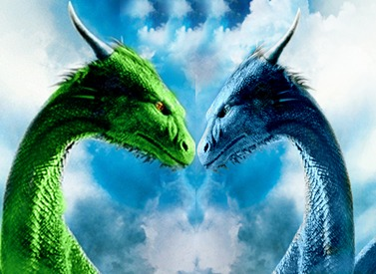
Nimit Parekh jkjkjjjjjjjjjjjjjjjjjjjjjjjjjjjjl;
O[[

OVER THE HORIZON

The wind caressed Eragon’s face as fresh tears poured down his cheeks and splashed on to the wood on the TalÍta. Above, Saphira keened. Her grief mingled with his almost incapicated him. Blödhgarm came and stood next to Eragon. His midnight-blue fur rippled with the motion of the wind. They looked over the side of the ship at the land they were leaving forever. Goodbye Alagaësia. Eragon thought. He saw the elf Arya, still waving, while FÍrnen spread his wings and let loose a stream of emerald fire, followed by an aching roar. Roran uttered another cry which echoed in the night, like a forlorn sound lingering nearby.
The ship was to follow the Edda River out to sea and then sail to Vroengard, where they were going to raise the Dragon Riders again.The thought cheered Eragon up tremendously. Saphira and I are going to be the new leaders of the Riders!
With a thump that rocked the boat dangerously, Saphira landed. Eragon took a small comfort in her company, it helped dull the ache in his heart, if only a little. Only a few days ago, Eragon had learned that that the green egg, the last of the three dragon eggs stolen by Galbatorix, which they took from his treasury, had hatched for Arya. He also learned that the elves had chosen her as their queen after her mother, Queen IslanzadÍ died at the hands of the commander of Galbatorix’s troops, Lord Barst. The EldunarÍ tried to keep Eragon from brooding over his sorrow by narrating to him more bits and pieces about the Riders. Despite their efforts, new film of tears appeared on his eyes.

The rest of the few weeks were uneventful. Suddenly that evening, the sun set over the horizon, a black object appeared. It was Saphira who first brought the black silhouette to everyone’s attention. Eragon, look over there. She said through their mental bond. She sent him a mental picture of the object . Eragon spoke a word in the ancient language.”Thurra,” he whispered. His tears immediately. He quickly called the elves and Cuaroc, who’s duty was to protect the dragon eggs. They connected their minds with the EldunarÍ so the consious of the drafons could see with their eyes, as they could neither see nor feel anything from within their coloured-crystal gems. As they floated closer, Blödhgarm smiled, revealing bladelike fangs.” That is Vroengard, Shadeslayer.”
Drawing upon the reseves of strength of the EldunarÍ, Eragon cast the long and complex spell that allowed the egg to appear once again from their pocket of space. As the blotch grew bgger and bigger , and they got nearer and nearer, they could seee that it was indeed Vroengard that they beheld. Eragon instictively grasped the hilt of Brisngr, his magical sword, in anticipation for the dark dangers that Vroengard had plenty of. The TalÍta slowed to a stop as it beached on the rocky shore. Saphira gently lowered Cuaroc on the golden bay. He was covered from head to toe in dragon saliva. With a quick spell from Eragon, the saliva dropped onto the sand.

