Edyline Espaillat
GRA 410 Process Book
edyline.espaillat@snhu,edu

Sitemap

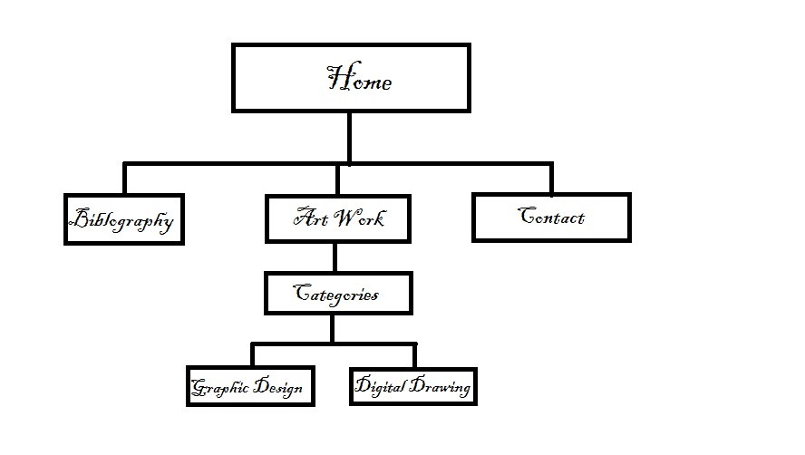

WireFrame-Desktop
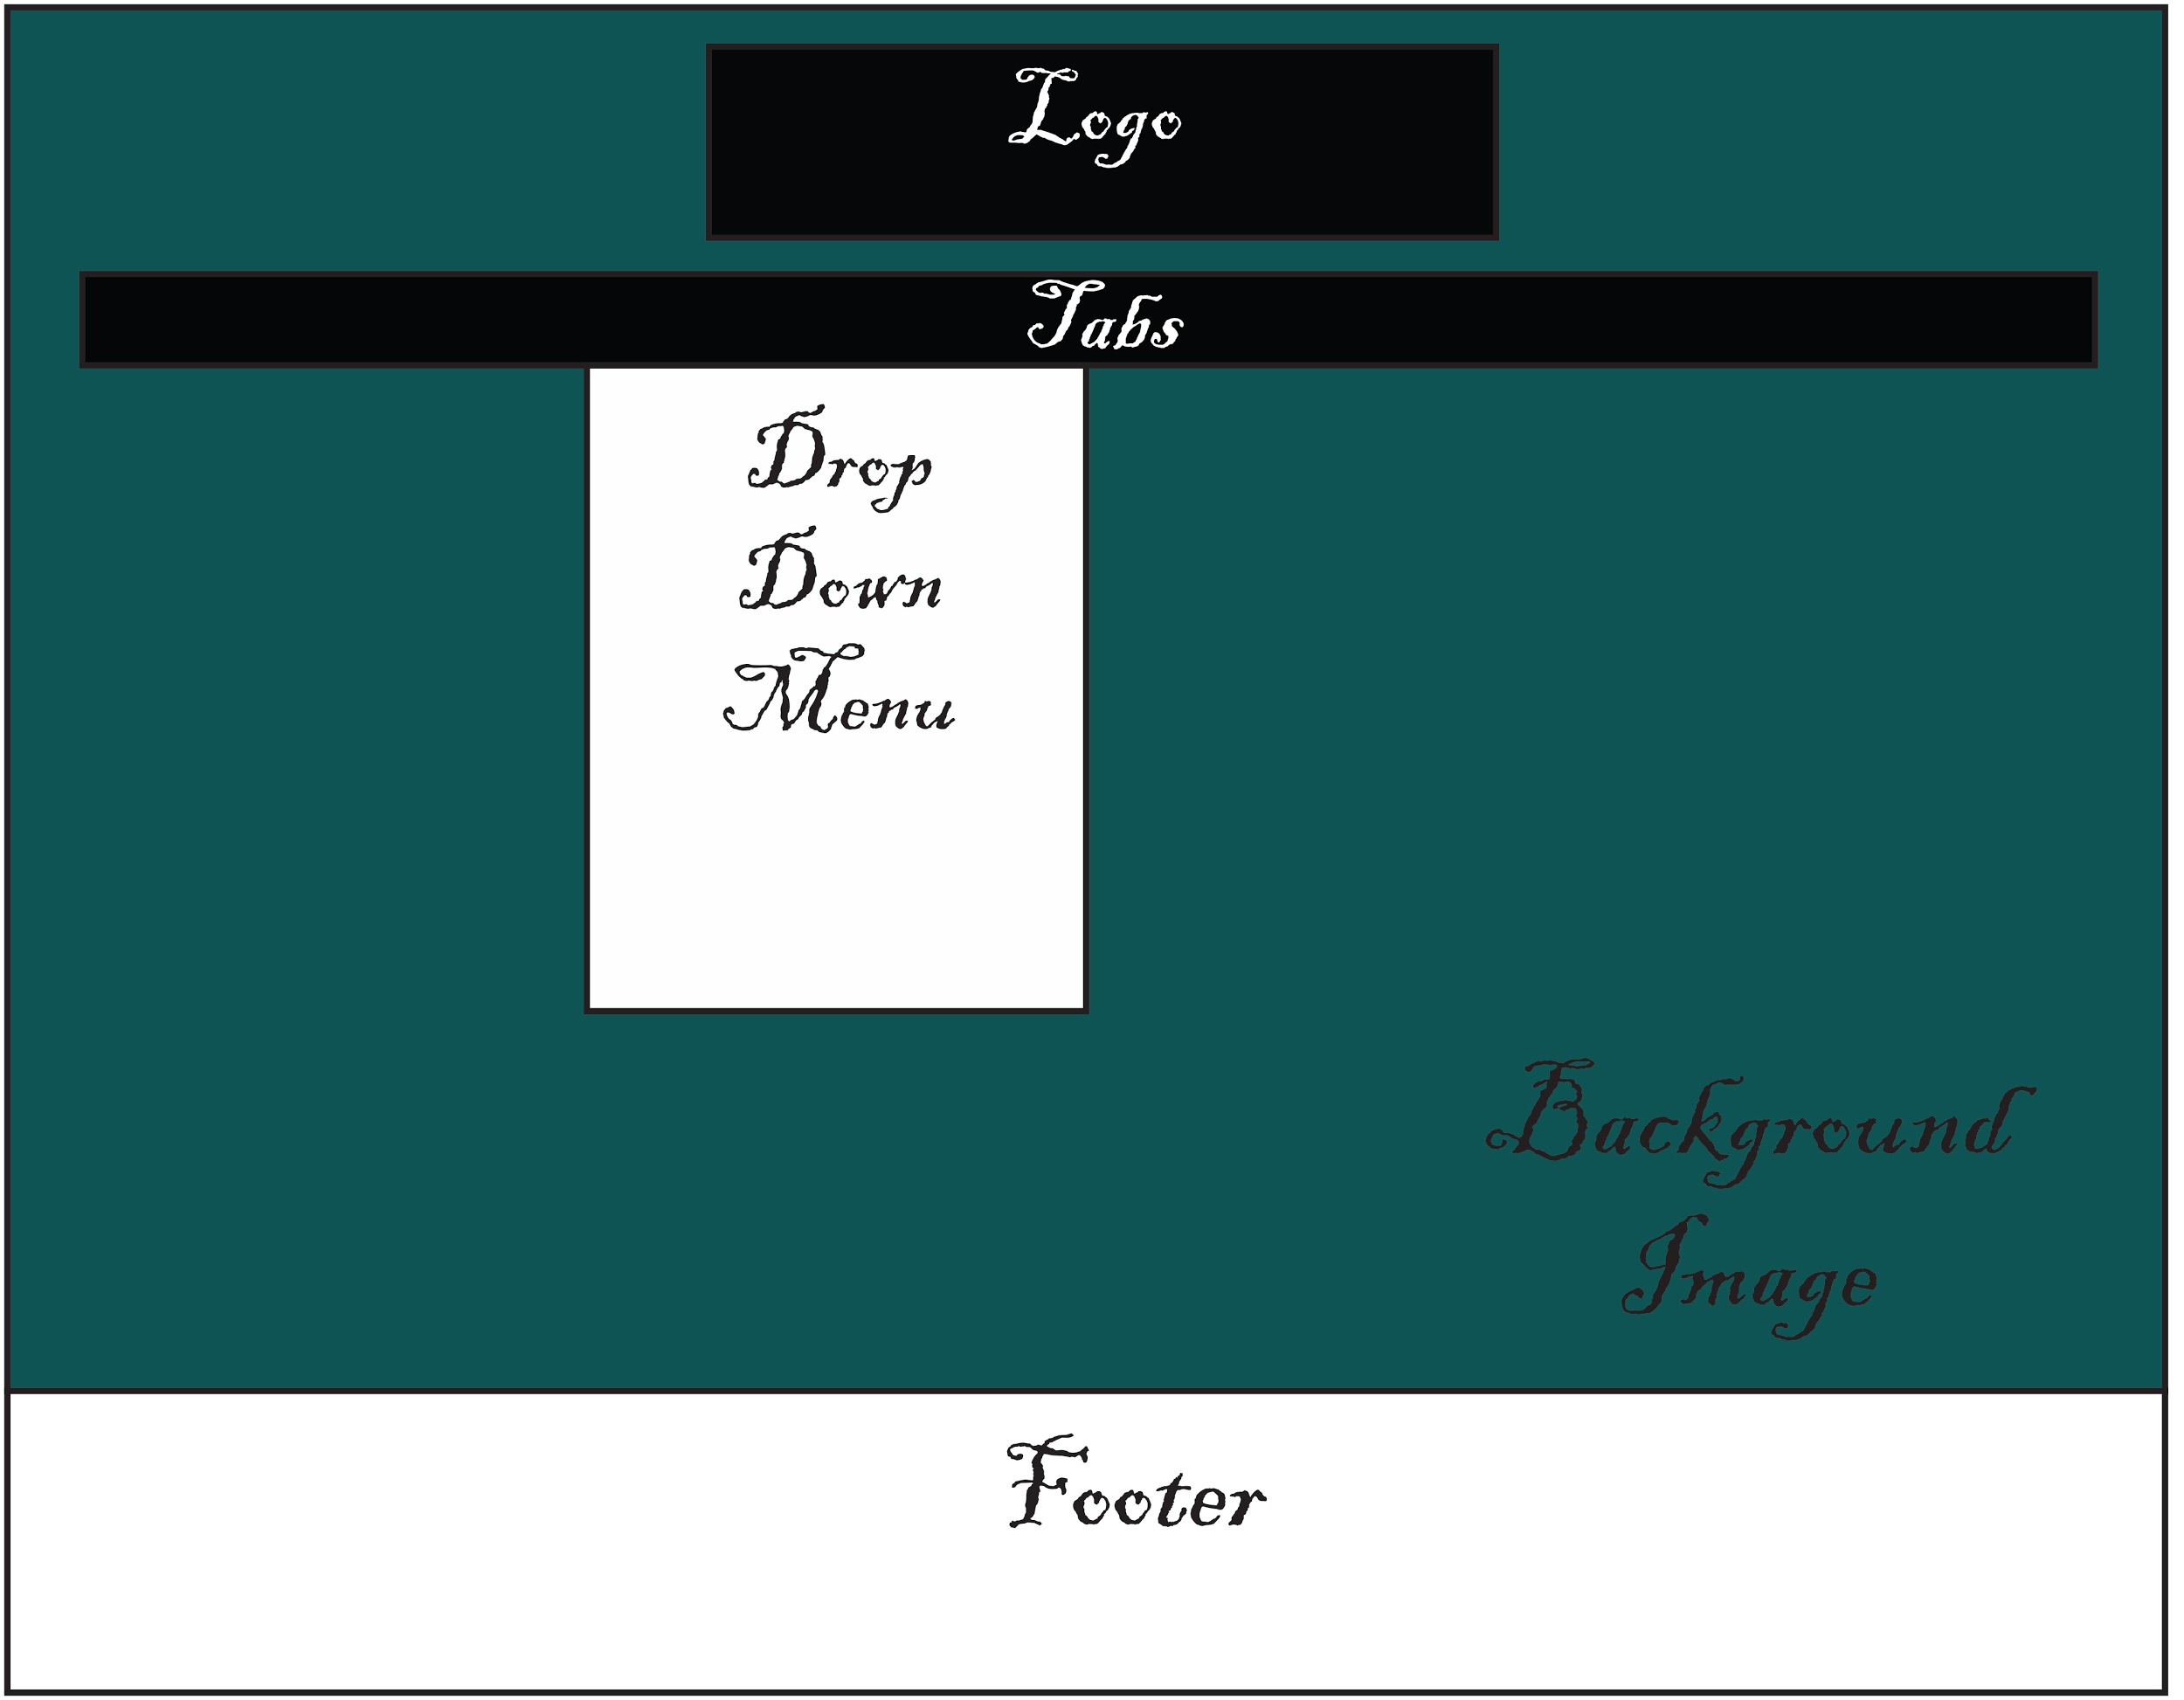

Wireframe- Tablet
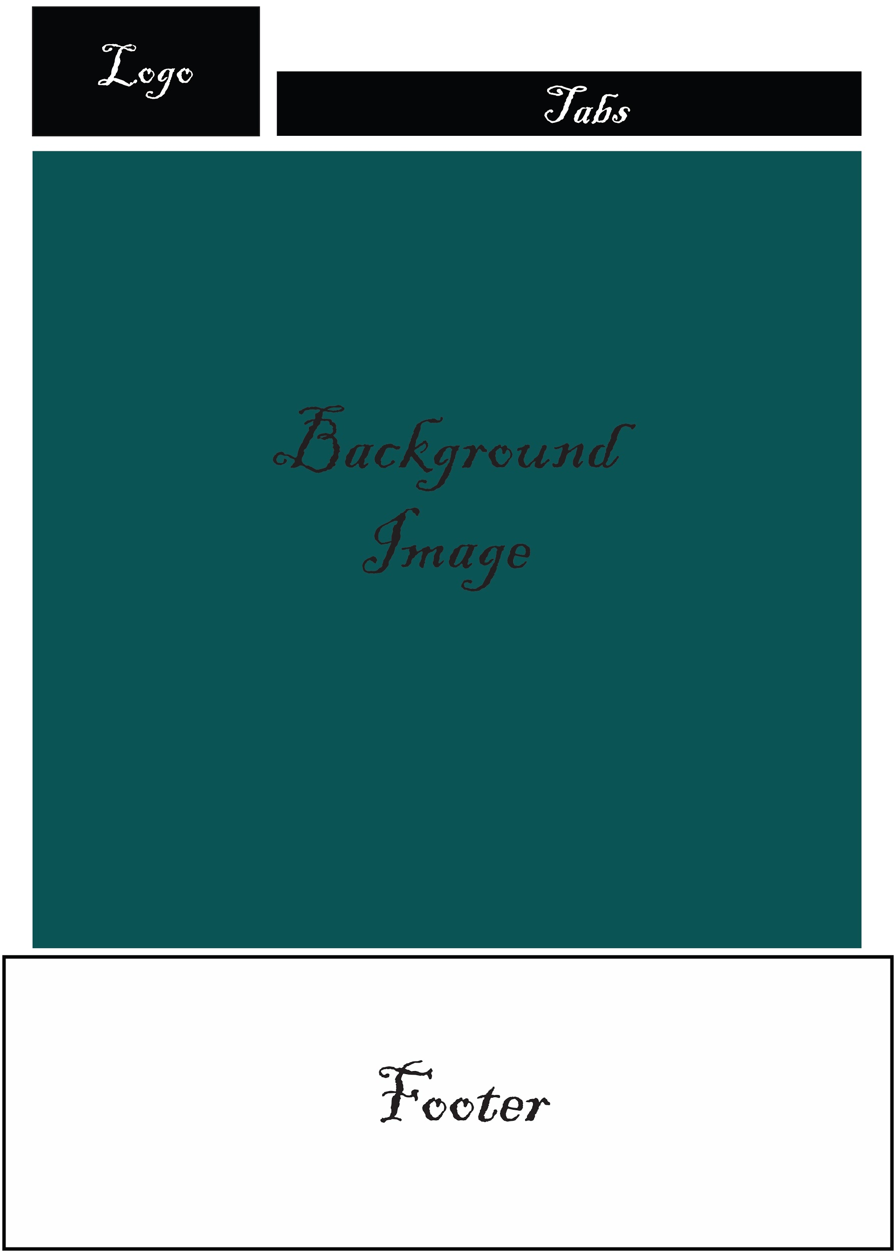

Wireframe- Mobile
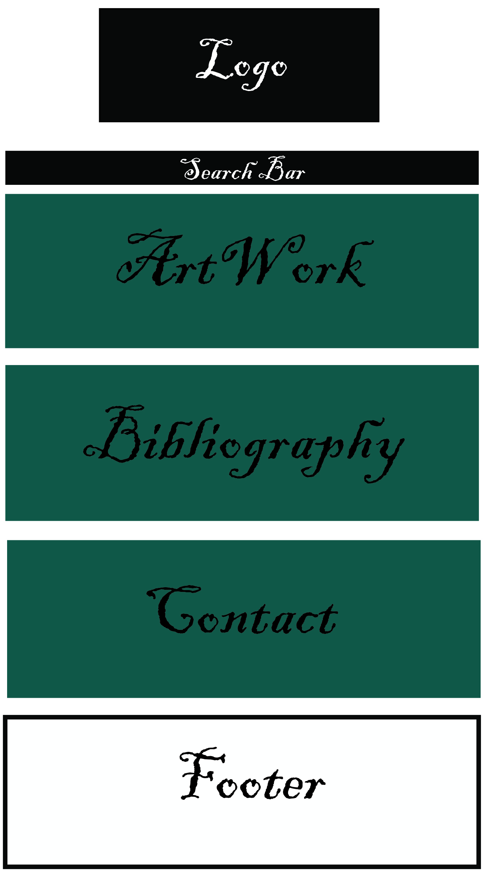

User Experience

User experience, also known as UX, is an important aspect of web design because it directly suits the needs of the visitors. User experience is how a visitor of website feels during his or her interaction with a system.(Gube 2010) The concepts and principles in relation to the importance of engaging content in a web site are readability, design, and marketing. Readability is important in order for content to be engaging because if the visitor cannot read the content, he or she will lose interest. More importantly, it will defeat the purpose of having the website in the first place. The visitors will not understand what the content is about. It is important to prevent the visual design choices from getting in the way of readability. Secondly, the importance of appealing visual design is important but it can easily be overdone if not one does not keep the principles and elements of design in mind. The visual design must be effective.
The concepts and principles in relation to the importance of audience interaction are simplicity, human factors, and consistent. (Gube 2010; Fundamental Principles of Great UX De...) The interaction must be simple because it is very easy to lose the interest of the visitors. If the website is not easy to navigate, they will eventually leave the site. The best way to have easy navigation is to keep it simple. If it is complicated, it will also confuse the visitors. Secondly, the interactions should feel more human like instead of machine like. (Fundamental Principles of Great UX De...) Lastly, context must be consistent and clear with visual hierarchy. For example, if the home page has content that is centered, then every other page should have the information centered. The information should also be arranged from most important to least important because it makes it much easier for the visitor to find what they are looking for or what they are trying to find out. The most important thing is to make the overall experience easier for the visitor.
My own experiences with the concepts and principles of both content and audience interaction was easy going. I received a lot of help from my fellow classmates and Professor from a previous course, Digital Graphic Design for the Web. What was most simple for me is the wireframes and consistency. I chose a simple layout and made sure all pages had centered content. The design process was also a simple process for me. I chose primary colors from the guideline recommended by the client and gave each page it’s own feature image. What was most difficult for me is the contact page. The text box I included was very difficult to align properly. Some boxes started further back than others. Overall, it was a rewarding experience.

References
(2016, February 28). What Is User Experience Design? Overview, Tools And Resources – Smashing Magazine. Retrieved November 13, 2016, from https://www.smashingmagazine.com/2010/10/what-is-user-experience-design-overview-tools-and-resources/
Fundamental Principles of Great UX Design | How to Deliver Great UX Design. (n.d.). Retrieved November 13, 2016, from http://www.uxmatters.com/mt/archives/2014/11/fundamental-principles-of-great-ux-design-how-to-deliver-great-ux-design.php

Digital Mock-Ups
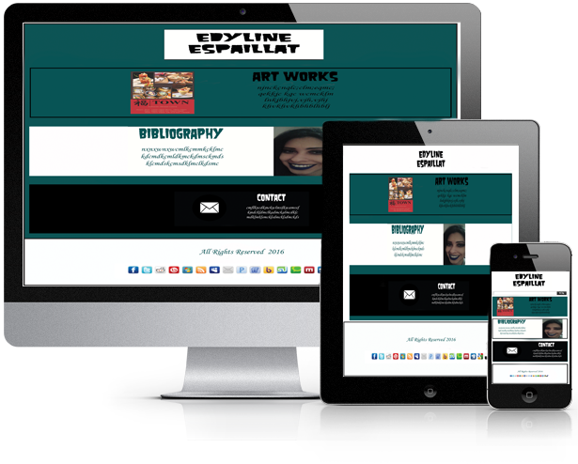

Code Snippets

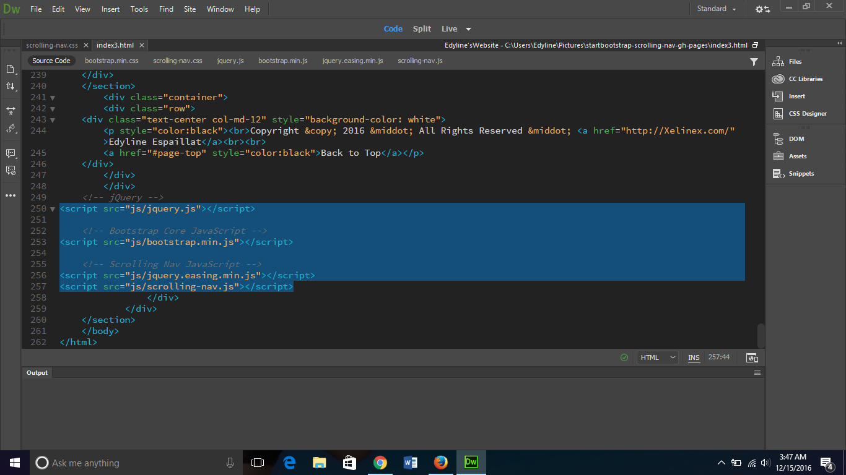

Troubleshooting Screenshots of Website
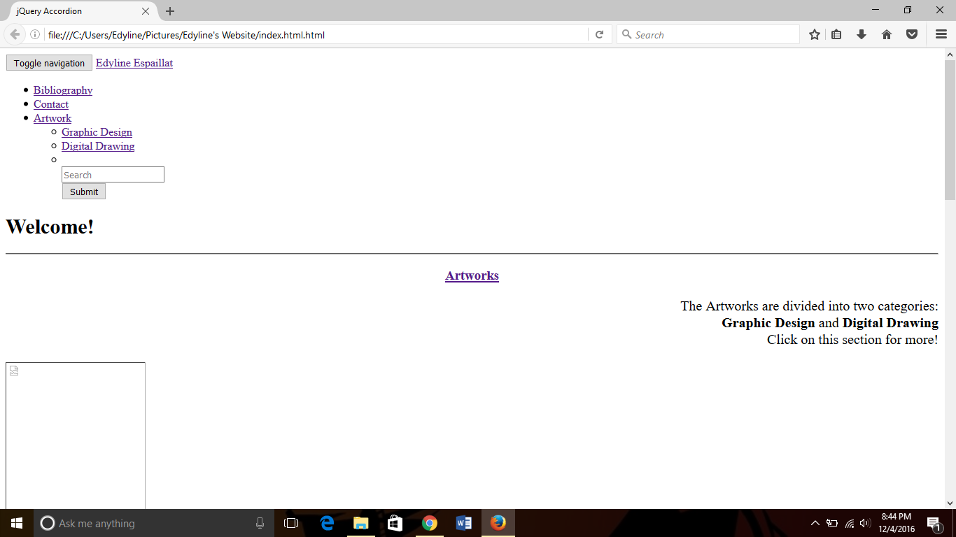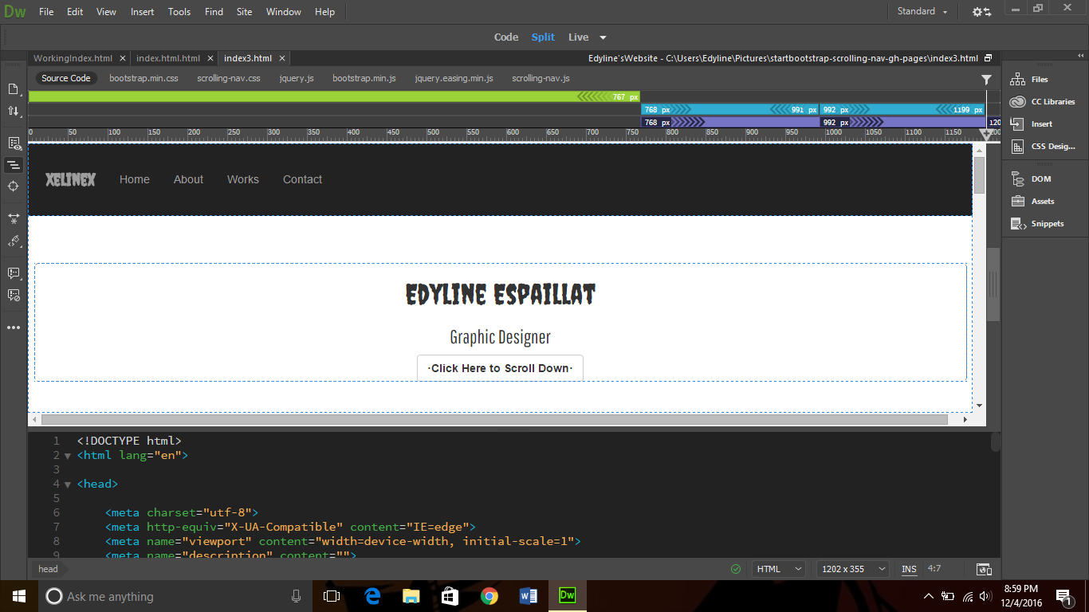

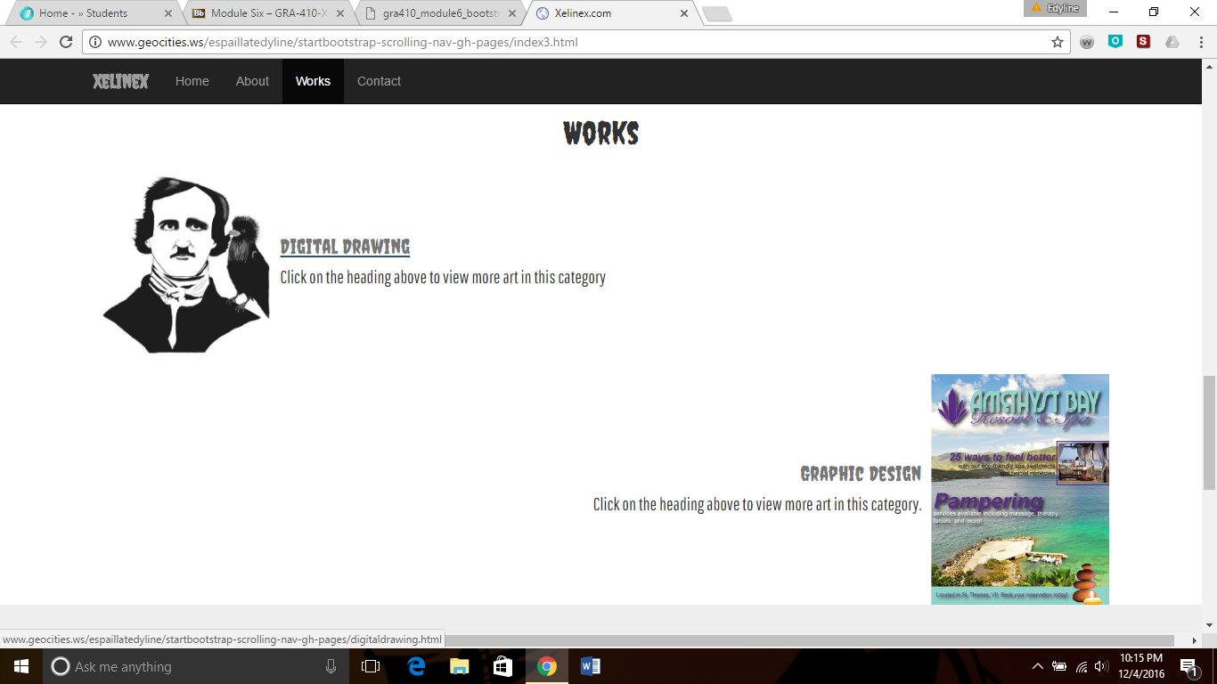

In the first screenshot, the content of the navigation bar along with the header and some of the first page is shown. I had a hard time making the navbar horizontal and the images I included were unable to be seen. As you can see in the second screenshot, I was able to fix all the issues and chose a different heading. The third screenshot is the “Artworks” page. As you can see from the previous screenshot, none of the images were shown, I successfully was able to fix that problem.

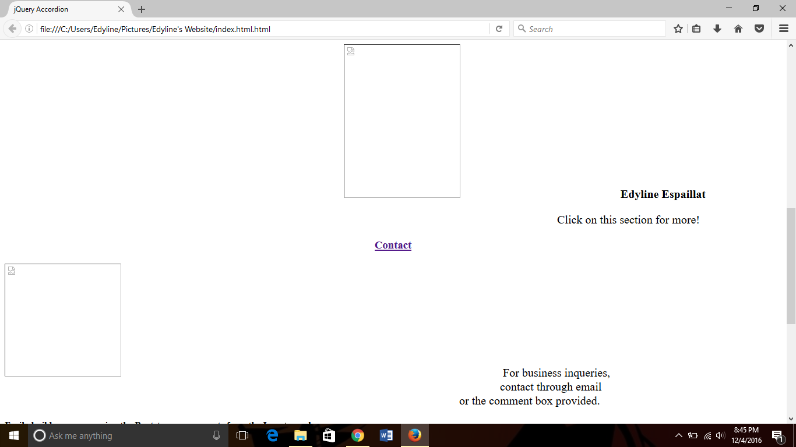
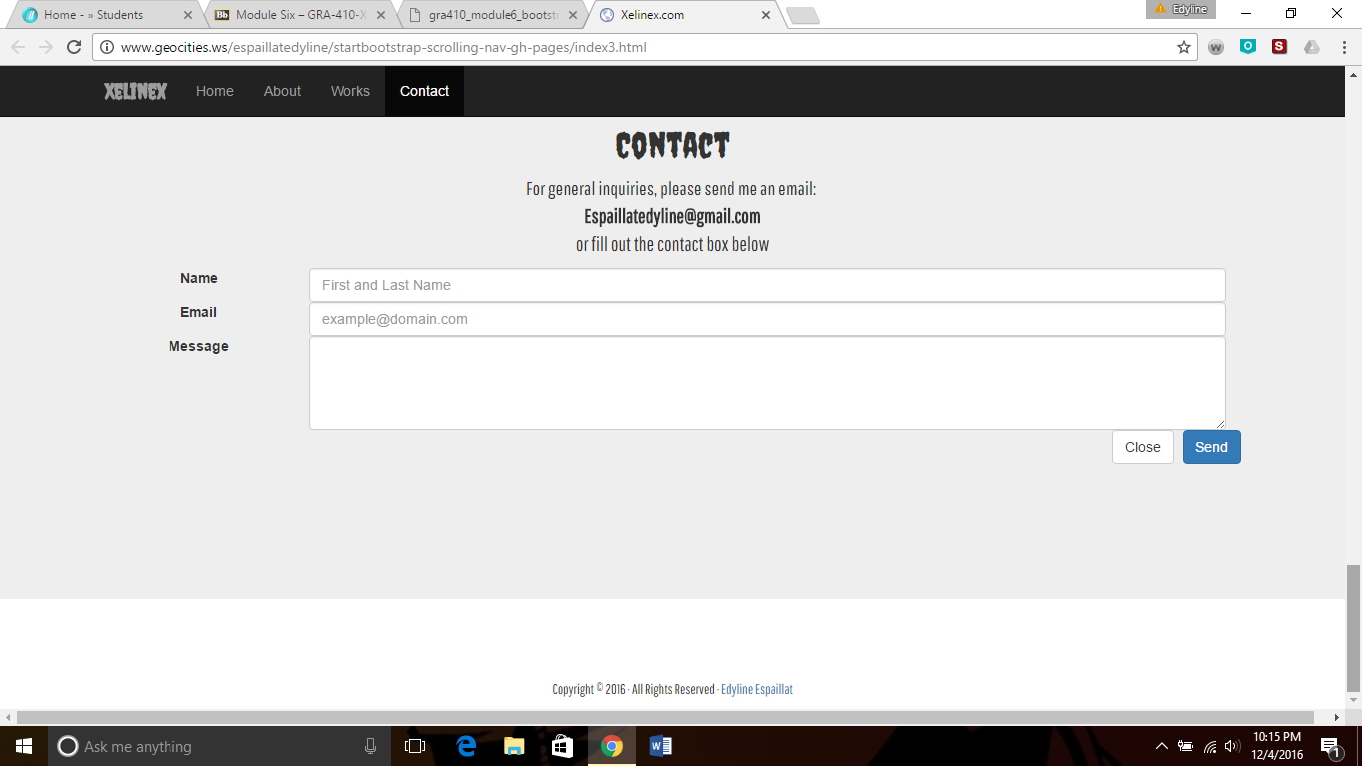
In first screenshot above, the “Contact” page included an unviewable image and some text on the right hand side. On the second one, I decided to remove the image and have a contact box instead. I also decided to center the text instead.

Live Link to Responsive Personal Portfolio Website

http://www.geocities.ws/espaillatedyline/startbootstrap-scrolling-nav/index3.html

