

The 8st weekly assignment

T
E
N
T
A
N
G
MICROSOFT OFFICE WORD

Di Susun Oleh :
Nama : Djoko Wahyudi
Nim : 1420000292
Kelas : Si D Pagi

CHAPTER I
PRELIMINARY

- History Of Microsoft Office Word
Microsoft Office Word is the creation history of Charles Simonyi, a developer of Bravo, the first GUI word processing system, which was developed at Xerox PARC. Charles groom Microsoft in 1981, to create projects for Microsoft.
After joining Microsoft, Charles Simonyi then projects a word processing system, hereinafter known as "Multi-Tool Word". In working on the project, Charles does not work alone, he recruited Richard Brodie, who was none other than a former Xerox employee, while working at Xerox Richard served as head of software engineering.

CHAPTER II
DISCUSSION

CHAPTER I PRELIMINARY. . . . . . . . . . . . . . . . . . . . . . . . . . . . . . . . . . . . . . . . . . . . . . . . . . . . . . .i
- History Of Microsoft Office Word . . . . . . . . . . . . . . . . . . . . . . . . . . . . . . . . . .1
CHAPTER II DISCUSSION . . . . . . . . . . . . . . . . . . . . . . . . . . . . . . . . . . . . . . . . . . . . . . . . . . . . . . .ii
CHAPTER III CONTENTS. . . . . . . . . . . . . . . . . . . . . . . . . . . . . . . . . . . . . . . . . . . . . . . . . . . . . . . .iii
- Understanding Microsoft Office Word . . . . . . . . . . . . . . . . . . . . . . . . . . . . . .2
- Functions And Benefits Of Microsoft Office . . . . . . . . . . . . . . . . . . . . . . . . . 3
- Document Part Familiar With Microsoft Office Word . . . . . . . . . . . . . . . . 4
- Familiar With Microsoft Office Word Window Elements . . . . . . . . . . . . . . . 5
CHAPTER IV COVER. . . . . . . . . . . . . . . . . . . . . . . . . . . . . . . . . . . . . . . . . . . . . . . . . . . . . . . . . . . .iiii

CHAPTER III
CONTENTS

- Understanding Microsoft Office Word
Microsoft Office Word is a word processing application that is very popular at the moment, Applications developed by Microsoft is included in the Microsoft Office package that contains Microsoft Office Word, Microsoft Office Excel, Microsoft Office PowerPoint, Microsoft Office Publisher Microsoft Office Access and others.
- Functions And Benefits Of Microsoft Office Word

- Functions Of Microsoft Office Word
The function of Microsoft Office Word is a word processor so that all work related to word processing can be done with this application as :

- Make letter.
- Make table.
- Make paper with various variations (Word Art).
- Insert images.
- Create documents.

- Benefits Of Microsoft Office Word
The benefits of Microsoft Word are as follows :
- Ease In Completing The Work
With microsoft word we can create documents in accordance with what we want and we can edit and change if an error occurs before it is printed. You can also create a table with variations according to what you want.
- Save Time At Work
By our use of Microsoft Word that we can save time in our work, we can use the mail function marge to make mass mailings that can save time when compared to having to type or write one by one letter to be printed.
- Save Paper And Costs.
With microsoft word we can save paper used because we can save the results of our work in the form of a file that does not require a lot of paper to print documents for archive and also will save operating costs.

- Document Part Familiar With Microsoft Office Word

- Office button is the button that consist of standard commands such as opening a document, save a document, etc.
- Quick Access Toolbar is a toolbar that contains a number of commands Customize Quick Access toolbar.
- Customize Quick Access Toolbar is a button to modify the commands in Microsoft Word 2007 on the Quick Access toolbar
- Tab is a tabulation shaped section which contains a number of orders in accordance with the group consisting of a command group tabs Home, Tab Insert, Page Layout tab, the tab References, Mailings tab, Tab Review and Tab View.
- Window control buttons consist of :
- is the Minimize button to minimize the window.
- is the Maximize button to maximize the window.
- Close is a button to close the window.
- Tab is characteristic emblem or mark the position of the tab line or paragraph.
- Dialog button is a button used to open a dialog box and modify the commands that are stored in it.
- View Ruler is part of the facility to set the bar line both horizontally and vertically.
- Ruler is part of the facility to set margins, or tabulation.
- Rollers line is part of the facility to scroll pages work both horizontally and vertically.
- The status line is part of the facility that contains the page number, zoom etc.
- Work yard is working medium white appears when a Microsoft Word 2007 is enabled.
- Regulatory Work Page Views is part of the facility to adjust the appearance of yard work, such as print layout, full screen reading, web layout, outline and draft.
- Zoom is part of the facility to regulate media work page views. Button plus minus buttons to zoom in and vice versa.

- Familiar With Microsoft Office Word Window Elements

- Menu Bar
The menu bar can be considered as a horizontal menu on the blog, which has a sub-sub-menu. The menu bar consists of the Home, Insert, Page Layout, References, Mailings, Review, and View. This window usually contains the tools menu and other features that have specific functions. Ms. display Word 2007 has a work environment that contains a set of toolbars. Overall there are 7 main tab bar in Microsoft Word 2007. Each button located on each tab in Microsoft Word 2007 to the fullest. Here is the view and each tab in an active state as well as the completeness of the operation command button in Microsoft Word 2007.
- Home
Home is the main menu will appear the first time you open Word 2007. The home menu consists of standard toolbar that font, and paragraph formatting tool bar, style and editing as well as the clipboard.
Know Function Definition and Microsoft Word 2007
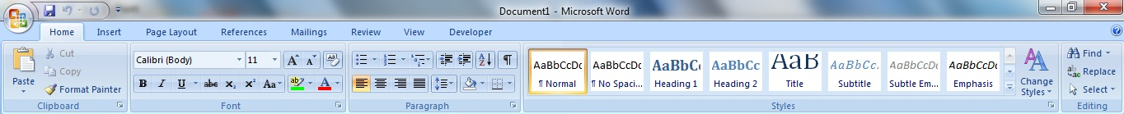
(click to enlarge)
- Insert
This tab is used to insert instructions into the document. Insert menu consists of : Pages, Tables, Illustrations, Links, Header & Footer, Text, Symbol.
Know Function Definition and Microsoft Word 2007.
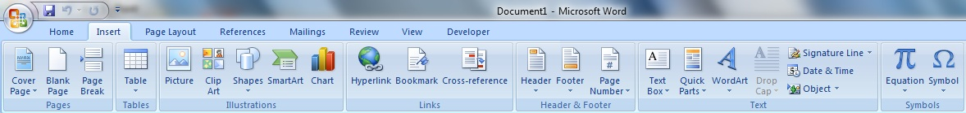
(click to enlarge)
- Page Layout
Page Layout tab is used to adjust the layout of the data, which include the Page Setup, memberiwarna background on a worksheet, set the spacing between lines, making the columns in the text, and set indentation. Menu page layout consists of: Themes, Page Setup, Page Background, Paragraph, Arrange.
Know Function Definition and Microsoft Word 2007.
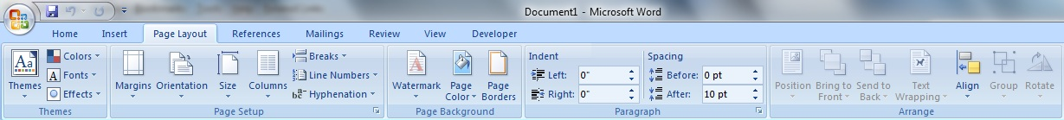
(click to enlarge)
- References
These tabs are used to enter various commands such as write footnote (footnote), insert images, and make a mark citasi. Note the references tab display
References tab. References consisting of: Table of Contents, Footnotes, Citations & Bibliography, Captions, Index, Table of Authorities.
Know Function Definition and Microsoft Word 2007.
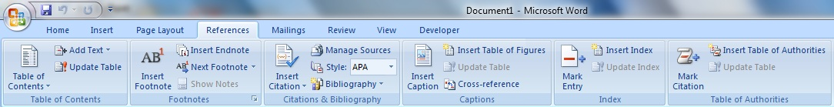
(click to enlarge)
- Mailings
This tab is useful to create a mail merge (bulk mail), text typed on the envelope, and make labels. Mailings is composed of: create, start a mail merge, write and insert Fields, preview results, finish.
Know Function Definition and Microsoft Word 2007.
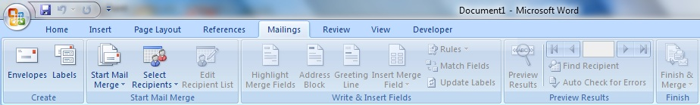
(click to enlarge)
- Review
Review tab is useful to check for grammatical errors and protect documents. Review consists of: proofing Comments, Tracking, changes, Compare, Protect.
Know Function Definition and Microsoft Word 2007.
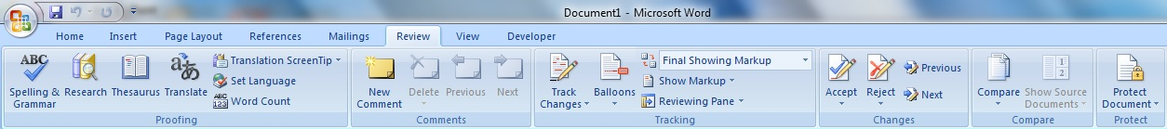
(click to enlarge)
- View
View tab is used to display or print the document on the screen, adjust the print size, and displays auxiliary lines on a worksheet. View menu serves to adjust the screen display of documents that we do. Here are the various functions of the tools contained in the View menu.
Know Function Definition and Microsoft Word 2007.
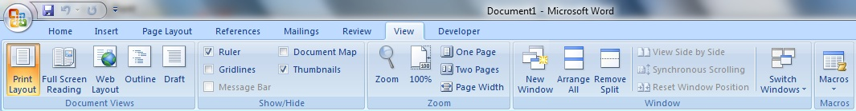

CHAPTER IV
COVER
1.1 Conclusion
After doing the analysis and implementation, that this new method can combine data processing and recapitulation attendance list calculation of employee salaries to simplify the calculation of both the recapitulated in the list of attendance and payroll calculation. So that system that runs on the company can be relied upon. Which in turn is will indirectly increase the amount of profit or profit companies, and reduce the number of the company's losses.
  - Suggestion
Suggestions authors write can hopefully be an improvement on the company in the future. Company is expected to soon replace the system attendance and payroll, becoming more complex systems for companies growing. In order to become an advancement for the company. So it will have a direct impact to profit or profit companies. The author is aware there are still many shortcomings on the analysis of the author do, it is expected the company can sort out which is the best system and immediately implement. In order Each system contained in the company can work well and to make the company moving towards the better.

