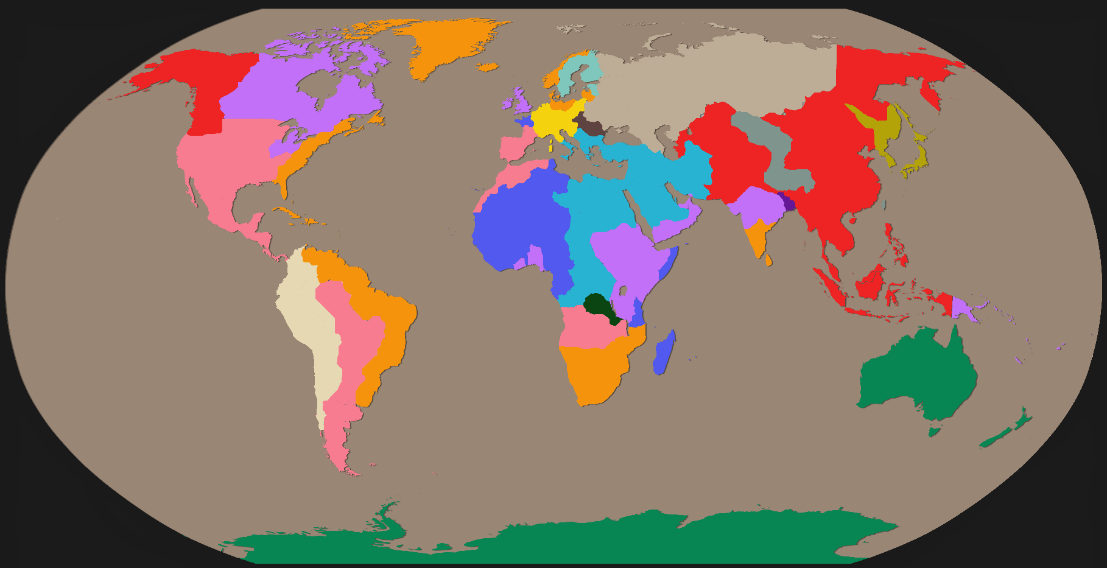
Great Empires of THE WORLD

World Population: 13.8 Billion
Year: 2039
Global War Status: Warm War

All World Powers
(In Order of Superiority)

- The Hellenic Empire
- The People’s Republic of China
- The Portuguese Empire
- The Kingdom of the Netherlands
- The Estonian Federation
- The British Empire
- The United Soviet States
- The French Empire
- The Incan Empire
- The Holy German Empire
- The United States of Australia
- The Great Japanese Empire
- The Incan Empire
- The Democratic Republic of The Congo
- The People’s Republic of Hungary
- The Nepalese Kingdom
- The Holy Kingdom of Tibet

Political Factions
The Hellenic League
-Hellenia
-Estonia
-Australia
-Germany

The Communist League
-China
-The Soviet States
-Hungary

The Colonist League
-Portugal
-The Netherlands
-Britain
-France

The Communist Resistance
-Tibet
-Nepal
-Japan

The Colonist Resistance
-The Incan Empire
-The Congo
General Overview

Persia never existed, leading to an un-unified Mesopotamia for Alexander the Great to completely destroy without much of a fight, leading to his successors swiftly taking much of Africa and West Asia.
The lack of a Persia to preserve Judaism means that Judaism and subsequently Christianity to not exist, the major Western religion is still the Hellenic (Greek) Parthenon.
The Incan empire is a major power, and native American populations in the colonies are actually significant, largely due to a lack of Spanish for there to be a Spanish inquisition, and the only part of the Americas touched by the British being Canada.
Australian history up to 1901 is largely the same; nearly total massacre of Aboriginals and penal colonisation, but instead of maintaining ties with the British, Australia (with NZ as a part of it) becomes entirely independent and does not engage with trade or diplomacy with Britain until 1947.
Due to a lack of an end to the White Australia Policy until 1989, Australia becomes a major Greek destination. By 2039 Australia is 63% Greek (many of whom are African) and less than 1% Asian.
Australia has the greatest wealth production in the world due to extremely rich mining grounds, largely profiting off selling uranium to Japan and metals such as gold, aluminium, coal, and iron to Germany.
The parts of Asia and Africa in the Hellenic Empire are just as western and modernised as real-world America or Australia, as opposed to its colonised/communist neighbours which are stricken with corruption, poor infrastructure and poverty due to negligence and poor governance from their overlords.
The Democratic Republic of the Congo has been waging an all-out war on its surrounding colonies after becoming independent in 2031. Its defences against the north-eastern colonies are largely successful as are its attacks on the southern colonies, with moderate help from the Hellens as well as the Incans. Likely taking over everything to its south within 15 years assuming support from the Colonist League doesn’t get too high. The Congo is on the rise.
Colonies in the Americas have been steadily taken over by the Incas in the south and Chinese in the north, widespread poverty and discontent among colonies makes this rather easy.
China, Hungary, and The Soviet States are in a similar position to real-world 1940-60s; tyrannical and corrupt governments and populations starving by the tens of millions.
Hellenia and The Colonist league have entered an agreement where Hellenia sends troops to the Indian area, protecting it from China. Hellenia also sends some supplies to Nepal, although they are largely self-sufficient.
Tibet is being slowly, but surely devoured by communism, and is nearly entirely cut off from its allies. Its only real military achievement is the takeover of Taiwan, a great military stronghold.
Nepal, despite its small size, can effectively fend off attacks largely due to military tactics being a strong part of all children’s education, leading to some of the greatest strategists in history.
With its rapid-fire technological advancement, Japan is actually beginning to take over some of the Chinse mainland and is becoming a major threat to China.
The British island colonies in South-East Asia are nearly entirely unprotected.

