Introduction & Verification Plan & Project Closure
Key Performance Indicator Program
_______________________________________
Derek Beaton
SNHU – IT-420 Advanced Information Systems Implementation

Table of Contents
Verification Plan…………………...……………………………………………..…….…..4
Feedback Plan……………………………………………………..………………4
Sponsor Feedback………………………………………………………..……….4
Pilot Users…………………………………………………………………………5
Criteria…………………………………………………………………………………....5
Test Cases…………………………………………………………………………………8
Postmortem Summary…………………....……………………………………………..15
Methodologies….. ……………………………………….……………………………...15
Method Evaluation……………………………………………….……………………...16
Risk Mitigation……………...…………………….…………………………………......17
Project Status……………..……………….....……………………………………………..17
Objectives……….…………….……..……………………………………………….....17
Issues…………………….......………………………………….………………….…...18
Alternative/Recommendations…………………………………………………….........18
Communication………….......……………………………………………………..…...20
Future Enhancements….………………....……………………….……………………..21
Implementation Support………………....………………………….…………………..21
Maintenance Plan………….……………....……………………………………...……….23
Appendix…..……………………..…………....………………………………………………23
IT-415 Documentation….......………………………………………………………..…..23
Project Proposal.......………………………...………...……………………..…..23
Project Plan…..........………………………...………………...……………..…..23
System Design Document…………………...………………………………..….23
Verification Plan.......…………………………….……….…………………………..….24
Project Status Report.…………………………….……….…………………………..….24
Prototype Files….......…………………………….………………………………….…..24
References……………………………………………………………………………………28

Verification Plan:

Feedback Plan:
Sponsor Feedback:
Feedback from the sponsor will be collected throughout the development phase. The presentation of information to the project sponsor will take the mode of face-to-face meetings, interviews, and upon completion of major milestones or packages- detailed walkthroughs will be performed. Daily update sessions will be held throughout the workweek to report the progress of the prior day, explain any risks or additional constraints encountered, and obtain general feedback from the project sponsor. In an effort to minimize unnecessary interruptions the daily meetings are to be held first thing in the morning. The daily sessions will ensure that the project sponsor is always up-to-date on current progress and able to monitor and control the project risks/scope effectively and efficiently. Regular artifacts provided to the project sponsor during the daily morning meetings will be presented in a non-formal and verbal form and are intended to provide relatively brief yet effective status updates on progress of the KPI system; explain any assumptions that may have been made in completing prior tasks; provide explanation of subsequent steps; obtain additional perspective, and request approval of tasks performed. Notes will be taken during and after the meetings as needed to document feedback and establish new action plans. Additional documentation such as analysis and design models; user interface design prototypes; sample input /output - to/from the system, and supporting detailed explanations for the decisions made throughout SDLC phases will be presented as completed, and updated as needed.
Pilot Users:
Upon completion of various packages/milestones a presentation of the system components created to-date will be drafted and distributed to the pilot users for their review. The members of the team are encourage to mark up the representations and be prepared to asks questions throughout the presentation to clear up any misconceptions, and identify discrepancies in design. One member of the group will be designated to take notes and draft a summary report that documents the minutes of the meeting/walkthrough and subsequently distributing the minutes of the meeting to the appropriate personnel.
Pre-deployment verification will also be conducted by designated pilot users/testers. Initial construction of the KPI system will begin with the creation of stubs for all the classes identified throughout the analysis and design phases (and subsequent iterations thereof). Testing is to be performed on each class upon its completion or each time its representation is changed to ensure quality of the class (Dennis et al, 2012). Additional forms of testing such as; Unit, Integration, System, and Acceptance testing is to be performed at the appropriate stages of development and feedback is to be documented via individual interview sessions and completion of preformatted survey/analysis forms that have been created to stimulate feedback relative to the stage of testing being performed.

Criteria:
Evaluation of feedback received will begin with an assessment of how, and to what extent the feedback aligns with the objectives of the system requirements, and how incorporation of the feedback provided will affect the projects scope. The system requirements determined in prior phases of the SDLC will be analyzed and factored into one of 3 categories which will be used as the criteria for determining the project’s successful completion and any relevant actions to be taken. The procedure for evaluating feedback received through verification testing will vary, and will depend upon the classification of its alignment with the system requirements. The 3 system requirement categories are: Must Work, Should Work, and Nice to (Brown, 2005).
Feedback identified as belonging to the Must Work category are considered critical to ensuring the project’s success and necessary to obtain the objectives and functionality that was promised. Requirements assigned to the Must Work category effectively specify the minimum features/functionality tolerated for project completion/acceptance. The project sponsor will be immediately notified of critical failures, glitches, omissions, or shortcomings for final review and acceptance of feedback classification. If the project sponsor determines the feedback is incorrectly classified it will be rejected and submitted back to the verification team for further processing. Otherwise, if the feedback classification is accepted the project sponsor will assign personnel to the resolution of the problem, and update the project scope (if needed). The required modifications will be identified and recorded in the KPI change log and all relevant documentation will be updated to reflect the modifications made. Subsequently, re-verification & validation of system documentation will need to be performed and any altered, or newly created classes, along with their linked or related modules will be subjected to the re-verification process as well. The test results/feedback will be logged, along with the action(s) taken, and included as an appendix in the project closure document. Items added to the appendix of the project closure document will be easily accessible for future review and will provide valuable insights that can be used in the development of future projects.
Feedback that is identified as belonging in the Should Work, or Nice to categories in relation to the system requirements will be subjected to further review before submission to the project sponsor for acceptance and approval of proposed changes. Feedbacks belonging to the Should Work category are not considered to be critical requirements that dictate the success or failure of the project- however, feedbacks identified in the Should Work category are still extremely important as they have a significant impact on the stakeholders satisfaction with the work performed. The high importance of Should Work elements dictate that they will be addressed before those classified to the Nice to category. To expedite the handling of Should Work requirements, the feedback received in this category will be factored into one of two categories: Existing features or functions already present in the system design; And, Suggested features or functions to include in the system design. Feedback identified as Existing- Should Work requirements will be analyzed for potential errors and possible solutions, and an estimated time to complete and verify the changes will be established then submitted to the project sponsor for review/acceptance. Similar to the process for Must Work requirements, the project sponsor will have the option to reclassify the feedback and action plan received to a lower category and return it to the project team(s) for further analysis, OR the project sponsor can reclassify the feedback to a higher category of Must Work requirements. Subsequent steps will follow as previously described for Must Work items.
Feedback obtained and identified in relation with the Nice to category are believed to contribute the least amount of value to the successful implementation of the project and are therefore evaluated for incorporation into the current system after all other Must Work and Should Work related requirements have been addressed. Similar to the feedback that was classified into the Should Work category, Nice to features/functions will be factored into one of two categories: Existing features or functions already present in the system design; And, Suggested features or functions to include in the system design. At this stage in the development process only Existing-Nice to features should be considered for incorporation into the initial system release/implementation- as much of the prior work associated with the analysis and design phases have already been completed and incorporated into the systems documentation. The project sponsor is still responsible for verifying the classification of optional or Nice to features, escalating to a higher category, allocating resources for current or upcoming version releases, or discarding the proposed changes altogether.
Test Cases:
Unit Tests:
Unit Test 1
Description:
[Step_1] The purpose of this test is to make sure that the authorized user is able to open and log into the KPI system.
[Step_2] The purpose of this test is to make sure that the system responds properly to the user credentials entered and the appropriate home screen is displayed for that user’s regional location.
Method:
[Step 1] Have an authorized user assigned from each regional location attempt to log into the system with the provided credentials. If the system accepts their credentials and the homepage displayed corresponds to the assigned location of the user, then the test is complete. If log in page does not accept user credentials, verify data entry and try again. Repeat failures will need to have code fixed and test re-run. If system accepts user credential, but the home page displayed is for another location besides the one assigned to the user, the code will need to be fixed and the test tried again.

Unit Test 2
Description:
[Step_1] The purpose of this test is to ensure that a service technician is able to enter their hours worked; tasks performed; and commit the time tracker information to the KPI database.
[Step_2] The purpose of this test is to verify the systems acceptance, storage, and use of time tracker data.
Method:
[Step_1] Have users assigned to a service technician group log into the KPI system and record their recent tasks performed and time spent on each task, then save the entry. Incomplete entries cannot be saved (hours cannot be entered without assigning a task / task cannot be entered without specifying time spent). If incomplete entries are detected a message box will appear prompting user to verify input data.
[Step_2] Have the user verify system acceptance of time tracker data by selecting the “View Time” button. A new window should open that displays the hours worked and activities performed in the past 30 days. Records will be sorted by day / date in a descending order from most recent back. If the recent entry is displayed proceed to step 3. If the recent entry is not shown the database administrator will need to query database to verify if record was saved; application developer will debug / fix code; repeat until desired function achieved.
[Step_3] Verify use of time tracker data by navigating to home page to view gauges and meters in dashboard. If gauge needles / meters update proceed to step 4. If gauge needles / meters do not function application developer will debug / fix code and test will be repeated until desired function achieved.
[Step_4] Verify accuracy of each gauges needle movement and accuracy of each gauges associated meter displaying the numerical calculation. If gauges / meters deviate from manual calculations by .02 or less the test is complete. Larger deviations will require application developer to debug /fix code and repeat testing until accurate calculations are achieved.

Unit Test 3
Description:
[Step_1] The purpose of this test is to ensure that members of the finance department are able to import service department revenue and expense information obtained from ERP database.
[Step_2] The purpose of this test is to verify the KPI systems acceptance, storage, and use of the imported financial records.
Method:
[Step_1] Have user with finance department authorizations log into KPI system and select the “Import Record” function. A new window will open with various options for importation of new records.
[Step_2] Financial records will be exported from ERP system to Excel files that are saved to either local workstation or network drive. The layout of the reports must be configured before importation can begin. User must assign/link each Excel column to database table column. (There will be an option to save templates for future re-use). Once the format is complete the user will need to specify the location of the report to import and this can be accomplished by manually typing / pasting the file address in the text field or selecting the “Browse” button to search for the file. Once the location is specified select “Save” to import record to KPI system. A message box will be displayed if any errors occurred otherwise user will be brought back to home screen.
[Step_3] Verify importation of record(s) by selecting the “View Records” button. A new window will open displaying a summary of recent records that have been imported sorted by import date. Double clicking an import record will open another window showing all the records that have been imported. If all data imported properly proceed to step 4. If record does not show in record list, or if record did not import properly- application developer will debug / fix code. Repeat process until desired result achieved.
[Step_4] Verify system use of financial records by monitoring gauge and meter activity. If gauges / meters update proceed to step 5. If gauge needles / meters do not function- application developer will debug / fix code and test will be repeated until desired function achieved.
[Step_5] Verify accuracy of each gauges needle movement and accuracy of each gauges associated meter displaying the numerical calculation. If gauges / meters deviate from manual calculations by .02 or less the test is complete. Larger deviations will require application developer to debug /fix code and repeat testing until accurate calculations are achieved.
Unit Test 4
Description:
[Step_1] The purpose of this test is to ensure that management is able to set performance specific to each location.
[Step_2] The purpose of this test is to verify system acceptance, storage, and use of the performance goals entered.
Method:
[Step_1] Have user with management level authorizations log into KPI system and select “Set KPI Goals” button. A new window will open with various options for setting KPI goals.
[Step_2] Select location to create performance goals for. Select the performance indicator(s) to be measured and enter in the min/max values for each color on the associated gauge (Green=Excellent, Green-Yellow = Good, Yellow = Fair, Orange = Poor, Red = Bad) then click “Save” to commit goal information to the gauges.
[Step_3] Verify that the layout of the gauge(s) match what was specified by the min/max values set in step 2. The min/max values specified will appear as tick marks on the ends of each color and will be labeled with the value specified when the goal was created (Sample shown below). If gauge appears as expected proceed to step 4. If gauge does not appear as expected- application developer will debug / fix code and test will be repeated until desired layout is achieved. Repeat steps 1 through 3 for each location.
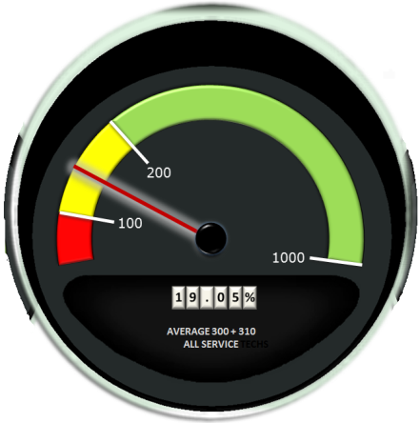
[Step_4] Global / company-wide performance goals should be auto calculated by summing the min/max values for each locations goal metrics for a given indicator. Verify layout of global performance gauges. If global performance gauges are as expected then test is complete. If global performance gauges are not displayed as expected- application developer will debug / fix code and test will be repeated until expected results are achieved.
Integration Test:
Description:
The previous units must be integrated and form a working program for this use case. Program testing will address issues with program construction and verification.
Method:
Integration tests will be performed to ensure that the modules function properly after integration. Black Box testing will be used to verify integration. Testers lacking knowledge of the systems internal structures will test the KPI program. Testers will provide inputs and verify the outputs against the expected results to ensure that the KPI program performs properly when integrated.
System Testing:
Description:
Analysts will perform system testing to ensure that all classes work together without error and examine how well the system meets business requirements and its usability, security, and performance under heavy load (Dennis, Wixom, & Tegarden, pp. 535).
- Infrastructure analyst will perform security testing to verify the KPI programs ability to prevent unauthorized access. Disaster recovery testing will be performed to ensure data can be properly recovered in the event of a disaster.
- A system performance test will be performed to check throughput and response times. Additional stress testing will be performed to check the system under loads (multiple users entering time tracker records, multiple finance personnel importing expense/revenue reports, running complex queries, etc.). The load test will determine at what point the system fails and ensure that it will meet performance requirements.
- Usability testing will be performed to check how convenient the system is to use for the end user. If necessary modifications will be made to reduce the end users perceived cost of using the system and increase system success.
- Documentation testing will be performed to verify the accuracy of system documentation, help systems, procedures, and tutorials.

Acceptance Testing:
Alpha Testing- End users will begin testing the system with made-up data to ensure the system meets the business requirements and is acceptable to the end users.
Beta Testing- Made-up/Alpha data will be removed from the system and end users will begin to use the system with real data while carefully monitoring the system for errors.

A Postmortem Summary
1 Methodologies
A RAD (Rapid Application Development) Phased Development methodology was used for the development of the KPI system. The CASE (Computer-aided Software Engineering) tools used throughout the SDLC of the KPI system include:
- Microsoft Visio- Used during analysis and design for creating analysis / design models (use-case diagram, class diagram, ERD diagram, etc.)
- Microsoft Visual Studio- Used during implementation for construction; verification and validation; and maintenance (construction of future versions/releases).
- Microsoft Project- Used in all phases of SDLC to manage scope of project (i.e. create a work plan to list the various tasks; assign staff; establish timeframes / deadlines; and identify the resulting deliverables).
With a phased development methodology- additional functionality can be added in future versions; any non-critical features that may have caused delays in application development can now be postponed and incorporated into a future version which will allow the program to provide value sooner.
2 Method Evaluation
Microsoft Visio was easy to use and required little training to utilize its benefits. Creating analysis and design diagrams with Microsoft Visio benefited the development of the KPI application by depicting various aspects of the system in a visual form that was easier to understand. The Visual Studio programming environment is able to significantly reduce construction time, and increase system quality / reliability. Some features of Visual Studio that reduced time and increased quality include:
- GUI builder- to simplify GUI design/construction.
- Code editor- that speeds up the process of coding with intelligent code completion and compiling code in the background to check for syntax and compilation errors.
- Debugger- debug the application to find and fix errors in code including the ability to set breakpoints (stop execution at a certain position); set watches (monitor variable values during execution); and even edit code while being debugged.
Microsoft Project was deemed appropriate for managing the project as it provided a visual representation of the project scope that was easy to read and update as needed. Though the project was not able to be fully implemented the phased development methodology would have been appropriate for the KPI system because non-critical features could have been omitted from the initial version and incorporated at a later date. For Example: The learning curve associated with the software used to create the 3D vehicle dashboard objects is the most significant factor delaying the implementation of the KPI system. Incorporating this functionality in a future version would reduce initial schedule overruns, and minimize the risk of project abandonment resulting from lack of completed deliverables.
3 Risk Mitigation
The 3D vehicle dashboard GUI presents a significant risk to the timely completion of the KPI program. Future projects of similar scope should consider outsourcing this functionality, hiring a consultant, recruiting new personnel with desired experience, or extend the schedule to accommodate existing developer’s acquisition of such skills. To mitigate the current KPI projects risk of abandonment, or severely overextending the project deadline- the 3d dashboard requirement was changed to a simpler 2d design. Additional schedule risks associated with the creation of the 3d gauges can been mitigated by using Doughnut and XY Scatter charts in Visual Studio and binding the legend and data point properties to the appropriate performance goal values specified by management. The original 3d dashboard and 3d gauge GUI requirement can be incorporated into a future version release of the KPI system after the necessary tools and skills have been acquired.
B Project Status
1 Objectives
The implementation plan adequately identifies and explains the following: required tasks; resulting deliverables; associated risks; main requirements; skills needed; standards to be followed; tests to be performed; verification and validation criteria; and incorporation of feedback obtained. The identification and detailed explanations of the aforementioned criteria in the implementation plan will lead to meeting most of the objectives set out in the KPI project proposal. Additional research should be done on the necessary tools and skills required to develop the 3D dashboard, custom gauges, and custom buttons. The one objective that it cannot guarantee is the transformation of the service department from a cost center to a profit center. This objective is subject to actions taken by management in response to information provided by the KPI system, and is not a direct function of the system itself. With the exception of the tools to be used, the implementation plan and supporting documentation should be sufficient to fully implement the proposed system and ensure that it is able to meet the obtainable and measurable objectives.
2 Issues
The one objective that was not sufficiently met was the design of the 3D vehicle dashboard. Unfamiliarity with 3D modeling tools prevented the creation of the 3D objects and custom controls to be used in the KPI system. This graphical design requirement produced unexpected complications with special software procurement, installation and configuration, and usability training.
3 Alternative/Recommendations:
Obtaining 3D design software was accomplished by installing the AutoCAD Design Suite Ultimate 2016 and operating on a 3 year student issued license. Difficulties arose with activating the student license and certain programs contained in the suite are still not functional. Substantial effort was required to gain access to 3ds Max which is the tool chosen for the creation of 3d objects. Use of the software proved to be even more challenging and an inherently lengthy learning curve was realized. To mitigate the risk of not completing the project on time a 3D dashboard was obtained from the community collaboration and sharing website called GrabCAD. Additional complications arose with incorporating the 3D object into the program design and so to keep the project on schedule the 3D dashboard was rendered into a 2D jpeg image and incorporated as a background of the home page/form. Development of the gauges to display KPI progress was also a challenge. The gauges incorporated into the design are actually just images of a gauge that was created in Excel using cells as a data source and two charts to create the image of the gauge and movement of the needle. Charts used in this process include: doughnut chart {doughnut chart creates the various levels of performance (Excellent, Good, Bad / Green, Yellow, Red)}, and an XY scatter chart {The needle that points to/indicates the level of progress}. With these shortcuts the KPI gauges could then be created and placed at appropriate locations on the form to emulate the dashboard of an automobile. The shortcuts taken result in a rather crude appearance of the main dashboard, are non-functional, and need to be developed before initial release of the system. To properly use 3D objects created in 3DS Max, custom Visual Studio plugins would need to be written and installed which is a capability not yet possessed by existing personnel and to acquire such skillset would greatly exceed the project scope. Other developing tools (such as GL Studio) are available that would greatly simplify the development of these 3D objects and their integration into the rest of the program. Consider investing in additional software tools / resources and allocate time for training.
It would be sensible to recruit new personnel with the required skills, or obtain necessary resources and training for existing developers prior to acceptance of a similar project. Another alternative would be to simply outsource this portion of the program as opposed to creating it in-house. Either of the above recommendations would ensure faster development and a better quality program.
4 Communication
A project status report is generated at the beginning of a milestone. The initial project report creates the schedule for the next period and specifies the milestones and their estimated date of completion. The project status report is filled out periodically as activities are completed, changes are requested, or new risks are encountered. The project status report is finalized when all tasks are completed or at the end date specified when the report was generated (whichever comes first). After a given period is over the next project report is generated. Any activities not completed in the prior period will be carried over to the next and a new schedule will be formed. The project status report is sent out to all stakeholders at the beginning and end of a scheduled milestone or as significant changes or risks are encountered. A sample project status report is attached in the appendix of this project closure document. Overall the project is currently behind on schedule. Complications with construction of various parts of the system- coupled with an overly optimistic deadline and insufficient time schedule have resulted in significant delays. All analysis and design tasks prior to implementation have been completed successfully; however, very few construction tasks have been started or completed. Serious consideration should be taken to set aside more time for the development of the KPI system to ensure its eventual successful completion. Despite the overrun in schedule, the development of the KPI system during normal working hours, with existing personnel, and when time allows- has allowed the project to stay within budget.
C Future Enhancements
The current KPI system has been designed with future enhancements in mind. Anticipated future enhancements include: More aesthetic home screen and realistic dashboard; User customization options (dashboard layout/design options, display colors / schemes, creation of user report variants, user specific shortcut/hotkeys, etc.); Expansion of the system to monitor other departments performance; And, possible integration with existing operational ERP database(s)- so as to eliminate the need for manual importation of revenue / expense data, reduce user requirements, and increase the accuracy of the system by incorporating the most recent information. Additional upgrades can also be made as discovered or needed.
D Implementation Support
As a way to motivate the adoption of the new system- users from all levels have been informed of its development and intended use early on since the analysis phase with periodic updates throughout subsequent phases. The costs associated with keeping the current system and business processes have already been realized across the board through budgetary cutbacks and reductions in staff. With the need for change already established, the potential benefits of the new system were then able to be received more openly and met with much less resistance. A heavy emphasis was made on the intention of maintaining job security for remaining employees. Additional incentives to encourage use of the new systems include the reduced time spent managing the system; more strategic resource management- to reduce large or unnecessary cutbacks; and the potential for bigger annual bonuses (because employee bonuses are in-part determined by company global profits). Though it is impossible to be completely certain, it is believed that the new system will be met with open arms and users from all levels will be dedicated to its success.
With the potential benefits to be received and costs to be avoided established, the ability to adopt the new system must then be provided. When a user is granted access to the KPI system, assigned to a user group, and given their user credentials for logging into the system- they will also be provided with a link to the training materials for the new system. The initial training will be provided to users via narrated screen share videos located on a network folder. The videos will be categorized by user roles/function and will walk a user through the various features of the program that they will be using. Additional user documentation will be created and incorporated into the system via a help menu. The existing help desk personnel will be responsible for handling requests that were unable to be solved via training videos and the integrated help menu. In the event that the help desk team is unable to resolve user problems they will be responsible for escalating the problem to the appropriate personnel.
If available, data from the prior year (or more) will be imported into the KPI program and the results derived from the new system will be compared with that of the previous system. If any deviations in accuracy are found the system will be corrected and redeployed for initial use. After thorough testing of the constructed KPI system is complete it will be installed following a parallel conversion approach. Both systems will be used for 3 to 6 months to ensure that there are no bugs in the new system at which point use of the old system will be terminated.
E Maintenance Plan
Regular backups of KPI system information will be performed in accordance with existing policies and procedures to mitigate risk of data loss or corruption. Development of system enhancements previously identified in Section C will begin after acceptance of the initial version. Upon completion of each major enhancement the new version will be tested and released with accompanying user documentation. This process will repeat until all of the Section C enhancements have been completed. Additional, system maintenance will be performed as needed upon approval of a change request by the project manager. Change requests related to bugs found in the system will be handled immediately to mitigate any potential damages to data or user acceptance of the system. Change requests related to minor improvements of the system will take priority after bug fixes so as to increase user acceptance and ensure that the system continues to meet the evolving business requirements.
F Appendix
1 Project Proposal
See attached: KPI System Proposal.docx
2 Project Plan
See attached: WBS3.mpp
3 System Design Document
See attached: KPI SDD. docx
4 Verification Plan
See attached: KPI-Verification-Plan.docx
5 Project Status Report
See attached: project_status_report_KPI.doc
6 Prototype Files
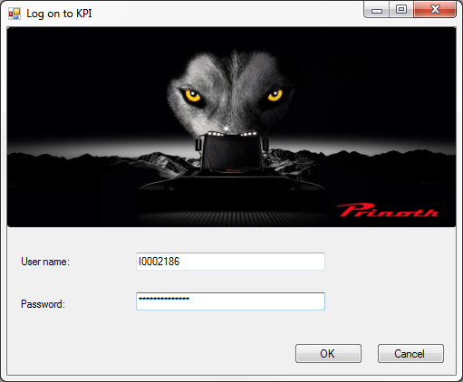
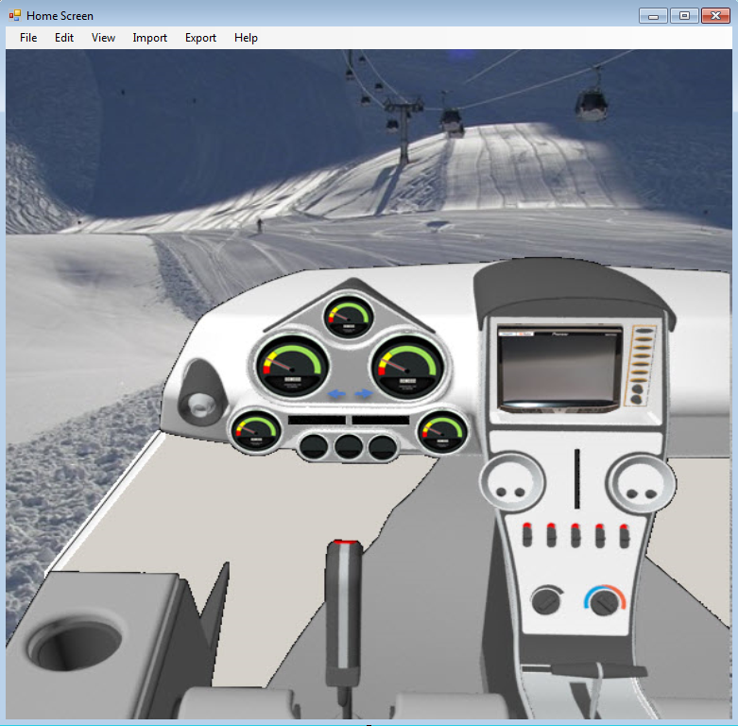
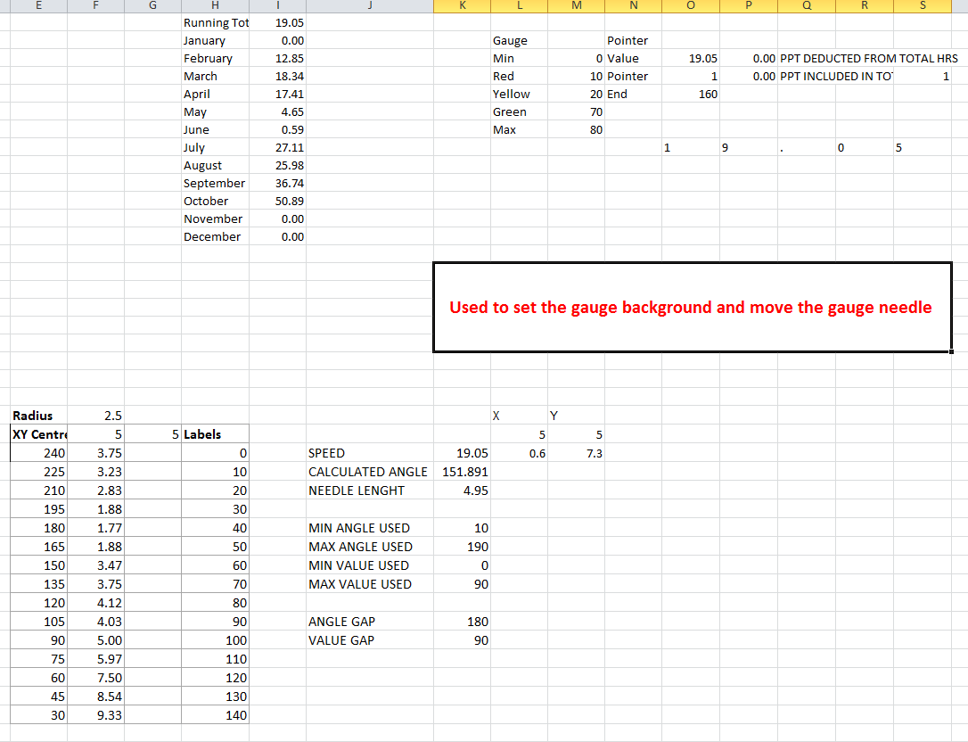
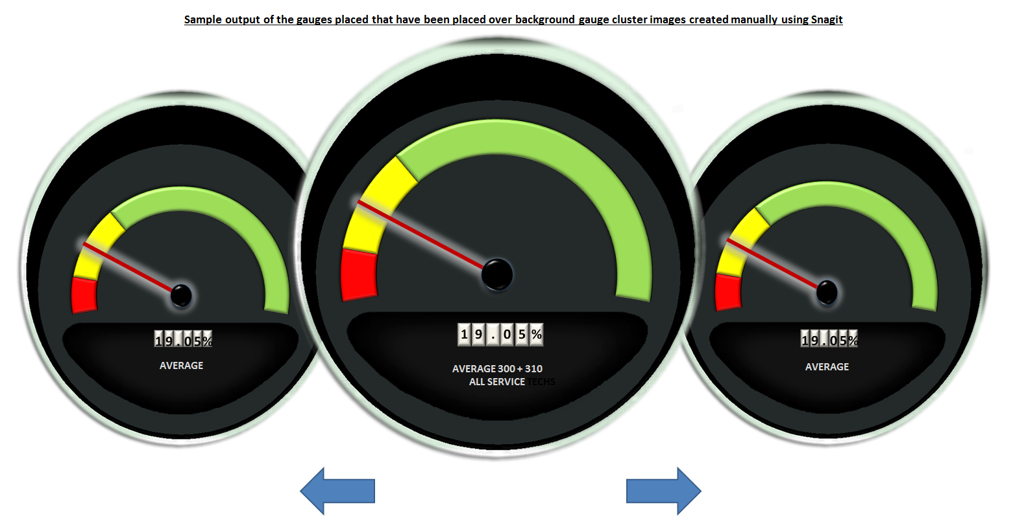
(Sample ERP reports to be imported into KPI system)
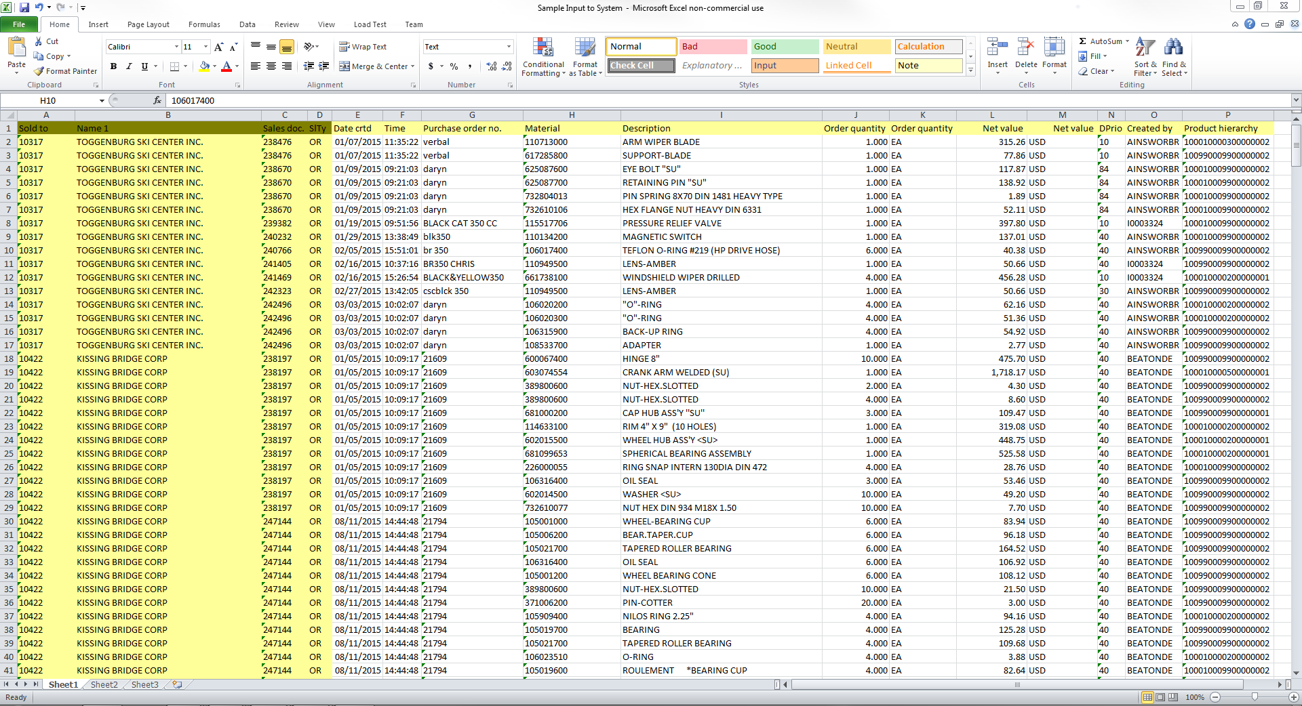

References
Dennis, A., Wixom, B., & Tegarden, D. (2012). Systems analysis & design with UML version 2.0: An object-oriented approach. Hoboken, NJ: John Wiley & Sons, Inc
Brown, S. (2005, June 27). How to improve verification planning. Retrieved October 11, 2015, from http://www.eetimes.com/document.asp?doc_id=1271287

