System Design Document
Key Performance Indicator Program
_______________________________________
Derek Beaton
SNHU – IT-415 Advanced Information Systems Design

Table of Contents
Introduction…...…………………………....………………………………………………..4
Purpose…………………………………………………………………………………….4
Scope…………………………………………………………………………….………...4
Requirements…...…………..………………………………………………………………...5
Non-Functional……………...………………………………………………………….....5
Operational………………………………………………………………………...5
Performance……………...…………………………………………………..…....5
Security…………………………….…………………………………………...…5
Safety……...………………...………………………………………………….....5
Functional…………………………………………………………………………………5
Manage Data………………………………………………………………………5
Set Performance Goals…………………………………………………………….6
Calculate KPI Progress……………………………………………………………6
Design……..………………………………………………………………………6
Constraints..…………………………………………………………….…………………….6
Resources………………………………………………………………………………………7
System Overview…………………………………………………………………………...8
Use-Case Diagram………………………………………………………………………...9
Use-Case Description_1……………………………………………..…………………..10
Use-Case Description_2………………………………………………..………………..11
Use-Case Description_3…………………………………………………..……………..12
Use-Case Description_4……………………………………………………..…………..13
Use-Case Description_5……………………………………………..…………………..14
Use-Case Description_6………………………………………………..………………..15
Use-Case Description_7…………………………………………………..……………..16
Class Diagram……………………………………………………………………………17
Class Responsibility Collaboration Cards……………………………………………….19
Documented Detailed Design…………………………………………………………27
Use of Structure and Behavior Diagrams………………………………………………..27
Design UI / Controls……………………………………………………………………..27
References................................................................................................................................28
A INTRODUCTION
1.1 Purpose
The purpose of the Key Performance Indicator (KPI) System Design Document (SDD) is to document the design of key functional components required to successfully implement a KPI system that can be used to optimize service department processes and make the service department a revenue source for the company.
1.2 Scope
The scope of the KPI SDD includes developing a system design for the following functional components:
- Data Management, including manual entry of service technician hours worked, activities performed, date, and hourly pay; Importation of itemized service department revenue records; Importation of itemized service department expenses, and database(s) for storage of service department performance data.
- Setting Performance Goals, including expenses to be incurred, revenue earned, hours spent on a given activity, setting performance ranges for each specified metric, setting annual, seasonal, and monthly goals for each metric.
- Calculation of KPI Goal Progress, including progress for each specified, performance metric, progress for each department location, progress for global performance, and calculate progress toward customized goals based on annual, seasonal, and monthly targets.
- Application architecture, including the design of file structures to accommodate future additions/expansions (be structurally independent), designing the user interface to show individual location and global progress in the form of a vehicle dashboard for each performance metric in each of the target periods (annual, seasonal, monthly), and means of providing authorized users access to more detailed custom reports, raw data, and calculation formulas.
B REQUIREMENTS
1 Nonfunctional Requirements
- Operational Requirements
  - The system shall operate in Windows Environment.
  - The system shall provide management reports.
  - The system shall provide rankings of service department performance.
  - The system shall be created with existing personnel, during normal working hours, and when time allows.
- Performance Requirements
  - The system shall be available for use 24 hours a day 365 days a year.
  - The system shall allow multiple users to access the system concurrently.
- Security Requirements
  - The system shall restrict access to setting the KPI target goals.
  - The system shall restrict access to employee salary information.
  - The system shall restrict access to profitability information.
  - The system shall terminate a user session after 15 minutes of inactivity.
- Safety Requirements
  - No specific safety requirements are anticipated.

2 Functional Requirements
- Manage Data
  - The system must accept manual entry of service technician hours that have been clocked, activities performed, corresponding date and technician hourly pay / annual salary.
  - The system must be able to import service department revenue records from Excel reports.
  - The system must be able to import service department expense records from Excel reports.
  - The system must be updated at least weekly.
  - The system must be able to distinguish between the different service center locations.
  - The system must keep historical KPI data.
- Set Performance Goals
  - The system must include actual cost and revenue information for each location.
  - The system must allow management to set performance goals by location and globally.
  - The system must allow management to set performance goals (location and globally) for each of the four Seasons (Winter, Spring, Summer, Fall).
  - The system must allow management to create performance ranges (very bad, poor, fair, good, excellent).
- Calculate KPI Goal Progress
  - The system must automatically calculate KPI progress for each performance metric.
  - The system must automatically calculate KPI progress for each location.
  - The system must automatically calculate global KPI progress.
  - The system must calculate progress towards annual, seasonal, and monthly goals.
- Design Requirements
  - The system must accommodate future expansion: I.E. - Changes to a files structure must not affect the programs ability to access the data (structural independence).
  - The system must display KPI progress in graphical form and will be consistent with the appearance of a vehicles dashboard.
  - The system must allow authorized users to generate detailed and customizable reports.
  - The system must display KPI progress for each service center as well as global performance.
  - The system must identify the units in which the measure will be reported.
  - The system must provide authorized users with the raw data elements and the detailed formula(s) used to calculate the performance measure.

C CONSTRAINTS
In an ideal implementation of the Service Department KPI System the historical records of service technician hours clocked, hourly/annual salaries, activities performed, total departmental expenses, total departmental revenues, and respective dates would be available. Existing documents would be analyzed and data manually entered or imported into the system. The default goal for these prior years would be to break even- no revenue would be earned or lost; and enough of the tasks performed would be paid customer work which would cover the expenses incurred from other non-revenue generating tasks. Having this historical data is critical to the success of the system. The performance of prior years when compared to the default (break-even) goal would serve as the industry benchmark that realistic and achievable future goals would be derived from. However, for this KPI the historical records are not available and therefore, will need to be simulated. KPI performance goals will be assigned using simulated past performance, calculations on performance measures will be tested for accuracy, and the output depicted on the gauges will then be validated. The system will be able to be fully tested however, the KPI system will not provide much useful Business Intelligence (BI) until a reasonable amount of history has been established. Additionally, some post-implementation “fine-tuning” will be required to complete the financial record import function once the format of the original financial reports is known.

D RESOURCES
The service department KPI will be developed using existing software such as: Microsoft Studio- to code the front end application in C#; Microsoft Visio- to create the UML behavioral and structural models and ERD diagrams for designing the database; Microsoft Project- for documenting the project plan and managing scope; and other Microsoft Office Suite products. The KPI program will have a front end GUI application installed on existing workstations that end users will interact with to enter time data, import financial records through, and obtain performance progress information and detailed reports from. The KPI program will access data stored in its database(s) located on an existing server running Microsoft SQL Server 2008 for the Relational Database Management System (RDBMS). The KPI system is to be created with existing personnel, during normal working hours, and when time allows. The KPI system will require little to no funding however, the scope of the project is subject to great fluctuation due to time, and available personnel constraints.

E SYSTEM OVERVIEW
Since the KPI projects initiation, decisions regarding the functionalities and features to be incorporated into the system have been based on input obtained mainly from the project sponsor with contributions obtained from other relevant stakeholders. These suggested functionalities and features have since been translated into the functional and non-functional requirements as demonstrated in the Analysis section of the project plan and the Requirements (section B) of the KPI system design document. To ensure the key business requirements for the KPI system are identified and demonstrate the interaction between the system, its users, and other external systems- a behavioral Use-Case diagram will be created. A use case diagram will depict the major processes that the system must perform in order to provide a benefit to an actor (system user / external system). Once completed the use case diagram will provide a high level demonstration of the systems users, their goals, and how the KPI system will provide a benefit to one or more of its users. Iteratively identifying the major high-level use cases in this manner helps prevent key business processes from being left out and informs subsequent tasks outlined in the project plan.
KPI Use-Case Diagram

Use Case Descriptions

After the key business requirements and processes to be performed have been established, and the required input, optional input, and query fields identified the next task of creating a high-level structured design begins with a class diagram. A class is a kind of person, place, or thing that the system will need to capture and store information about. Each class has a list of attributes that describe or identify an instance of the class, and each class has a list of operations that the class can perform. The class diagram provides a high level structured design of the system to be implemented by showing the static relationships between the classes as well as their allowed behaviors and states. The compilation of business requirements, system processes, input / query fields, and high-level structured design will inform the next task on the project plan and aid in the development of the information systems output format.

KPI Class Diagram

CRC Cards

F DOCUMENTED DETAILED DESIGN
1 Use of Structure and Behavior Diagrams
Even with all of the development tools available today it would still be disastrous to jump right into coding without creating a detailed, or low-level design of the system first. Fortunately, the prior analysis phases completed have effectively outlined all of the critical components needed before the design phase could begin. These critical components include: the determination and clarification of key business requirements, processes the system must perform to provide value, the resources required to perform system processes, the users responsible for providing the required resources, and a high level structural design of the system. It is these components obtained through the analysis phase that will inform the decisions behind a useful and practical design of the Graphical User Interface (GUI) and Controls.
2 Design UI / Controls
When designing the human-computer interface layer of the KPI system it is important to take into consideration the three fundamental parts that make up the user-computer interface: navigation mechanism- how the user will give instructions to the KPI system; input mechanism- how the system captures information; and output mechanism- how the system will provide the information to the user.
2.1 Navigation Mechanism(s)
Upon opening the front end application the user should be greeted with a log on window prompting them for their user name and password. A mistyped username or password will prompt the user to re-enter their credentials. During the authentication process the system will determine which functions the user has access to (according to the predefined authorizations assigned by management / administration). Locked fields for a given user will not be visible or accessible. The initial screen will be the cockpit with dashboard gauge clusters for that given users location (Prototype shown below). The initial dashboard will be created by incorporating 3ds Max model renderings created from products contained in the AutoCAD Design Suite Ultimate 2016 (For this project I will be using the free student license with software downloaded on my own computer, **For the actual implementation I would be using ******** existing AutoCAD licenses and company computers - Hopefully with Engineering Dept. Support**). The initial dashboard window will have the usual menu bar at the top of the screen for those who prefer the traditional Windows-style approach to using the system; however, all of the functions will also be accessible from the dashboard. The Fan control knob on the lower right hand corner will be used to switch between the different service departments locations. The temperature switch/ knob will be used to scroll through a given locations KPI performance by Season / Fiscal Quarter (Winter (Q1), Spring (Q2), Summer (Q3), and Fall (Q4)). With each change in season/quarter the background image shown through the windshield will also change to represent the corresponding time of year (Rough representation shown below: blue = Winter, green = Spring, red = Summer, and orange = Fall). Clicking the arrows (in center of all the gauges) will allow the user to scroll through performance info one year at a time. Selecting a different location from a dropdown box on the LCD screen will allow the user to view KPI information for another location. To exit the application one can use the top menu bar, or simply click “Escape” on their keyboard.
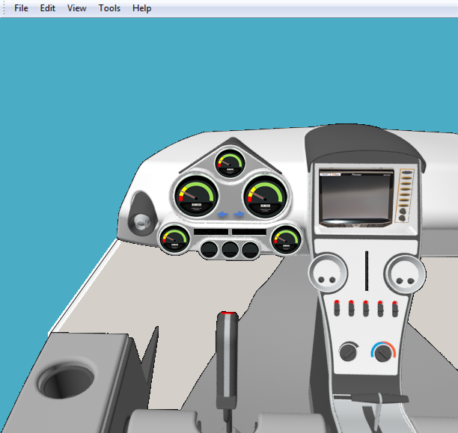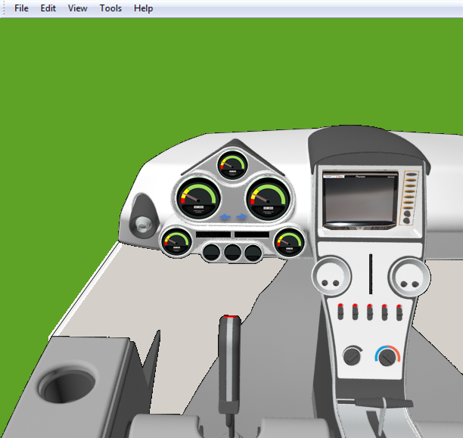
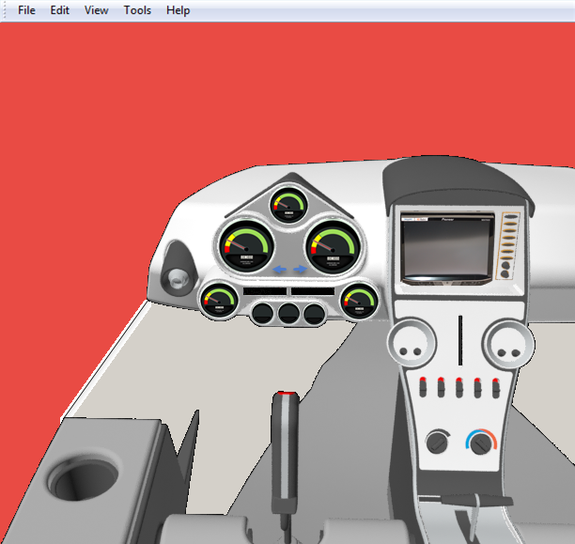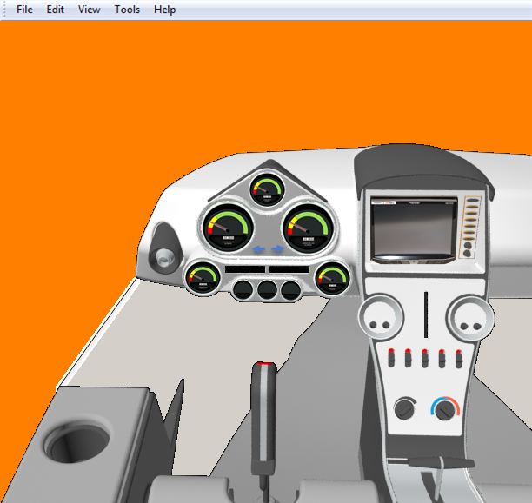
(Prototype Dashboard, Harris, 2014)

2.2 Input Mechanism(s)
In an effort to keep things as simple as possible and expedite the information gathering process many of the necessary functions will be provided using “one-click” operations with custom buttons created on the main dashboard as described in section 2.1 of the SDD. These one-click methods are essentially “read-only” functions and are intended to allow the user to view existing KPI information quickly. However, there are other functions that need to be performed in order to maintain the system and will require a larger, more formal, and organized window design.
The requirements for the service technician are relatively simple. The service technicians can simply log into the KPI program and click on joystick to open the time tracker form (separate window). The technicians will enter in the hours worked, tasks performed and respective dates. It is worth noting that this process must be completed on a weekly basis and that service technicians will be allowed to create/modify records within one month of the current date to accommodate for vacation, temporary/short term disabilities, or other unexpected absences. (Wages and Salary/ Payroll information will be added and maintained by finance department).
Once the finance department has the necessary report(s) they can log into the KPI system and click on the throttle control in the center console. Doing so will open up a dialog box asking for the destination path and name of the file. The file import request can be cancelled at any time however, once the destination and file is confirmed, the responsible party can approve the import and the information will be automatically transferred into the KPI database tables and no further action will be required.
Management will access the forms they need by clicking on the LCD screen. The available options shown in managements screen will be more extensive than the average user and will include access to all of the additional required forms through an added column on the left side (similar to a Windows Explorer window). Management assumes the role of system administrator and has the ability to grant access to other users and determine their access privileges. The screen used to enter performance goals will consist of a few radio buttons to perform quick calculations on target goals or copy existing goals over to a new year; check boxes to select specific goals/criteria to copy or modify, special command buttons to execute certain functions, and a spreadsheet-style table to quickly enter in each locations Min/Max performance values for each performance metric (left hand column), and for every season/quarter of a given year (top row). 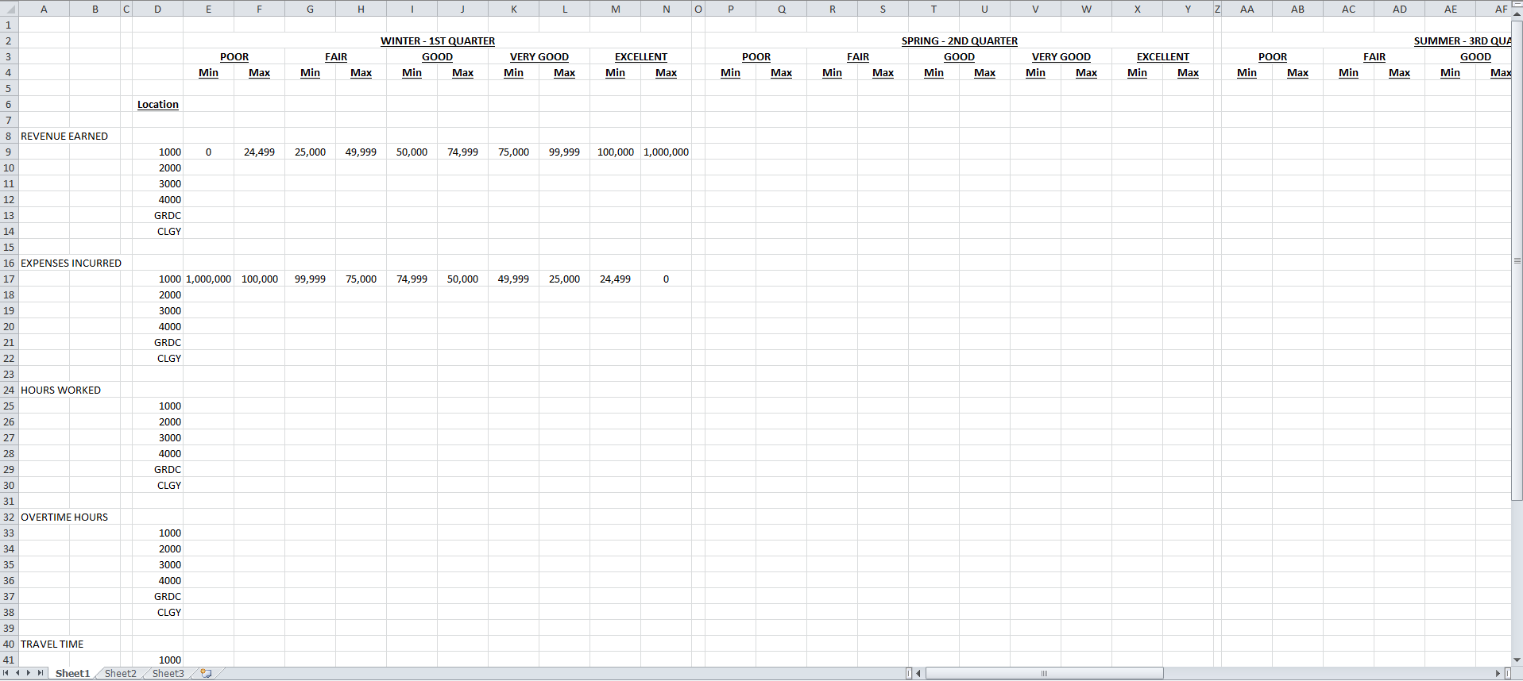
The data type of each gauge will be determined by the values the gauge is meant to measure. The main purpose of the KPI system is to provide decision makers with timely and accurate information at a glance. This is achieved by use of the gauges in the initial dashboard; however should members of management require more detailed profitability reports, then they can acquire them from the custom report screen that can be accessed from the main LCD screen menu.
2.3 Output Mechanism(s)
The output mechanisms of the KPI program are customizable gauges that depict at a glance the overall performance of the service department in achieving company goals.
The process for obtaining and entering in the data needed to provide the required information has been streamlined so that it can easily be done on a weekly basis. The increased frequency with which the system receives data and the automatic update of the gauges whenever new records are added ensures that the system is always current and management is receiving the most accurate information.

References
Harris, T. (2014, April 9). Icon A5 Interior. Retrieved August 30, 2015. From:
https://grabcad.com/library/icon-a5-interior-1?utm_campaign=eng-similarmodels&utm_content=first-model-downloaded&utm_medium=email&utm_source=user-email

