Black Eyed Peas Biography.

Ever since they formed in the environs of Los Angeles, The Black Eyed Peas always has been characterized by an excessive passion by spirit and the energy of hip-hop.
The members of this group are called William (1975), Taboo (1975), Apl. Of AP (1974), and Fergie (1976).

Will. I.Am and Apl.de. Ap knew himself in 1989 and immediately they started planning ideas and to tack his thousands of musical references. There passed the years in which, for duo at the time, a hollow and a name was done in the scenes of the hip hop and of the soul of Los Angeles. After an unsuccessful contract with the stamp Ruthless the group decides to recruit another member, Taboo, and to continue forward.

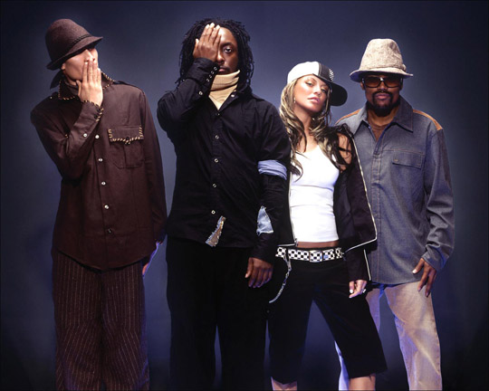

Soon the remuneration comes to them and they register for Interscope Records. In 1998 the premiere of the group comes finally, behind the front. The three for then adopt The Roots's musical aesthetics with three MC's rhyming and a band behind for the direct ones. On this disc there collaborates the great Macy Gray that would repeat collaboration on the following disc of the group.

With the arrival of the new century also there comes the Black Eyed Peas second disc, bridging the gap. A disc riddled with collaborations at the expense of stars and secret figures of L.A's scene: Chali2na, Kim Hill, Wyclef Jean, Of the Soul or Mos Def collaborates on a rich disc in instrumentation and with a funky air. Again the BEP's refuse to follow the modes and invoice a disc that confuses the most purist and that opens them a new range of public foreign to the scene of the hip-hop but equally unconditionally.

And 2003, the Elephunk year comes, the third album of the group. After the too habitual comparisons with The Roots or Jurassic 5 the group, this time extended to quartet with Fergie's incorporation (a fan widow become a nun who happens to form a part of the set), decides to give him another return of nut to her career. "Elephunk" is the album with collaborations as those of the group hardcore Pope Roach, the Brazilian legend Sergio Mendes or the white hero of the black music Justin Timberlake. All that and a few songs full of paces and musical "miscegenation".

Why did the members of Black eyed Peas create the song Where is the love?

-Will. I.Am: what inspired us to write “Where is the love " is not a global problem, is a human problem because I believe that the persons have not found the love inside them. All our global problems are based on world leaders who have a lack of love inside them.

-Taboo: What happened on September 11 affected us enough. We did not know if the industry of the music was going to close or if the United States were going to separate of the map. It was a humiliating experience. It showed us that at the end of the day, everything what we have is our friendship. Nevertheless, nobody was touching this matter. Because of it we did this song, to speak on this topic "Taboo".

-Fergie: The rappers have a responsibility. They are the reporters of the streets. If you ignore what is happening and only you speak of you necklace, what person's class are you you?.

- Apl.de. Ap: It was a therapy for my because I began to think where it was in my life now and it did me well. I was in a dark moment (drugs).

Commentaries of every member of the group

Raice: The work was enterteining enough, but a bit complicated, because I don't understand some words.

Amalia: The work was very interesting. I like me very much, and hope that it returns to do another work as this one.

Atreyu: The work was very interesting, because thanks to, I have learned to write better in English.

David: I believe that this one has been the work more entertaining that I have done. Thanks to this work, I have learned many new words. I hope that it returns to do another work as this one.

Why do we choose this group?
We choose this group, due to the fact that we like the hip-hop music and that like the songs that they speak real-life.

How do we divide the tasks?

Raice: He looked for information, helped in the translation of the letter of the song, and also he helped with the discography.
Amalia: She looked for information and also she did the discography.
Atreyu: He looked for information and also she did the translation of the letter of the song.
David: He looked for information and also he did the biography of the group.

Letter of the song (English).

Where Is The Love (English)

What's wrong with the world, mama
People livin' like they ain't got no mamas
I think the whole world addicted to the drama
Only attracted to things that'll bring you trauma
Overseas, yeah, we try to stop terrorism
But we still got terrorists here livin'
In the USA, the big CIA
The Bloods and The Crips and the KKK
But if you only have love for your own race
Then you only leave space to discriminate
And to discriminate only generates hate
And when you hate then you're bound to get irate, yeah
Badness is what you demonstrate
And that's exactly how anger works and operates
N**, you gotta have love just to set it straight
Take control of your mind and meditate
Let your soul gravitate to the love, y'all, y'all
People killin', people dyin'
Children hurt and you hear them cryin'
Can you practice what you preach
And would you turn the other cheek
Father, Father, Father help us
Send us some guidance from above
'Cause people got me, got me questionin'
Where is the love (Love)
Where is the love (The love)
Where is the love (The love)
Where is the love
The love, the love
It just ain't the same, always unchanged
New days are strange, is the world insane?
If love and peace is so strong
Why are there pieces of love that don't belong
Nations droppin' bombs
Chemical gasses fillin' lungs of little ones
With the ongoin' sufferin' as the youth die young
So ask yourself is the lovin' really gone
So I could ask myself really what is goin' wrong
In this world that we livin' in people keep on givin'
in
Makin' wrong decisions, only visions of them dividends
Not respectin' each other, deny thy brother
A war is goin' on but the reason's undercover
The truth is kept secret, it's swept under the rug
If you never know truth then you never know love
Where's the love, y'all, come on (I don't know)
Where's the truth, y'all, come on (I don't know)
Where's the love, y'all
People killin', people dyin'
Children hurt and you hear them cryin'
Can you practice what you preach
And would you turn the other cheek
Father, Father, Father help us
Send us some guidance from above
'Cause people got me, got me questionin'
Where is the love (Love)
Where is the love (The love)
Where is the love (The love)
Where is the love
The love, the love
I feel the weight of the world on my shoulder
As I'm gettin' older, y'all, people gets colder
Most of us only care about money makin'
Selfishness got us followin' our own direction
Wrong information always shown by the media
Negative images is the main criteria
Infecting the young minds faster than bacteria
Kids want to act like what they see in the cinema
Yo', whatever happened to the values of humanity
Whatever happened to the fairness in equality
Instead in spreading love we're spreading animosity
Lack of understanding, leading lives away from unity
That's the reason why sometimes I'm feelin' under
That's the reason why sometimes I'm feelin' down
There's no wonder why sometimes I'm feelin' under
Gotta keep my faith alive till love is found
People killin', people dyin'
Children hurt and you hear them cryin'
Can you practice what you preach
And would you turn the other cheek
Father, Father, Father help us
Send us some guidance from above
'Cause people got me, got me questionin'
Where is the love (Love) x7

WHERE IS THE LOVE? (Spanish)

¿Que está pasando en el mundo mamá,
la gente vive como si no tuvieran madre
Creo que todo el mundo es adicto al drama,
Solo atraídos a las cosas
que les causarán traumas
En el exterior, sí, tratamos de parar el terrorismo,
pero tenemos terroristas viviendo
En EUA, la gran CIA,
los “Blood” y los “Crips” y los del “KKK”
Pero si solo amas a tu propia raza,
entonces solo dejas espacio para discriminar
Y discriminar solo genera odio,
Y cuando odias
estás limitado a enfurecerte, sí
Maldad es lo que demuestras,
y así es exactamente
como opera la ira
Amigo, tienes que tener amor
para aclarar las cosas,
controlar tu mente y meditar
Deja gravitar a tu alma al amor, todos, todos
Gente matando, gente muriendo,
niños lastimados escúchalos llorar
¿Puedes predicar con el ejemplo,
y pondrás la otra mejilla?
Padre, padre, padre ayúdanos,
envíanos tu dirección desde arriba
Porque la gente me hace, me hace preguntarme
¿Dónde está el amor? (Amor)
¿Dónde está el amor? (el amor) (x2)
¿Dónde está el amor, el amor, el amor?
Simplemente no es lo mismo,
siempre sin cambio,
los nuevos días son extraños,
¿Está loco el mundo?
Si el amor y la paz son tan fuertes
¿Por que hay partes del amor que no encajan?
Naciones tirando bombas,
gases químicos llenando los pulmones
de los pequeños.
Con el sufrimiento reinante
y la juventud muriendo joven
Así que pregúntate si el amor realmente se ha ido
Para poder preguntarme realmente
que es lo que está mal
En este mundo en el que vivimos
en gente que sigue rindiéndose
Tomando decisiones equivocadas,
solo visiones de sus dividendos
Sin respetarse unos a otros,
negando a sus hermanos
Una guerra está pasando
pero la razón está disfrazada
La verdad se mantiene en secreto,
se barre debajo del tapete
Si no conoces la verdad
entonces no conoces el amor
¿Dónde está el amor, vamos (no lo sé),
Dónde está la verdad, vamos (no lo sé)
donde está el amor,
Gente matando, gente muriendo,
niños lastimados y los escuchas llorar
¿Puedes predicar con el ejemplo,
y pondrás la otra mejilla?
Padre, padre, padre ayúdanos,
Envíanos tu dirección desde arriba
Porque la gente me hace, me hace preguntarme
¿Dónde está el amor? (Amor)
¿Dónde está el amor? (el amor) (x2)
¿Dónde está el amor, el amor, el amor?
Siento el peso del mundo en mis hombros
Mientras envejezco,
toda la gente se vuelve más fría
La mayoría de nosotros solo nos preocupamos
por hacer dinero
El egoísmo nos tiene siguiendo
la dirección equivocada
Los medios muestran la información equivocada
Imágenes negativas son el criterio principal
Infectando las mentes jóvenes
más rápido que las bacterias
Los niños quieren actuar como lo ven en el cine
¿Qué les pasó
a los valores de la humanidad?
¿Qué le pasó a la imparcialidad en la igualdad?
En vez de entregar amor entregamos animosidad
Carencia de solidaridad,
guiando las vidas fuera de la unidad
Es por eso que a veces me siento abajo
Es por eso que a veces me siento mal
No hay duda de por que
a veces me siento abajo
Tengo que mantener mi fe viva
hasta que se encuentre el amor
Gente matando, gente muriendo,
niños lastimados y los escuchas llorar
¿Puedes predicar con el ejemplo,
y pondrás la otra mejilla?
Padre, padre, padre ayúdanos,
Envíanos tu dirección desde arriba
Porque la gente me hace, me hace preguntarme
¿Dónde está el amor? (Amor) x 7

DISCOGRAPHY:

BEHIND THE FRONT (1)

Fallin’ up
Clap your hands
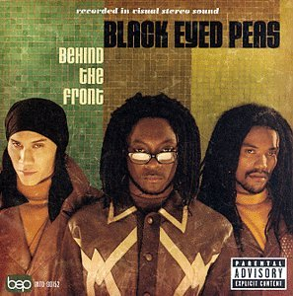
Joints & Jam
Way u make me feel
Movement
Karma
Be free
Say Goodbye
Duet
Communication
What it is
¿Que dices?
A8
Love won’t wait
Head bobs
Positivity

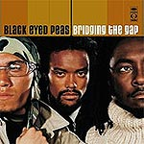
BRINGING THE GAPS (2)

Bep empire
Weekends
Get original
Hot
Cali to New York
Lil' Lil'
On my own
Release
Brindging the gaps
Go go
Rap song
Bringing it back
Tell your mama come
Request + line

ELEPHUNK (3)
Pump it
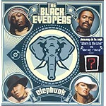
Labor day (it’s a holiday)
Let’s get retarded
Hey mama
Shut up
Smells like funk
Latin girls
Sexy
Fly away
The boogie that be
The apl song
Anxiety
Where is the love
Third eye

MONKEY BUSINESS (4)
Hands up
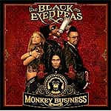
Don’t punk whit my heart
My style
Don’t lie
My humps
Like that
Dum duddley
Feel it
Gone going
They don’t want music
Disco club
Bebot
Audio delite al low fidelity
Union
Work done by:

Amalia de Valcárcel Galván Nº 9
David Henríquez Hernández Nº 13
Atreyu Piñero Hernández Nº28
Raice Santos Hernández Nº 30

