MIRACLES DIRECTORY


MIRACLES’ President
Lim Ji Yuan
36720
jylim416@gmail.com
017-6401696

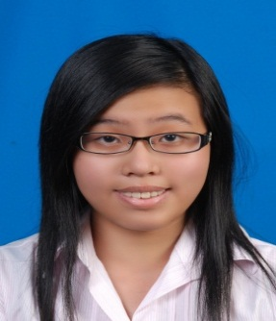
MIRACLES’ Vice President
Lim Mei Yuen
36731
meiyuen_92@hotmail.com
016-9793742

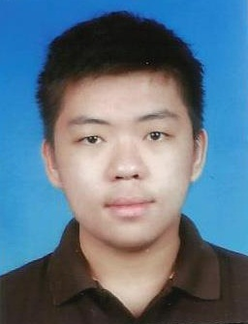
MIRACLES’ Secretary
Phang Sai Foong
38393
cliffordphang@yahoo.com
017-8783318

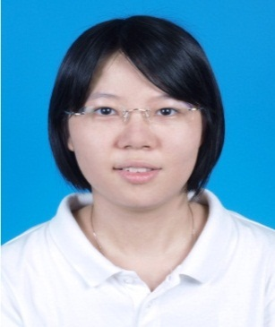
MIRACLES’ Treasurer
Chan Yee Ling
35677
yeeling825@hotmail.com
016-6920657

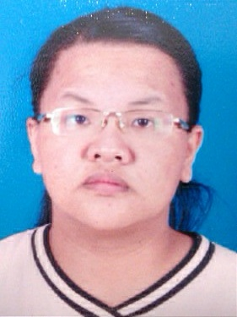
MIRACLES’ Project Director
Liaw Chai Yin
36684
chaiyin@hotmail.com
014-8811150

