MIRACLES Head Office

Mailing Address:
No:9 Jalan Miracle, 94000 Kuching, Sarawak, Malaysia.

Contact us:
Phone No: 082-828298
Fax: 082-828296
e-mail: miracles@hotmail.com
Websites: www.miracle.com.my

Office Hours:
Monday – Friday: 9:00AM – 5:30PM
Saturday: 9:00AM – 1:00PM
Note: Closed on Sundays and Public Holidays
Map
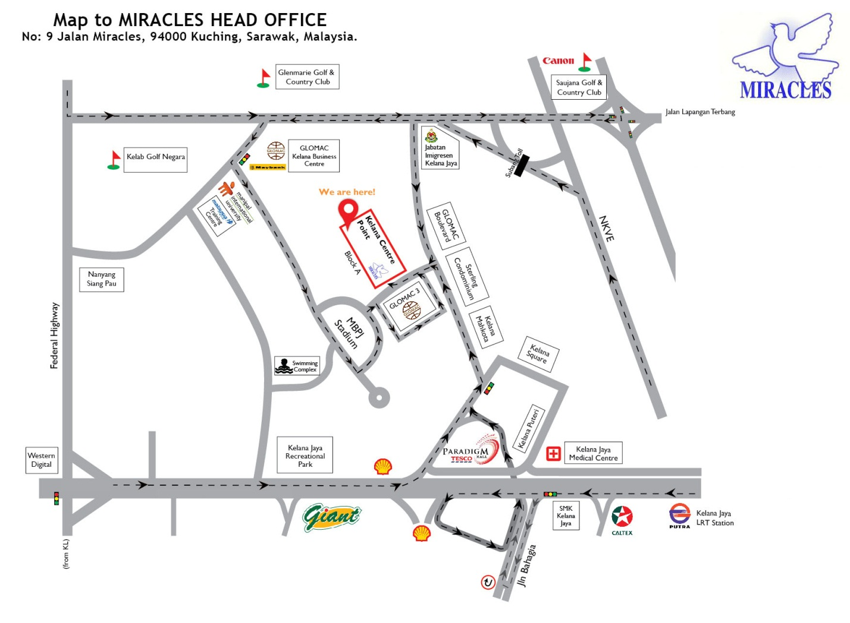
MIRACLES IS A REGISTERED CHARITY NUMBER 787898

