Friends
“Love is rarer than genius itself. And friendship is rarer than love”
-Charles Pierre Péguy (1873 - 1914)

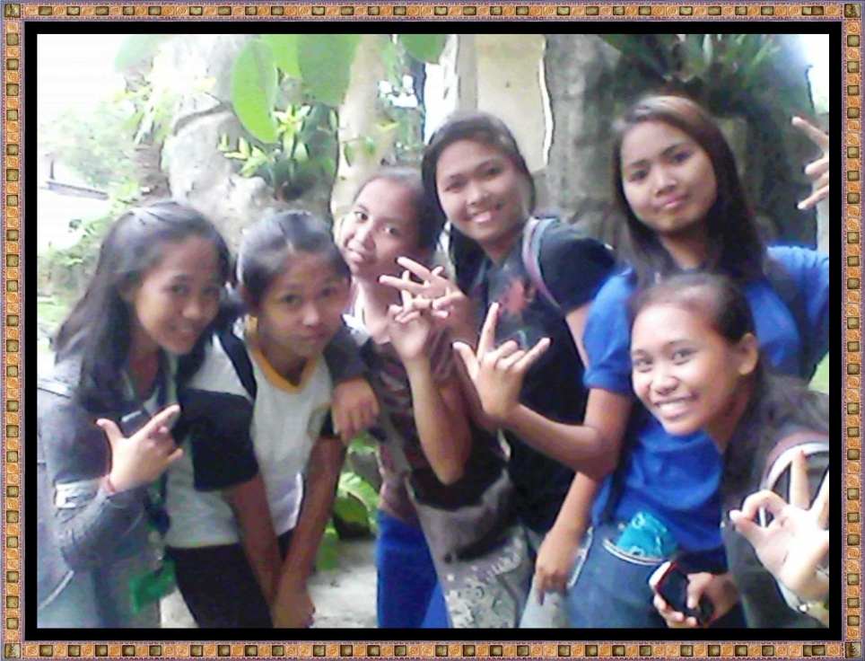

“A friend in the market is better than money in the chest.”
Thomas Fuller (1654 - 1734)
____________________________________________________________________________

Good friends are wonderful.


They're there to support you and to help you. They make you laugh and feel good. I am lucky; I have three very good friends. Sure, I have lots of other friends. But these three people, I would take a bullet for.
Looking back it's hard to believe how much my friends have shaped my life. It's hard to think of what my life would be like without them. We are more similar than we know and mean a lot to each other. It saddens me to think that we will probably only be able to see each other on a daily basis for four more years. But, of course, we're going to fill those four years with memories of our times together.
Friends will come and go in your life, but more important than how long a friendship lasts, is that a good friend will love you for who you are. The way you can tell the sign of a good friend is by looking at the actions they take –big and small – that show they care.

Someone has said, “A friend is a person who is willing to take me the way I am.” Accepting this as one definition of the word, may I quickly suggest that we are something less than a real friend if we leave a person the same way we find him?
There seems to be a misunderstanding on the part of some men today as to what it means to be a friend. Acts of a friend should result in self-improvement, better attitudes, self-reliance, comfort, consolation, self-respect, and better welfare. Certainly the word friend is misused if it is identified with a person who contributes to our delinquency, misery, and heartaches. When we make a man feel he is wanted, his whole attitude changes. Our friendship will be recognizable if our actions and attitudes result in improvement and independence.
It takes courage to be a real friend. Some of us endanger the valued classification of friend because of our unwillingness to be one under all circumstances. Fear can deprive us of friendship. Some of us identify our closest friends as those with the courage to remain and share themselves with us under all circumstances. A friend is a person who will suggest and render the best for us regardless of the immediate consequences. Sir Winston Churchill became Great Britain’s greatest friend in his country’s darkest hour because he was courageous enough to call for “blood, toil, tears, and sweat” when some would have accepted him more readily as a friend had he advocated peaceful surrender.

