Merging Old technology and New Technology to meet the Programmable Logic Control communication needs at MG Industries

By Armani Ballesteros

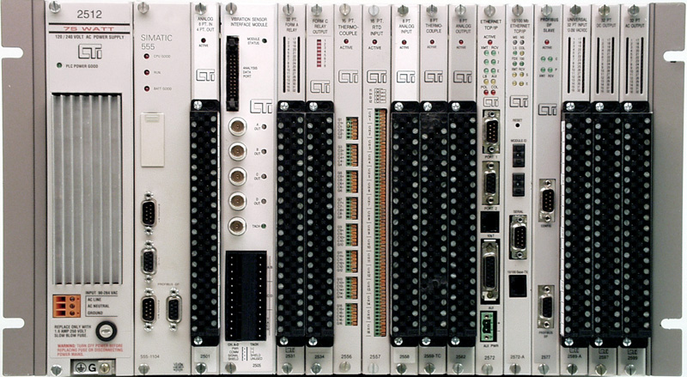
Finding communication solutions for the Programmable Logic Control (PLC) shown in figure: 1 It occurred to me to utilize the network and new communication technology like: Transition Control Protocol /Internet Protocol knows as TCP/IP. This would enable remote access to the PLC’s program from remote sites.
Simatic TI 505 PLC fig1

Since 1990’s until now the Application Productivity Tool (APT) Process companies used APT software. The Control Engineer utilizes this software to develop, program, troubleshoot and communicate to the Simatic TI 505 PLC’s. The majority of process industries use the505 PLC. APT software communicates with the Siemens 505 PLC’s. The PLC’s are part of a Computer Family that execute specific commands without any operating system.

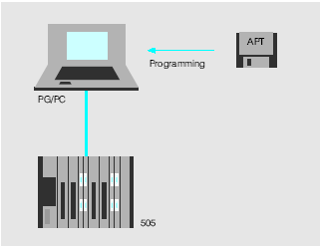
The PLC is a reliable industrial computer contains the program that was developed by the control Engineer using APT software. The PLC runs multitasks with or without interaction 365 days out of the year. Some of the multitasks that are accomplished by electrical controlling devices like: motors, valves, monitor flow meter, level sensors. In addition it can also provides alarms, trending data, billing information, call daily, and monthly reports etc. All of this is accomplished with no or minimal down time.

The PLC has the ability to scan the program within milliseconds. The PLC is a very reliable and powerful computer. Besides this it also allows direct interface to a Personal Computer entitled Human Machine Interface (HMI).

The HMI has a graphical representation of the process like the 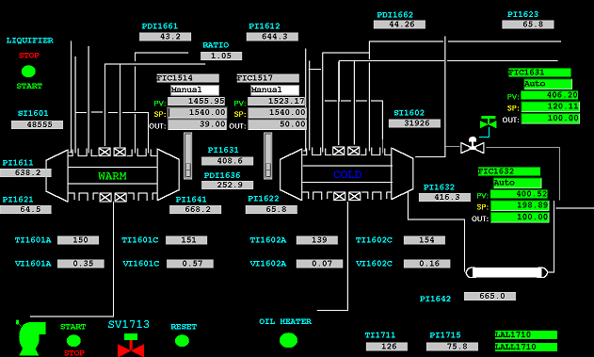front panel on the an airplane .
Moreover the key controls run like an autopilot on an airplane, my analogy. The operator decides what mode to chose: manual or auto. Furthermore the HMI constantly informs the operators about the status of the process and any abnormalities.

For your information, The PLC software APT is a legacy DOS application owned by Siemens. Recently, Siemens released the latest APT version that runs on Windows 2000 O.S. but it is still using the DOS Operating System. Siemens informed me they had no intentions of developing any windows based software that would replace APT. The APT software is considered a mature product meaning no new revisions will be released. Eventually it will be obsolete. .

To replace control systems to new PLC and Windows based software would have cost thousands or even millions of dollars. Besides since these PLC were very reliable is was not required to replace them at this time. However, I wanted to be able to communicate more effectively with the software.

My belief that the APT from Siemens is obsolete is evident through the limitations encountered through the way this software communicates with the PLC’s.

There are three well-known communications protocols between APT and PLC. One is via a communication port known as RS232 or Com port or RS485 and the other communication protocol is the Siemens industrial communication protocol that is known as H1.

The RS232 communication is a protocol using ASCII characters data which only allowing communicating maximum speed of 19200-baud rate. The cable between the PC and PLC with limitation because the cable should not be greater then 100 feet long.

While the H1 communication is an industrial Ethernet Siemens protocol similar to TCP/IP but is limited to drivers and hardware.

When a change is approve and modification(s) to the program codes are required, the Control Engineer has to be on-site to make a simple or complex change costing thousands of dollars in travel and labor cost.

Since in the past it was impossible to enhance any new way of communication between the APT and PLC because driver used by the APT also the Windows 2000 programs can not support DOS images; remote access was impossible.

In February 2004, I was able to set-up a driver and accomplish communication to a PLC using the company network. This was made possible by using a new TCP/IP card build by a third party for the Simatic 505. I was able to load new programs, and change the program from a remote location utilizing this new driver. This new method of communication is safe, because the PLC uses a very unique protocol of communication. It is impossible to load incorrect characters because the PLC will not process or recognize them. As a result of the card having a unique address, For example 192.192.1.2 would be the cards address.

The test was run on test rack (lab setting) and was successful.

The control engineer can take advantage of the new technology to assist plant personal via network. Enabling him to download modification to program code.

Initially the Control Engineer may have concerns in making the change to the PLC remotely. I can insure you with time and proper procedures the confidence in the new technology will be greatly appreciated.

Another initial concern would be if the control engineer make an erroneous selection on the software could shut down of the plant. My logic is If you make a mistake on site or remotely the results will be the same.

In order to accomplish the communication to the PLC a new driver and a new card is required.

Also this new TCP/IP card can be setup to import data like the daily reports or monthly reports without any human interaction. Avoiding human error eliminating hundreds of thousands of dollars in cost. In addition, it minimizes the cost of personal there is required to obtain and process this data. Finally, data can be imported directly to common windows application. An example of data imported could be: pay meters, tank inventories, daily reports, specific or mathematical equations or results. Information can be instantaneously collected and data can be transferred into plant statistics.

