MOTHERBOARD
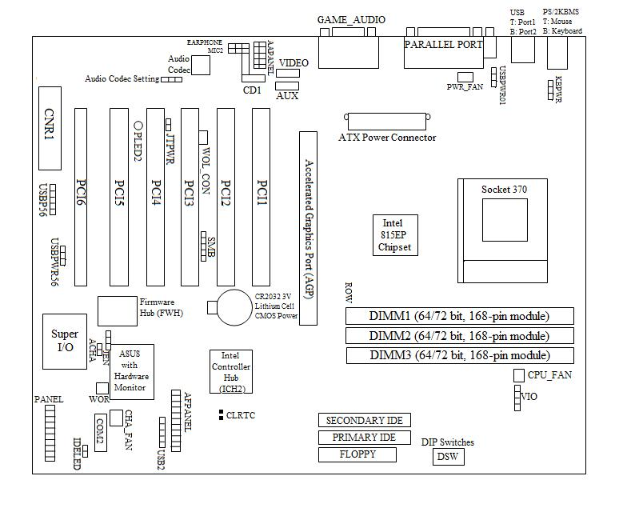

PCI – Peripheral Component Interconnect is an interconnection system between a microprocessor and attached devices in which expansion slots are spaced closely for high speed operation.
Accelerated Graphics Port (AGP) – an interface specification that enables 3-D graphics to display quickly on ordinary personal computers.
CNR1 – Communication and Networking Riser slot. This connector supports specially designed network, audio, or modem riser cards.
USBPWR56 – USB Device Wake Up, these allow you to disable or enable the USB device wake up function.
JEN – JumperFree Mode, these jumper allows you to enable or disable the JumperFree mode. The JumperFrere mode allows processor settings to be made through the BIOS setup.
KBPWR – Keyboard Power Up (KBPWR) allows you to disable or enable the keyboard power up function.
VIO – Voltage I/O Setting, this jumper allows you to select the voltage supplied to the DRAM, chipset, AGP, and PCI. The default setting if 3.40V should be used unless processor overlocking requires a higher voltage.
DSW – CPU External Frequency Setting (DSW), this option tells the clock generator what frequency to send to the CPU, DRAM, AGP, and the PCI bus. This allows the selection of the CPU’s External frequency.
DIMM – Dual Inline Memory Modules. A DIMM (dual in-line memory module) is a double SIMM (single in-line memory module). Like a SIMM, it's a module containing one or several random access memory ( RAM ) chips on a small circuit board with pins that connect it to the computer motherboard. A DIMM has a 168-pin connector and supports 64-bit data transfer. It is considered likely that future computers will standardize on the DIMM.
AGP – Accelerated Graphics Port Slot. This motherboard provides an accelerated graphics port (AGP) slot to support AGP graphics cards.
USB – Universal Serial BUS Ports 0 & 1. Two USB ports are available for connecting USB devices. For additional USB ports, you can use the USB headers and mount it to the chassis.
Parallel Port Connector (Burgundy 25-pin PRINTER) – You can enable the parallel port and choose the IRQ through Onboard Parallel Port.
Serial Port Connectors (COM1 , COM2) – One serial port is ready for a mouse or other serial devices. A second serial port is available using a serial port bracket connected from the motherboard to an expansion slot opening.
Game/MIDI Connector (Gold 15-pin GAME_AUDIO) – You may connect game joysticks or game pads to this connector for playing games. Connect MIDI devices for playing or editing professional audio.
Audio Port Connectors (Three 1/8” GAME_AUDIO) – Line Out (lime) can be connected to headphones or preferably powered speakers. Line In (light blue) allows tape players or other audio sources to be recorded by your computer or played through the Line Out (lime). Mic (pink) allows microphones to be connected for inputting voice.
Floppy Disk Drive Connector (34-1pin FLOPPY) – This connector supports the provided floppy drive ribbon cable. After connecting the single end to the board, connect the two plugs on the other end to the floppy drives.
Primary (blue) / Secondary IDE Connectors (Two 40-1pin IDE) – These connectors support the provided IDE hard disk ribbon cable.
IDE Activity LED (2-pin IDELED) – This connector supplies power to the cabinet’s IDE activity LED. Read and write activity by devices connected to the Primary or Secondary IDE connectors will cause the LED to light up.
Power Supply (PWR_FAN), CPU (CPU_FAN), Chassis (CHA_FAN) fan connectors (3pins) – These connectors support cooling fans of 350mA (4.2 Watts) or less.
Internal Audio Connectors (4-pin CD1, AUX, VIDEO, MODEM) – These connectors allow you to receive stereo audio input from such sound sources as a CD-ROM, TV tuner, or MPEG card. The MODEM connector allows the onboard audio to interface with a voice modem card with a similar connector.
Headphone True-Level Line Out Header (3-pin EARPHONE) – This connector allows you to connect chassis mounted headphone to the motherboard instead of having to attach an external headphone onto the ATX connectors.
Internal Microphone Connector (3-pin MIC2) – This connector allows you to connect chassis mounted microphone to the motherboard instead of having to attach an external microphone onto the ATX connectors.
ASUS iPanel Connector (12-1pin AFPANEL) – This connector allows you to connect an optional ASUS iPanel, an easy to access drive bay with front I/O ports, status LEDs, and space reserved for a hard disk drive.
ASUS iPanel Audio Connector (12-1pin AAPANEL) – Connect the audio cable from the optional ASUS iPanel to this for front panel audio control.
SMB Connector – This connector allows you to connect SMBus (System Management Bus) devices.
Chassis Intrusion Lead (2-pin ACHA) – This lead is for a chassis designed for chassis intrusion detection.
Wake-On-LAN Connector (3-pin WOL_CON) – This connector connects to a LAN card with a Wake-On-LAN output, such as the ASUS PCI-L101 Ethernet card. The connector powers up the system when a wakeup packet or signal is received through the LAN card.
Wake-On-Ring Connector (2-pin WOR_CON) – This connector connects to internal modem cards with a Wake-On-Ring output. The connector powers up the system when a ringup packet or signal is received through the internal modem card.
ATX Power Supply Connector (20-pin block ATXPWR) – This connector connects to an ATX power supply. The plug from the power supply will only insert in one orientation because of the different hole sizes.
Power Supply Thermal Sensor Connector (2-pin JTPWR) – If you have a power supply with thermal monitoring, connect its thermal sensor cable to this connector.
System Power LED Lead (3-1pin PWRLED) – This 3-1pin connector connects the system power LED, which lights when the system is powered on and blinks when it is in sleep mode.
Keyboard Lock Switch Lead (2-pin KEYLOCK) – This 2-pin connector connects to the case-mounted key switch to allow keyboard locking.
System Warning Speaker Connector (4-pin SPEAKER) – This 4-pin connector connects the case-mounted speaker. Two sources (LINE_OUT and SPEAKER) will allow you to hear system beeps and warnings. Only SPEAKER will allow you to hear system beeps before the integrated audio has been properly initialized.

