Chapter 5.

Hindu Deities

( and their symbolism)

contents

0.Introduction

1.OM

2.Lord Venkateswara

3. Saraswathi

4. Lakshmi

5.Durga

6. Radhakrishna

7. Rama and Seetha

8. Hanuman

9. Shrinath

10.Lakshmi Narayana

11.Ganesh

12. Karthikeya

13.Shiva

14.Mahavir

15. Lord Jagannath of Puri

16.Lord Chitragupta

17.Nava Grahas

Popular Hindu Deities

( and their symbolism)

0. Introduction
: According to the basic principles of Hindu Philosophy God is Infinite, all powerful, and exists everywhere. Hence to convince the common people, the great sages of ancient India, conceived the Infinite should be explained in Finite forms. They conceived the best such forms are human figures endowed with such qualities and powers as may be needed for achievement of specific activities in this world. All the different deities are therefore symbolic of supreme powers in various fields personified in poetic forms by the great sages and described in pictorial forms by the great artists Accordingly, even though God is one Infinity, He is shown in the form of several deities in human forms each with the highest of power and qualities expected of human beings for specific activity. In the following the some of the Deities are described explaining their status in Hindu Society and also the symbolic aspects they represent. Under the title of each Deity a sloka is also mentioned. This is one of the frequently uttered sloka for invocation of the Deity concerned
- OM

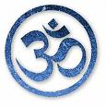

OM Ityekaksharam Brahma Omitedam Sarvam

OM has been considered by great sages of India as the center of Spiritualism from which all paths lead to the Ultimate Reality. It is considered as the origin of the Universe itself. Some theories of Western Science also corroborate this view in a way. It is also called ‘Pranava’ universally accepted as a symbol or logo of Sanathana Dharma. It is highly extolled in Vedas, Upanishads, Geeta and various Hindu Scriptures. All religious rites and hymns invoking various deities are started with the utterance and repetition of OM as it helps to concentrate on the ongoing spiritual procedures and practices and also help in meditation. Actually OM consists of three independent syllables A U M each having a significant meaning. ‘A’ stands for Adima meaning the beginning. ‘U’ stands for Utkarsha meaning progress, and ‘M’ represents the end Miti. Thus the sound OM is the power responsible for creation, preservation and dissolution (Brahma, Vishnu, and Shiva) of the Universe. There are also several other interpretations on the symbolism of ‘OM’ available in Hindu literature such as it represents the three states of human conscience etc. The lips and vocal muscles also move in the same order of A, U, M, as the sound of OM is uttered signifying the opening , continuing, and closing of the power of prayers Hence the Wisdom of Vedic Masters gave ‘OM’ as an ideal logo, deity, and idol for the worship of all gods. Incidentally the attributes of Omnipresent , Omniscience etc to God contain initially OM. The Hindu temple of Cincinnati is one of very unique institutions in the world to have placed ‘OM’ in the center of worship among several deities installed there. It is also interesting to note that in the English concept of God as ‘OMnicient’ and
‘Omnipresent’ the words contain the two letters ‘O’ & ‘M’ as also similar in the phonetics of Christian ‘Amen’ and Arabic ‘Amin’

2. Lord Venkateswara

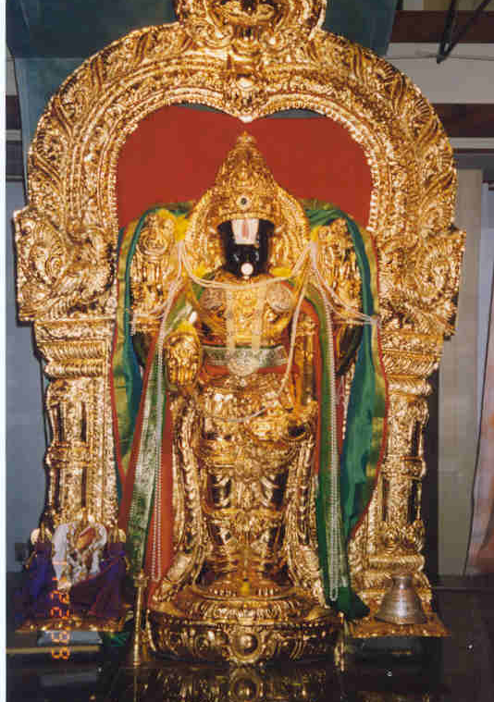

Vina Venkatesam Nanatho Nanatha
Sada Venkatesam Smarami Smarami

Lord Venkateswara is the presiding deity of a very ancient and famous temple at the seven hills of Tirupati in South India. He is supposed to be the incarnation of Lord Vishni in the present Yuga and has two consorts Sri Devi and Bhu Devi. He is also known by the names, Sreenivasa, Balaji and other names in various parts of India. The shrine at Tirupati is visited by thousands of pilgrims every day and it is among the richest temples in India with a daily total income of nearly ten lakhs of rupees. His glory has been sung by many saints and poets, chief among them is Annamacharya. The management of the temple at Tirupati, patronizes and sponsors several undertakings of religious, cultural, charitable, social and educational activities. It has also established a huge complex at Pittsburgh (PA) which is visited by many Americans and visitors from different parts of the world including India. Fridays and Saturdays are the most important days of the week for the deity and so special Pujas(rituals of worship) are performed on these days.

3.Saraswathi

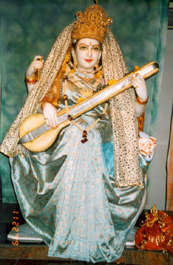

Saraswathi Namstubhyam Varade Kamarupini
Vidyarambham Karishyami Siddhirbhavatu-me-sada

Goddess Saraswathi symbolizes the Power of Knowledge and is worshipped in all parts of India, particularly during Navaratri period. She is shown as riding on a swan or sometimes sitting on lotus flower. Swan is a bird with power of separating water from milk and so represents the power of discrimination. Lotus represents Purity and Truth. The four hands of the Goddess represent mind, intellect, consciousness, and ego which are the requisite attributes of Knowledge. She is shown as playing the Indian musical instrument Veena, symbolizing that Knowledge tunes up the mind and intellect of Man to draw out of him the music and melody of life. As the entire Creation and all activities there in, require to be supported by true knowledge, the Goddess Saraswathi is given the status of a consort to Lord Brahma, the Creator of the Universe, as conceived in Hindu mythology

4. Lakshmi

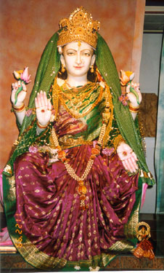

Namastestu Mahamaya Sree Peethe Surapujite
Sankhachakra Gadahaste Maha Lakshmi Namostute

Goddess Lakshmi is symbolic representation of Wealth, Peace and Happiness. As wealth, both material and spiritual, is essentially required for protection and maintenance of worldly objects, Goddess Lakshmi is shown as the consort of Lord Vishnu who symbolizes the power of maintenance and protection of the Universe. Her four hands indicate that she provides ‘artha’ ‘dharma’ ‘kama’ and ‘moksha’ popularly known as ‘Purushartha Chatushtaya’ She is sitting on a Lotus flower, a symbol of Purity and Truth. She is supposed to have emerged during churning of ocean symbolizing development of values of life when one’s mind is churned by the process of reflection and contemplation upon one’s Higher Self. She is worshipped all over India particularly during Diwali

5. Durga

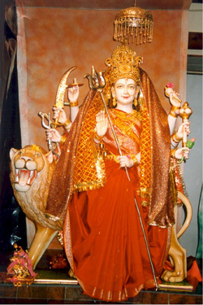
Om Rakthaksh Raktajihwadi Sikshnaya Namonamaha
Om Mahishasura Dorvirya Nigrahayai Namonamaha

Goddess Durga riding on the most powerful and brave animal, the lion, is the symbol of very high strength and courage to conquer even the most powerful demons (Evils) of the world. She is given eight hands each holding the most powerful weapon given to her by various gods to destroy their greatest enemy Mahishasura, and who could not be destroyed by themselves. Incidentally this is also symbolic of superior power of woman over man in certain events as envisaged by the great sages of India.. She is worshipped by all communities particularly during Navaratri and has several names as Mahakalika, Brahmani, Bhavani, etc. mentioned in the famous Durga Sapta Shati (Durgashtakam). Bhavani was Ishta Deva of Shivaji and several warriors of Indian history. Kali is the form mostly worshipped in Bengal and She was also the Ishta Deva of Ramakrishna Paramahansa

6. Radhakrishna

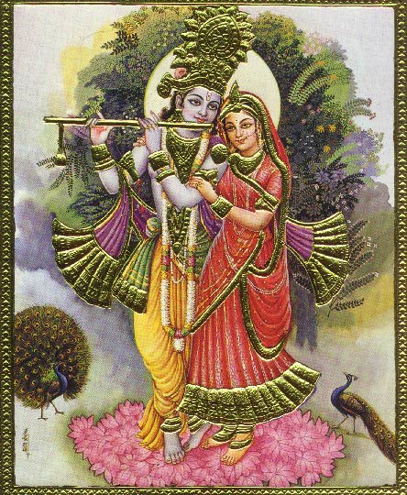

Bolo Sada Tere Nam, Radheshyam Radheshyam

Lord Krishna is supposed to be the incarnation of Vishnu depicting transformation of the Infinite to the Finite ways of material world. Radha is supposed to be the most beautiful and most beloved of all Gopis with whom Krishna played. Her constant companionship by his side represents the selfless and ideal love and devotion needed by the entire humanity towards Divinity. All prayers to Radhakrishna and several stories associated with Radha and Krishna explain the science of self-realization and devotion in life through interaction of Gyan,(Knowledge), Karma (Action), and Bhakti(Worship) yogas (Physico-spiritual exercises) The combination of Radha and Krishna is a constant reminder to the devotee about the ultimate merging of one’s Self with the Lord. Several temples of Radhakrishna have come up particularly in Northern India.

7. Rama and Seeth

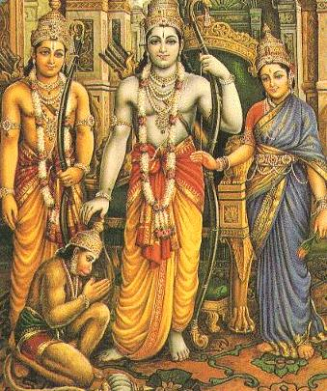

Ramaya Ramabhadraya Ramachandraya Vedhase
Raghunathaya Nathaye Seethayampathaye Namaha

Rama and Seetha are supposed to be the incarnations of Lord Vishnu and his consort Lakshmi respectively representing the most ideal Man and Woman on earth as conceived by the great sage Valmiki in Ramayana. The entire life of Rama and several stories in Ramayana depict Rama as an ideal embodiment of Dharma (duties) in everyday life, as a perfect son obeying the orders and fulfilling the wishes of his parents, as a just and democratic monarch satisfying the wishes of every individual in the country, as an ideal husband caring for the welfare and reputation of his wife, as a loving and caring eldest brother, as a noble enemy of those who did evil acts in the world, and above all as the most perfect human being in all aspects. As Truth, Nobility and Perfection are personified in him, he is often referred as “Maryada Purushottam” and his governance is referred as “Ram Rajya” the ideal Statecraft for peace , prosperity and joy to everybody

8. Hanuman

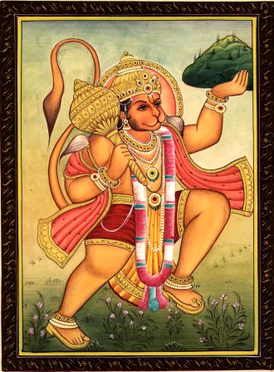
Manojanam Marutatulya Vegam, Jitendriyam Buddhimatam Varishtam
Vaatatmajam Vanarayudha Mukhyam, Sriramadutam Sirasanamami

In Ramayana, the great epic poem of India, Hanuman is depicted as chief of an army with enormous strength and strategy, as an extreme loyalist to his master, and as highly devoted to the Supreme. He is also shown as a very able diplomatic ambassador of a king and could conquer all difficult situations with extreme urgent swiftness. In the perception of the great sage Valmiki who created Ramayana, Hanuman is given the shape of a leader of monkeys to indicate the manipulative strength of Spiritualistic tendencies of human Mind to achieve the many material objectives. Hanuman is considered as the heart and soul of Ramayana. He is said to be the son of Anjani with the blessings of Vayu the god of Wind power. Hence he is also known as Vayu putra, Anjani suta. He is also supposed to be having the powers of Rudra and so he is also known as Shankar Suvan. Because of his selfless service, Bhagwan Rama himself remained permanently indebted to him throughout his life. Temples of Hanuman are found all over India even in remote villages, small towns .

9. Shrinathji

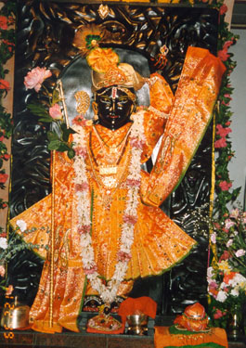

Sasanka Chakram Sakirita Kundalam Sapeeta Vastram Sarasiruhekshanam
Sahara Vakshsthala Kuasthabhasriyam Namami Vishnum Sirasa Chaturbhujam

The famous temple of Lord Shrinath, an image of Lord Krishna is located in Nathdwara near Udaipur, Rajashthan, constructed in 1783 A.D. He is Ishta Deva of Pushtimarg or Vallabha Sampradaya of Vaishnavism. He is also known as Govardhan or Shriji Bava. Shrinathji represents Krishna lifting the Govardhan Hill to subdue Indra who was sending downpour of rain causing considerable hardship to the cowherds of Gokul. As most Hindu idols represent symbolically the various aspects of Hindu philosophy, the icon of Shrinathji is indicative of need of shedding ego in human mind and surrendering to him completely for getting out of worldly miseries and holding on tight to God to unite with Satchitananda and reach the Ultimate. This is the fundamental principle of Vishnava Sampradaya.

10. Lakshmi Narayana

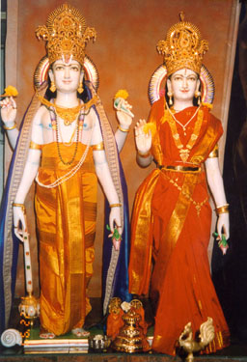

Akashatpathitham Toyam Yadhagachati Sagaram
Sarvadeva namaskaraha Kesavam Prathigachathi

Narayana or Vishnu is the God , the Supreme Power, for the preservation of the Universe and Dharma. As Wealth is needed for such preservation, the same is personified in Goddess Lakshmi as his consort. Vishnu is supposed to have already taken ten Avataras (incarnations) to preserve Dharma on earth whenever it was on the decline. These ten incarnations (Dasavataras) symbolically represent the state of gradual and orderly physical evolution of human beings on earth from Matsyavatara (Fish) to Kalikavatara modern worldly Man. Some believe that they also represent the gradual spiritual evolution in Man from his birth to his end. The four hands represent the four aspects that function in human beings., the Mind, Ego, Intellect and Conscience. The articles in his hands are the symbols of the most essential types of energy required for the preservation of the Universe; Sankha (Conch) for the sound energy, Chakra (Discuss) for the heat energy, Padma (Lotus) for the light energy, and Gada (Mace) for the Electro-magnetic energy. As all water in the form of rain from the sky eventually merges into ocean so also worshipping all gods leads only to one Supreme God who is known by the name of Vishnu or Narayana

11. Ganesh

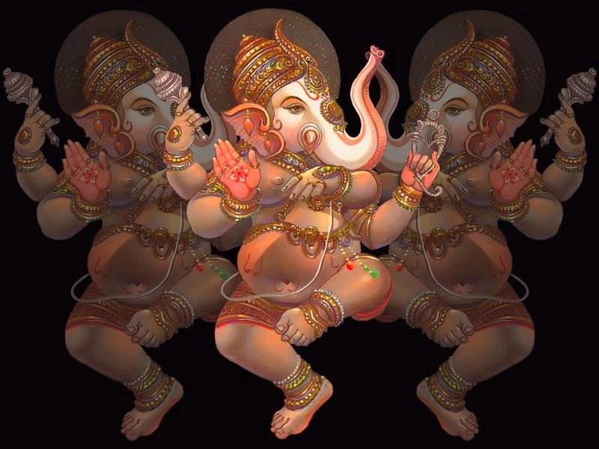

Agajanana Padmarkam Gajanana Maharnisam
Anekadantham Bhaktanam Ekadantam upasmahe

Sri Ganesh is the first son of Lord Shiva and is depicted in several forms and poses including feminine forms and worshipped in several places of the world. He is also known as Vighneswara, Vinayaka, Ganapathi, and many more names suggestive of various powers attributed to him. Primarily, He is the lord to remove all obstacles and bestowing Wisdom. Hence He is invariably worshipped before the commencement of any auspicious ceremony by all communities in India. His two spouses are Buddhi (Intelligence) and Siddhi (Acievement) The several parts of the icon of elephant head, human body with several hands, riding on a mouse, symbolically represent the need of several spiritual and material tools required for perfecting oneself to the highest Wisdom in any field of his choice. Several legendary stories abound to explain philosophically the various paths of righteous and peaceful living.

12. Kartikeya

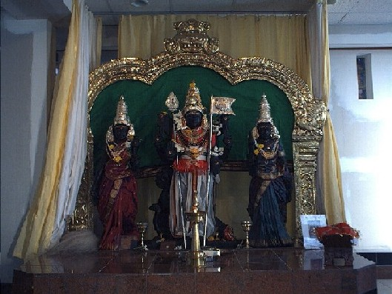

Om Ttatpurushaya Vidmahe, Maha Senaya Dhimahi
Tanno Shanmukha Prachodayat
Lord Kartikeya also known as Shanmukha or Subrahmanyam is the second son of Lord Shiva and goddess Uma (Parvati). He is worshipped throughout India and even abroad but more particularly in South India where He is more popularly known as Murugan or Kumaran. His consorts are Valli and Devayani. He is shown as commander-in-chief of an army which destroyed many demons symbolically the negative tendencies (Vasanas) which overshadow the Divine Self in human beings He is shown as riding on a peacock which symbolizes vanity in human perceptions as manifested in the lengthy ecstatic dancing of the bird with colorful feathers spread out in a delightful form

13. Shiva

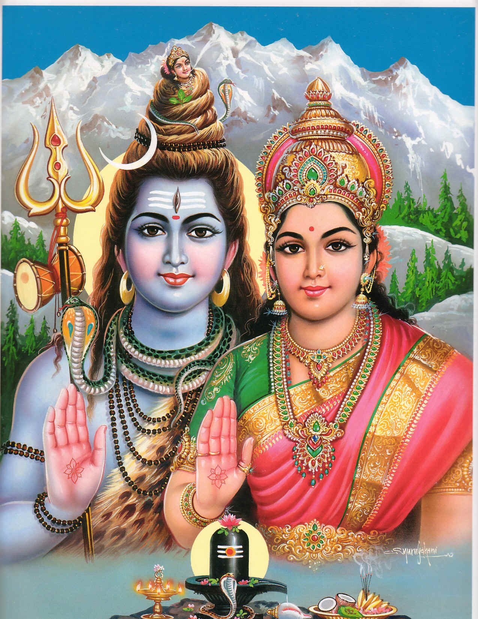

Brahmamurari Surarjita Lingam Nirmala Bhashita Sobhita Lingam
Janmaja Dukha Vinsaka Lingam Tatpranamami Sadasiva Lingam

Lord Shiva also known as Shankar is invoked as Master of Life and Death and worshipped in several forms and ways. He is also known as Mahadeva greatest of all gods, because He sipped poison to save the lives of all Devas. Hence He is also called Neelakantha.- the blue throated Deva. The icon in the form of Linga and Yoni is interpreted as a phallic emblem, a symbol of generative power in Nature understood in its full purity by ancient sages. There are twelve sacred Lingas known as “Jyothir Lingas” in India. Another conception of Shiva is that of ‘Ardhanareeswara’, to highlight the scientific principle of Animus and Anima and that of silent Dakshinamurthi symbolizing that silence is the language of Realization. Shiva is the God with three eyes-Triyambaka Deva- symbolizing sun, moon and fire which constitute threefold vital powers for human survival and death, which are invoked during sacrifices and Yagnas.- sacred fire rituals as per Vedas

14. Mahavir

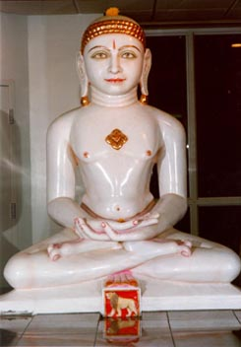

Om Mangalam Gurudevaya Mahaneeya Gunatmane
Sarvalokaya Saranyaya Sadhurupaya Mangalam

Bhagawan Mahavir was born in Kundanpur Royal family. Having denounced the pleasures of Royalty he led the life of ‘Shraman’- a life of a great self-realized Spiritual Master. He is considered as twenty fourth Thirthankar(incarnation) of Jain religion. He was against any sort of violence, be it in thought or in deed. He propagated non-violence and spread the nectar of love for the entire mankind in the world. His concept of Ahimsa (Non-violence) was much more widely broad-based than normal, and he desired his followers to lead a very highly disciplined and pure life. He preached Kewalya Gyan (Knowledge of seclusiveness and detachment) as the ultimate aim of human life and advocated purity, self-discipline and Tapasya ( Deep yogic meditation)) to achieve the Ultimate

15. Lord Jagannath of Puri

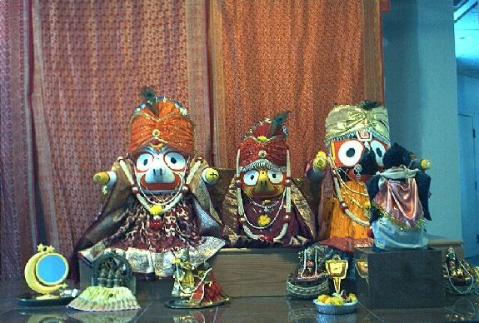

Hare Krishna Hare Krishna Krishna Krishna Hare Hare
Puiri is an ancient town on the east coast of India , most famous for a very ancient temple of Lord Jagannath,(another name for Lord Krishna) his brother Balbhadra and sister Subhadra. There are many anecdotes relating to the shape of the deities, Once there was a king by name Indradyumna who had lost his cherished deity while carrying the same from one place to another, but later he had a dream that his Lord would come to him again sailing in the sea. After a few days they found a huge log coming to the shore and the king desired that the log may be beautifully carved out into the original forms of his deities. Two craftsmen named Vishnu and Vishvakarma started the job in a closed and hidden area under nobody’s view. They laid a condition that no one will look at he figures before they are completed.. At one point the craftsmen wished to relax for a while and temporarily stopped the work ..As no noise was forthcoming from the area of their work the king and his wife thought the work was completed and so peeped into the area. At this point the craftsmen suddenly vanished without finishing the rest of the work. Thus as we see today the faces of the deities are well formed but not the hands and feet. Religious literature have indicated several symbolic aspects of the shapes and colors of the deities , and several anecdotes exist, all leading to the one concept of Eternal Truth (Sanathana Dharma),and the existence of one Supreme God. There are many annual rituals performed in the temple with great religious fervor from many generations and from devotees from many parts of the world. .Among them the Rath Yatra is the most important. All the deities are dressed and decorated with leaves roots, pulp and twigs for the occasion and carried in special chariots for a distance about 3 kilometers in about 12 hours. Part of the path is cleaned with golden broomstick by the descendents of the old rulers of Puri.. There are many other popular ceremonies also which according to legend signify the great attachment of Lord Krishna to his devotees some of whom claim to be blood relations of Krishna. The ISCON movement have established various centers and spread the activities world wide with great religious fervor

16. Lord Chitragupta

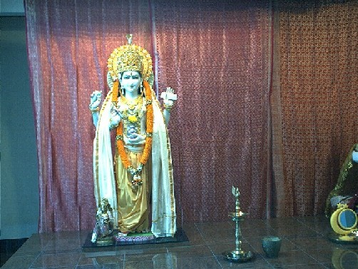

Om Chitravaso Swasti Te Paramshiya

Lord Chitragupta Ji is supposed to have originated from the body of Lord Brahma the Creator of the Universe (Manas Putra born out of Cosmic influences) and so he is named “Kayashtha” Hence all his descendents on earth are known as Kayashthas. They are a community, mostly spread out in Northern parts of India, Chitraguptaji is endowed with powers to control the activities of all beings in the Universe. . He is supposed to maintain a complete record of all good and bad deeds of all beings .He administers rewards and punishments to people as they deserve and grant boons to his devotees. He is supposed to have blessed Bhishma Pitamaha of Mahabharat to have a control on the time of his death.. He is supposed to be guided by the principles of life enunciated by Dharamraj and also served as his principle advisor on matters of Dharma .His followers adopt mainly the principles of Vaishnavism and also worship Bhawani- Durgaji

17. Navgrahas
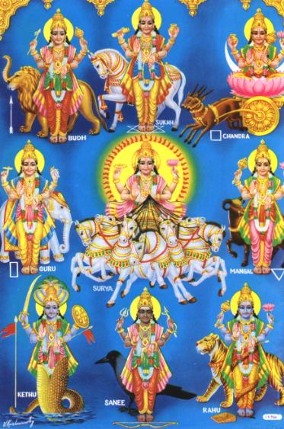
BRAHMAMURARI TRIPURANTHAKARII BHANU, SHASHI, BHOOMI SUTO BUDHASCHJA GURUSCHA, SHUKRAH, SHANI RAHU, KETAVAH KURVANTU SARVE MAM SU PRABHATAM
Navgrahas refer to the nine celestial bodies in Cosmos which are said to have influence on the lives of people, the are Ravi (Sun), Chandra (Moon), Kuja (Mars), Budha (Mercury), Guru (Jupiter), Sukra (Venus), Sani (Saturn), Rahu and Ketu which are respectively the invisible North and South Nodes of the moon . Some interpret these bodies as Neptune and Pluto.

The Sun is the central figure around which all the other bodies revolve with the moon revolving around the earth along with the earth’s motion. The science of Astrology, predicts the life progress of individuals on earth, depending on the position of the celestial bodies in the Cosmos at the time of birth of an individual These celestial bodies, particularly the Sun and Moon have profound influence on the climate of different geographical regions of the world. It is for all these reasons they are worshiped by Hindus during various religious rituals, at times special offerings are made to the Navgrahas to ward off any adverse effects on the life of an individual.

(N.B: There are many more commonly worshipped gods (Deities ) and these will be added later)

