Bahria University, Lahore Campus
Department of Computer Sciences
Lab Journal 02
(Spring 2023)

Course: | IC&T Lab | Date: 28, Feb 2023
Course Code: | CSL-114 | Max Marks: 10
Faculty’s Name: |  | Lab Engineer: Ayesha Seher

Name: ____________________________________ Enroll No: _______________________

Objectives:
The objective of this lab is to understand following concepts:
- Microsoft Word Office
- Introduction to MS Word including Font Style, Size, Color, Heading etc. Adding pictures, shapes and table of content are also part of this lab.

Lab Tasks:
Task 1:

Create a word file and write a note on a topic of your own choice and follow the instructions given below.
- Min 4 pages
- 3-5 pictures
- Cover Page
- Table of content
- Add heading and sub-heading for the table of content as discussed in the lab
Task:
Change formatting such that the document appears like below.
- The basic font is Times New Roman 12.
- Underline, italicize, and bold "Summary".
- Justify alignment on first paragraph.
- Center aligns the "One Thing" summary.
- Bold "One Thing Table".
- Make "My Study Checklist" in Arial font size 14 and bold.

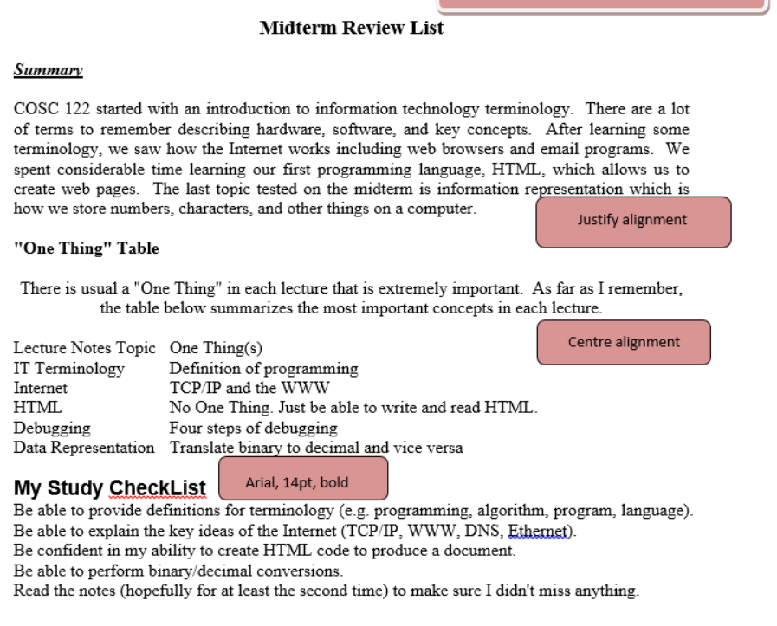

Sample Text:
Midterm Review List

Summary

COSC 122 started with an introduction to information technology terminology. There are a lot of terms to remember describing hardware, software, and key concepts. After learning some terminology, we saw how the Internet works including web browsers and email programs. We spent considerable time learning our first programming language, HTML, which allows us to create web pages. The last topic tested on the midterm is information representation which is how we store numbers, characters, and other things on a computer.

"One Thing" Table

There is usual a "One Thing" in each lecture that is extremely important. As far as I remember, the table below summarizes the most important concepts in each lecture.

Lecture Notes Topic One Thing(s)
IT Terminology Definition of programming
Internet TCP/IP and the WWW
HTML No One Thing. Just be able to write and read HTML.
Debugging Four steps of debugging
Data Representation Translate binary to decimal and vice versa

My Study CheckList
Be able to provide definitions for terminology (e.g. programming, algorithm, program, language).
Be able to explain the key ideas of the Internet (TCP/IP, WWW, DNS, Ethernet).
Be confident in my ability to create HTML code to produce a document.
Be able to perform binary/decimal conversions.
Read the notes (hopefully for at least the second time) to make sure I didn't miss anything.

Lab Grading Sheet:

Task | Max Marks | Obtained Marks | Comments(if any)
1. | 5
2. | 5
Total | 10 |  | Signature

Note: Attempt all tasks and get them checked by your Lab Instructor.

