Learnability:
- Is it possible for the user to learn how to use the ATM kiosk without the help of anyone?
Yes, as long as he can comprehend what the ATM’s programmed instructions. Some ATMs offered an option to select what language they can use so that people who understand only Tagalog can learn the system with ease.

- How possible is it for the user to learn how to use the ATM kiosk without of any help?
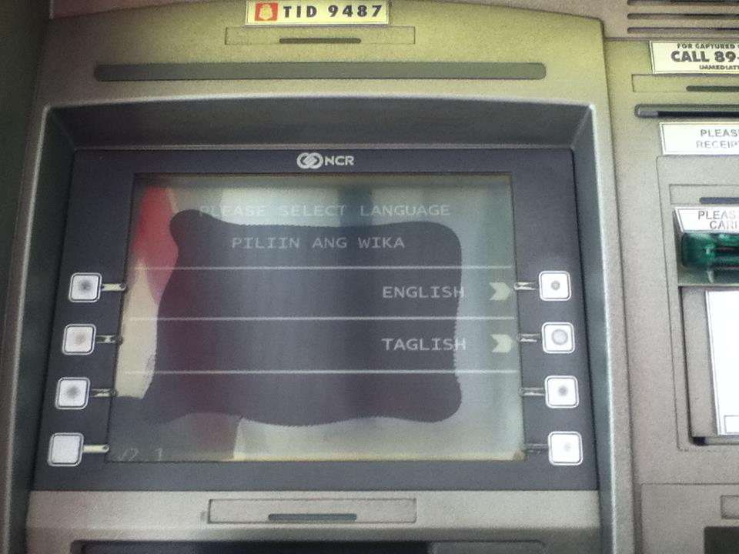
It is possible to learn how to use the machine without the help of anyone or by just exploring it for the machine simply contains a screen and a set of buttons. The machine also tells the user what to do next so the user will not have a hard time using the ATM Machine.

Memorability:
- Will it be hard for the user to remember the steps on how to use the ATM machine? Why or why not?
No, since the ATM machines only consists of buttons and the machine also tells the user what to do next, the user will not have a hard time in remembering the steps on how to use the ATM machine.

- How long will it take the user to memorize the steps of using the machine?
Since the machine tells the user what to do and the machine only contains of a screen and a button, as long as the user knows how to read and follow the instructions given by the ATM machine, learning and remembering how to use the machine will only take a short period of time.
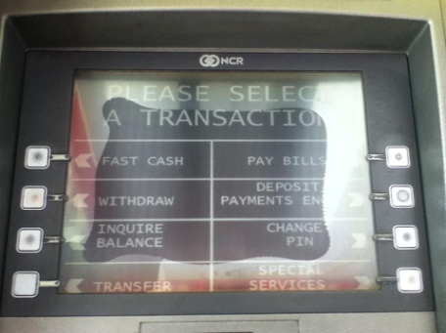
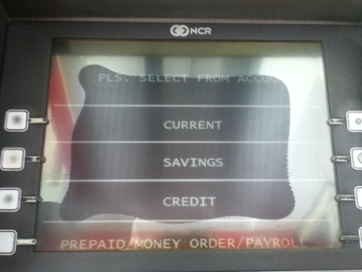

Safety:
- Is the machine safe to use? Does it have security measures?
Yes, it is safe to use for it has security measures like entering the pin or password of the user in order to confirm his/her transaction. With that, it will not be easy for people to get cash from the user’s card unless they know the card’s pin number.

- What security measures did the machine have?
The machines of different banks offered different kind of protection. Some machines required the user to enter his/her pin every time he/she tries to do any transaction. Some machines already have a phone hotline and a screenshot of security tips for the users to utilize.

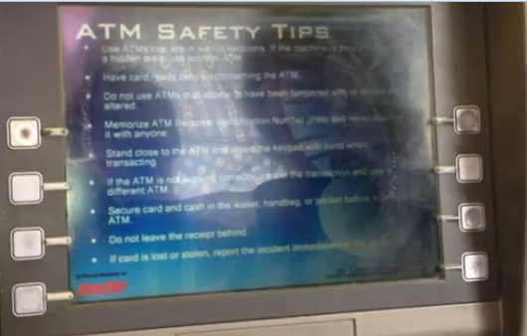
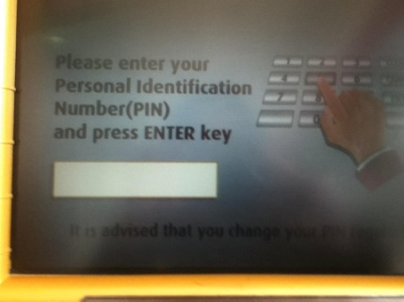

Utility:
- Does the machine give the user’s needs?
Yes, it was able to give the user’s needs. The machine was able to provide services without the help of any teller or clerk. It also gave special services that made the user’s work easier (paying bills, loading cellphones, etc.)

- Does it extend to the user’s wants?
The ATMs that we used did. Though they did not have the same extent, they had other transactions that a user might want to use. Some had deposits, fast cash, and bill payments through the machine which can be useful for the users in a certain period of time.
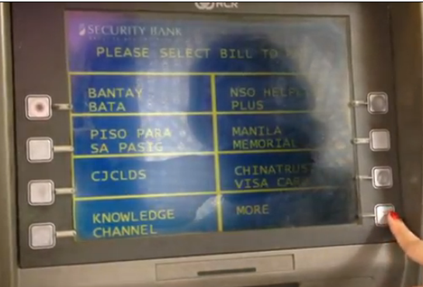
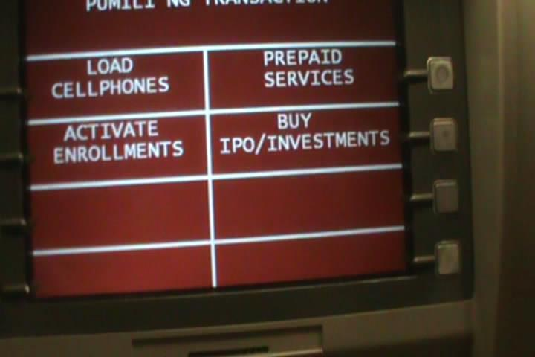

Effectiveness:
- Is the machine effective to use? How so?
Yes, it is effective to use for it successfully carried-out all the services (withdraw, deposit, load, balance inquiry, etc.) we asked the machine to do.

- How effective is the machine?
The machine is effective for it didn’t only successfully carried-out all the tasks it was asked to do but the machine was also able to process the correct amount of cash it was asked to withdraw. It was also successful to show the summary of cash deposited and display the balance of the user.

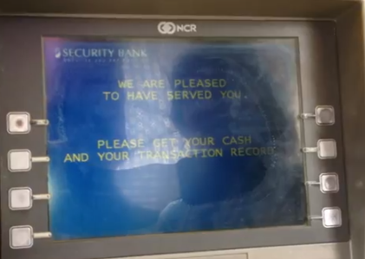

Efficiency:
- How can the ATM be considered as efficient?
It is efficient when the ATM gives sufficient support to the user to finish a transaction. The ATM machines that we used are efficient because it helped us finish our desired task (withdraw, balance inquiry, fast cash, etc.) with ease.

- What characteristics does the ATM have that made the machine efficient?
The ATM has a simple look and is very usable. It runs smoothly and has minimum errors with transactions as long as it is maintained properly and timely. It does not need too much maintenance with the software because of its simple but compact design.
