Security Bank

Effectiveness:
- How is the ATM effective? Is it capable of doing desired tasks and transactions?
Yes, it is capable of doing the tasks the users want or need it to do. The expectations with the tasks are met and transactions are functioning well. The machine was able to provide what is expected.

- Was there a transaction that the ATM did not complete?
The deposit is the transaction that failed. The ATM did not have service because it needed envelopes inside the ATM which was not available as of the moment we used it.

- Will the ATM still function properly given a situation that it is used continually?
It will still function properly if given maintenance. The software is compact and does not need any updates because it already gives what the users want and need.
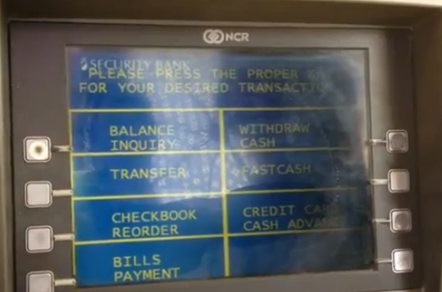
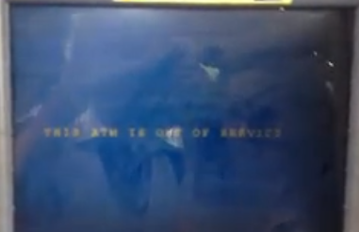

Efficiency:
- Did the ATM support the user well?
Yes, it did support us well when we were trying to use it. The system gave us instruction which helped us do a transaction easily.

- What made this ATM efficient?
The ATM is efficient because its system supports the user accordingly to finish a desired task. The user is given a set of transaction the machine can do and given buttons for choosing the options.

Safety:
- Did the ATM show any signs/errors that it may harm your account or your card? Was the experience safe?
The ATM functioned properly when we used it. It always offered us protection by always entering our pin when we insert the card. Prior to our last experience with the machine, it is safe.

- What safety measures did the ATM offer you?
The screen displays tips with what precautions you need to do in order for your transaction to be safe. It also requires you to enter the pin whenever you insert the card.

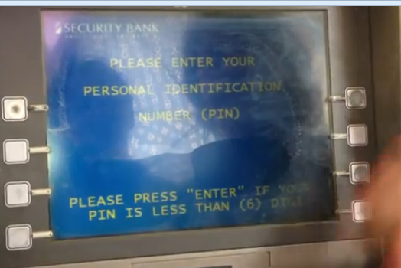
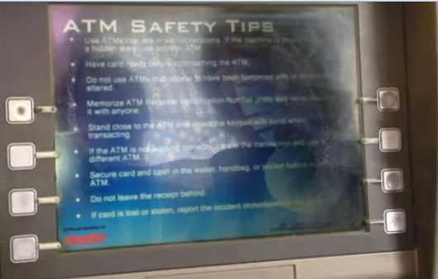

Utility:
- To what extent did the ATM provide functionalities?
The ATM provided the varieties of functions. They had the essential functions (withdraw, balance inquiry, fast cash, bill payments) of an ATM. It gave what the users’ needs.
- Did the ATM offer more than what the user needs?
It gave options to pay bills for many companies. It also has a checkbook order. It gave a variety of choices that you may utilize in a certain point.

- Did the ATM have a function of deposit?
It did have a function of depositing. Unfortunately, it lacks convenience as it requires maintenance with refilling the ATM with envelopes. It is a bad design because it cannot be utilize well.

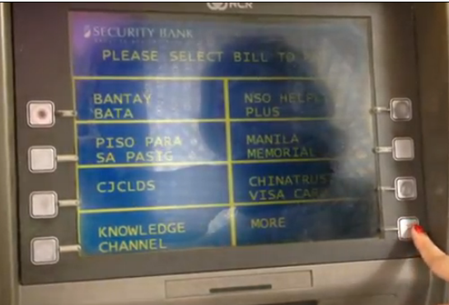

Learnability:
- Will it be easy for first time users to utilize the ATM?
Yes, there are instructions that would help the user do a task easily. It also has a simple layout and not a lot of buttons to confuse you with it. The ATM is simple and is easy to understand.
- How easy is it to use the ATM?
By just following the directions and reading the text on the screen, you can simply do your task without the help of others. I also believe that the one focal design of this ATM is to avoid mistakes a novice user might make.
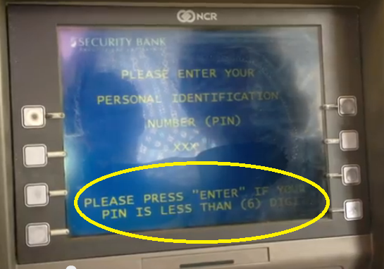

Memorability:
- Will it be hard for a user to remember the process of using the ATM?
No, it will not. The steps of using the ATM are simple. It doesn’t require much for you to use it properly.
- Will it take much time for a user to remember the process of the ATM?
The process of doing a transaction is already there. It is as simple as it looks and it won’t take time for a user to remember how to use an ATM.

