Metrobank
Effectiveness
- The ATM Kiosk accomplishes the purposes of a simple ATM. It has simple functions like withdraw and checking balance which are essential to ATMs.
- It is simple for the users to do transactions. Users can simply do what they want to.
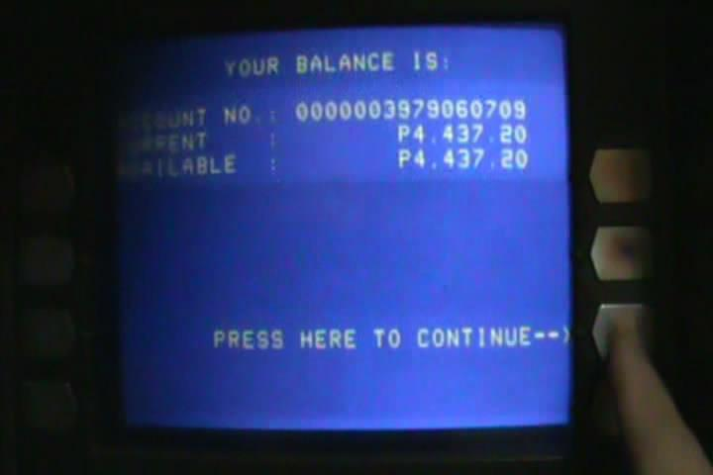
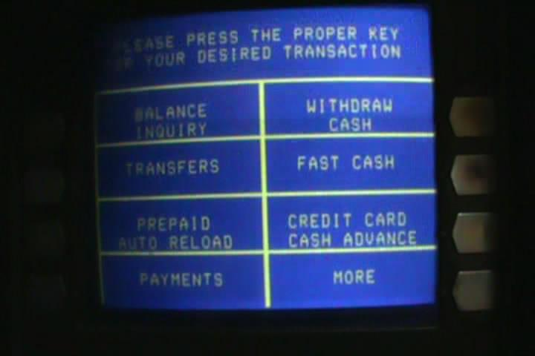
Efficiency
- It has simple instructions which can help the user do their task consuming less time and with satisfaction.
- It has steps which will help the user finish their task efficiently.
Safety
- It requires you to input your pin whenever you do a transaction to ensure that it is the owner or a trustee that uses the card.
- It also shows a reminder in where you can report something that is suspicious.
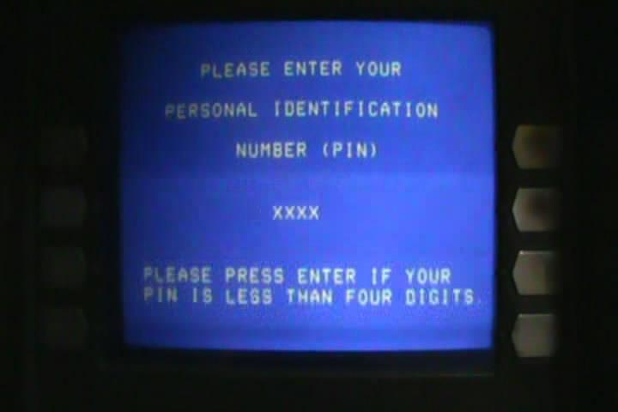
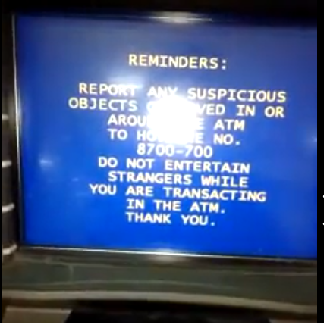

Utility
- This kiosk also has Prepaid Autoload, Transfers, etc which are additional functions to the ATM.
- It can help users to make use of this ATM because of the variety that it offers.
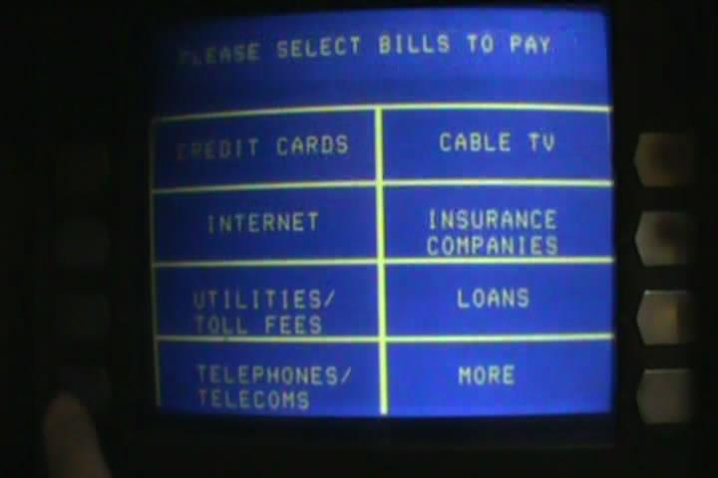

Learnability
- The instructions are understandable and clear. It can guide you to what task do you want to achieve.
- A simple layout with simple buttons can help the users use the ATM with ease
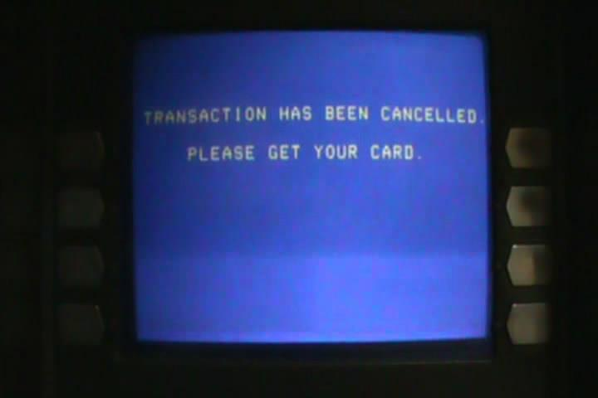

Memorability

- There are borders to which the buttons are correctly aligned to which will help the user memorize it and help him use it for future transactions.
- There are instructions. Once learned you can be guided accordingly and not make many mistakes.
