

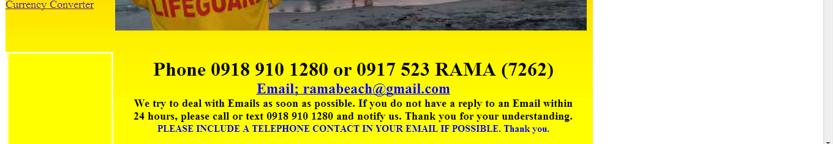

Fig. 1
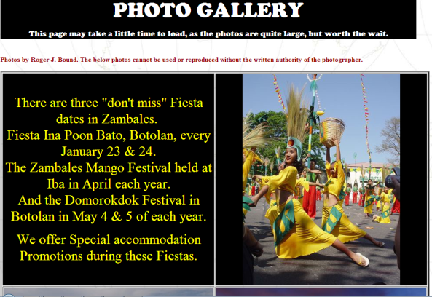
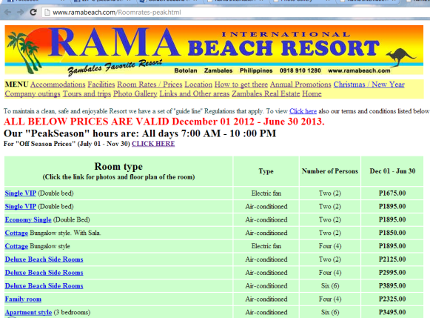

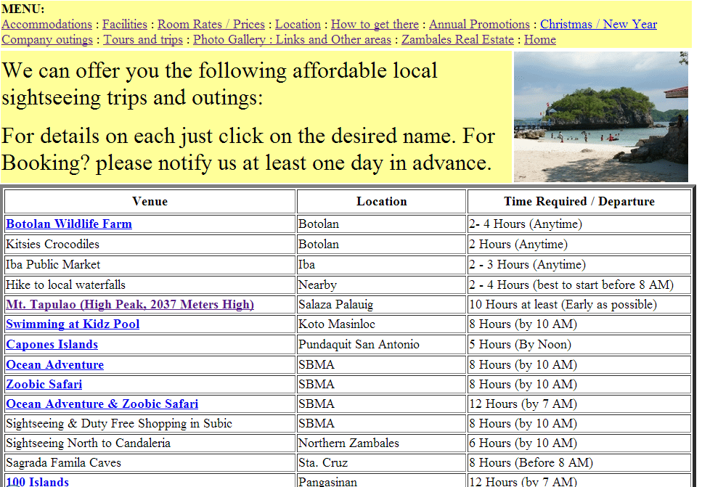
Fig. 2 Fig. 3
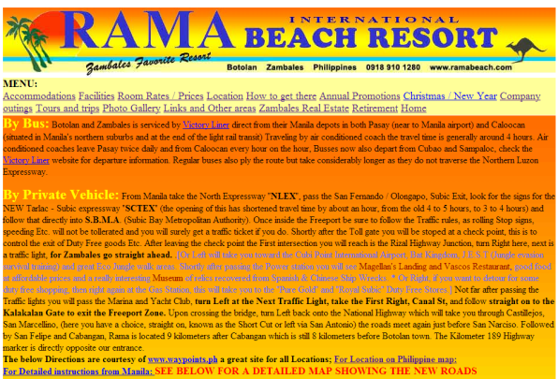

Fig. 4 Fig. 5
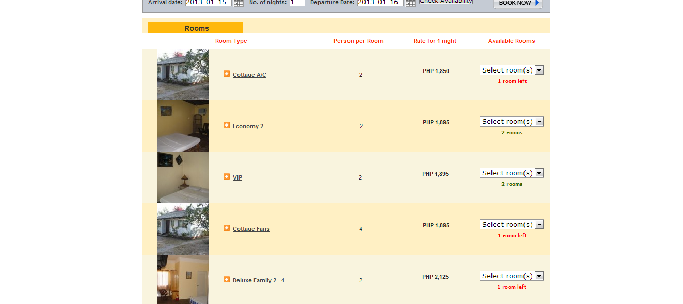
Fig. 6

Name of site: Rama International Beach Resort
URL: http://www.ramabeach.com/
Brief Background:
The site of Rama International Beach Resort is the bridge to web-users. The site informs the users about the accommodations, prices, facilities, and other services of the resort. It also has a gallery to show the beauty of the resort. It represents the resort and the offers it may present to the user.
Site Objectives: | Site Features:
- To show how much they can offer and the uniqueness of their resort  - To use the web as a network to attract more people  - To entice people with the gallery of their resort | - Room rates and prices. It also displays what rooms are available. (See Fig. 2)  - A gallery of what the resort looks like. (See Fig. 3)  - A display of what the resort may offer to a customer (See Fig. 4).  - A retirement accommodation.  - A set of instructions/guide on how to get to the resort.(See Fig. 5)  - A list of major places of interest that may help the customer be more enticed.  - Annual Promotions – A way to get customers to be lured by the promotions in the given dates.  - Online Reservation ( See Fig. 6)
Strengths: | Weaknesses:
- The contact is already shown in the Home page. ( See fig. 1)  - The Online Reservation looks very tidy and has simple steps. ( See Fig. 6)  - There is a link for a currency converter which might help customers outside the Philippines.  - The Online Reservation page shows the available rooms. ( See Fig. 6) | - A second-generation website.  - The photo gallery is very limited.  - The color is not soothing to the eyes. It makes the site look noisy. ( See fig. 1)  - The interface didn’t have any foundation. The layout structure is not well-planned.  - The website has no consistency. The navigations are on the left at the home page and in other pages, it is on the top.  - Very unorganized. Links are everywhere and there is no unity.  - The video wasn’t given much work. Many of the information in the video are in the webpage itself.  - The use of fonts and font color are not consistent. Using many fonts is unnecessary and makes the viewer lose focus. (See Fig. 5)

