P5 – Uploading my Website to The internet
I.C.T – Lewis Stephenson
In this task I will show the process carried out to upload my website to a server on the internet. This is the final stage to the overall creation of the website, allowing others to then view the website on the internet for my clients benefit. This website will hopefully spread the name of Active Wirral and become a successful and regularly used website for active sports athletes and people Around Wirral; looking for information about sports within facilities across Wirral.
Within the creation of my website, I used tools such as Dreamweaver to create a successful website and layout and design the website which will resemble that of the finished product once online; on the internet. I feel that the website had to be finished to an extremely professional standard with no faults. This means I had to create the website correctly first time as I could not then alter it once on the internet. The way in which I am going to allow other users access the website is by putting the finished website onto the internet. When you click on a hypertext link, or put a website address in your browser's (The browser is the program you're using to view this web page, either Explorer, AOL, or Netscape) address line, which then sends a request via your modem. The request is then heading to another computer, asking for a particular web page to be sent back to your computer so that you can view it.
The computer housing that web page you requested is called a host server. Servers basically requests information from various computers around the world to receive the correct information to then find the website requested by them which is stored on the central location often hosting hundreds of web pages. Your host server doesn't have to be your internet access provider. Prices for host sites vary widely, and you might find a host that offers the same host packages as someone else. I feel that overall uploading my website will cost them money which is a main disadvantage to your website as the money may not generate any direct income meaning the expenses of the website outweigh that of the income.
The factors which affect the speed in which this happens is the website content, the quality of your computer and the quality of your internet. I feel that the website created has little coding through images of a small file size, small videos and only relevant interactions. I haven’t created a website with high resolution images that require larger file sizes; which intern require more coding. When creating my website I took these points into consideration to reduce the overall coding of the website; to then maintain a good download speed through reduced coding. In addition I feel that the performance of the website is then altered on the viewer’s point of view. I feel that any users of the website may affect the performance of the website through their computers and internet quality. I feel depending on the ‘spec’ of their computer, the overall speed and quality of viewing the website will be altered depending on how well their connection and computer is. I feel a better computer will add to a smoother running computer, where as a better broadband connection ( for example 10mb/s broadband) and will also add to the overall performance.
The processes I took in order to upload my website to the internet via a server are that:
I firstly created the website on Dreamer. This tool aloud me structure, layout and create my overall finished product to the upload it to the internet for the whole world to view; via the World Wide Web.
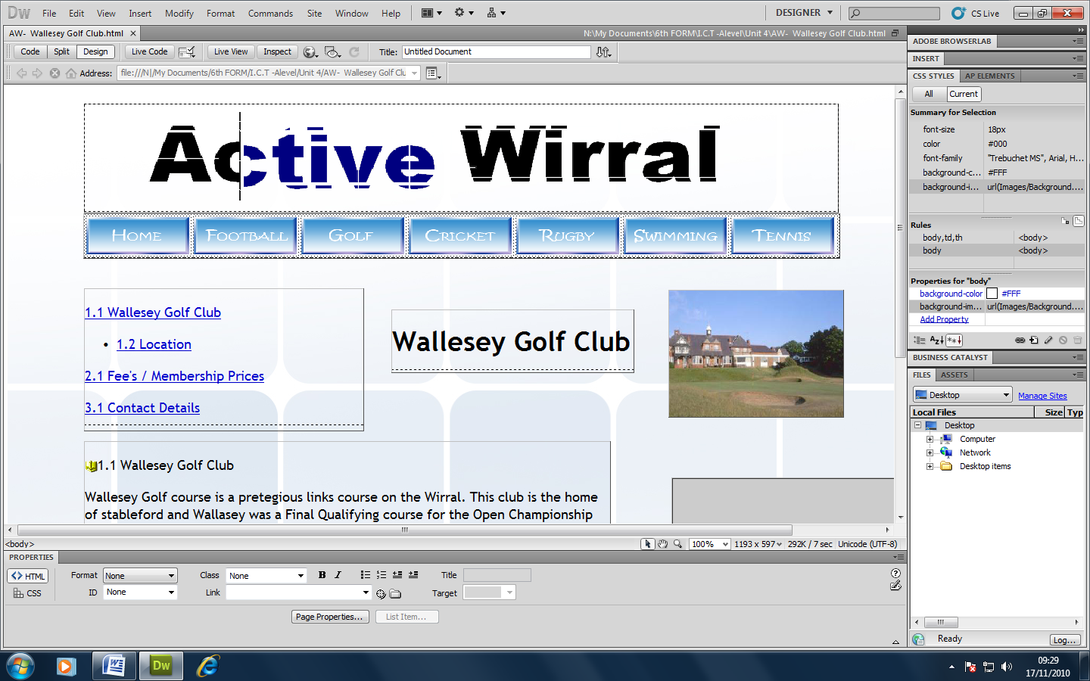
From this print screen you can see how this tool allowed me to structure and form the finished product of my website so that it would look effective and professional.

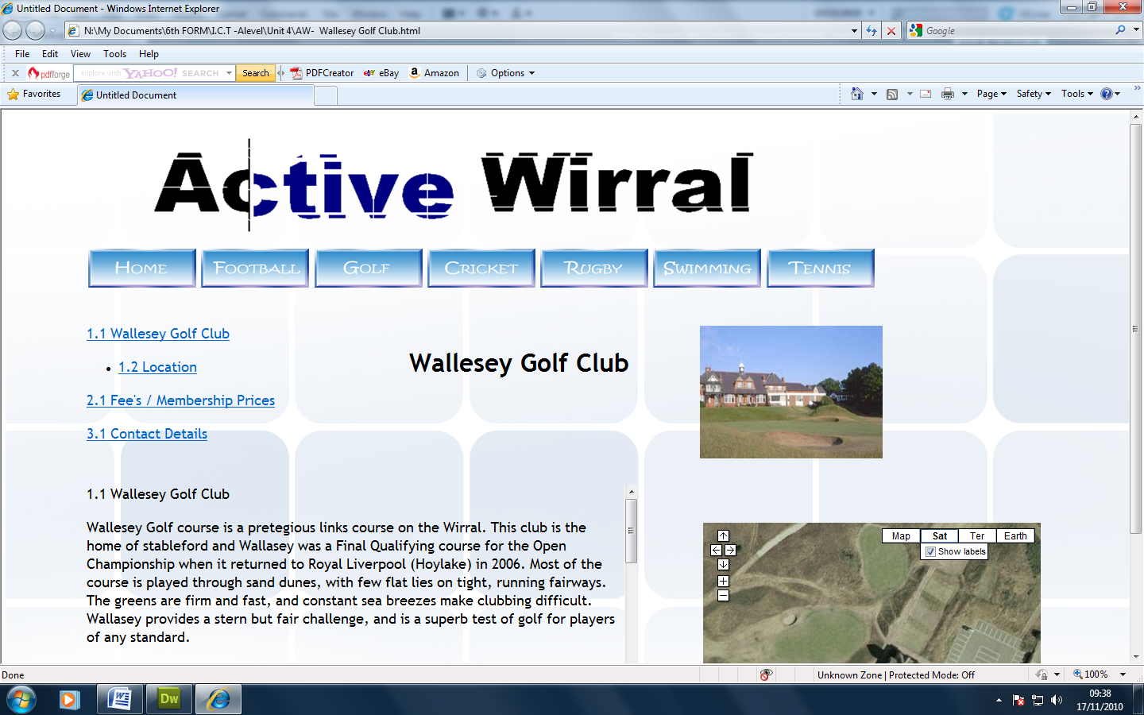This is how my website would look once on the internet. To test whether my website would work, once on the web and it would retain its structure and layout I tested the website on the internet. Once on Dreamweaver this was done by following: File/ Preview in Brower/ Internet Explorer or (Shortcut F12). This shows how my website retains its strucure and layout on the itnernet; thorugh testing.

