ICT - Report on the W3C compliancy of websites.
Lewis Stephenson

This report will hopefully help to explain how current websites have to follow W3C guidelines so that websites being created or existing websites are accessible and visible for various people. When creating websites the guidelines they set have to be followed so that your website is compliant. In addition I will explain how these guidelines are followed as I create my own website and how I am following the rules of a W3C website.
The actual guidelines set by the World Wide Web Consortium state that all websites have to comply and follow the regulations set by W3C so that the website is to standard. The website I am creating has to follow these guidelines so that it complies with standards. The basic standards websites have to follow are that:
- It must be accessible to disabled users.
- It must be accessible from different web browsers, and from various devices such as phones, iPods, laptops, PC’s, etc.
- It must function no matter what type of equipment it is accessed from.
- It should contain minimum coding to ensure fast download speeds and easy navigation.
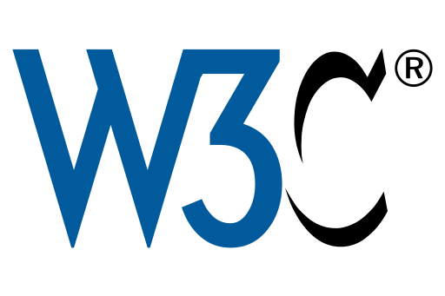
As you can see here, the image shows the W3C logo. In some cases, website displays this image to show how they follow standards set by w3C which are listed above.

This logo is the general governing body which enforces standards such as W3C. They are responsible for making sure all websites benefit a large target audience and can be viewed for the majority of all users which access the internet on the World Wide Web.

I feel that the general benefit of following these guidelines set by W3C is so that your website is accessible from various places. This is beneficial to the owner of the website as the site will receive more views as the public can enter the World Wide Web from various devices and still access your website. In addition I feel that if you make your website accessible for disabled user by making font sizes bigger and laying your website out clearer, it not only makes your website more professional but general simpler to understand. Also making and designing your website for the needs of the users will expand your customer market as well as your target audience.

