Evaluation and Review of my Website
I.C.T – Lewis Stephenson
The creation of this website was to produce and design an interactive website for a local organisation or company. I would create two designs in which a representative from the business or company would choose. This gave the client options into how they wanted their website to be laid out. The purpose for creating the website is that the business/ company could then use this created website as a part of their work. This would benefit them as it would advertise and showcase the business or company to the internet, as well as creating and expanding their new market and target audience; through the World Wide Web. When creating my website I had to consider many factors, so that it was effective, interactive, professional and W3C compliant. These factors would create and strong and professional website that would appeal to many target audiences.
The website I created had to be effective and purposeful. The website in which I created was targeted for an athletic audience, so that a wide variety of active people across the Wirral would visit my website; www.Activewirral.com for information on sports and sports facilities across the Wirral. The way in which I made this website effective was by providing relevant information, pictures, directions, prices and descriptions about sports and sports facilities which host these sports across the Wirral.

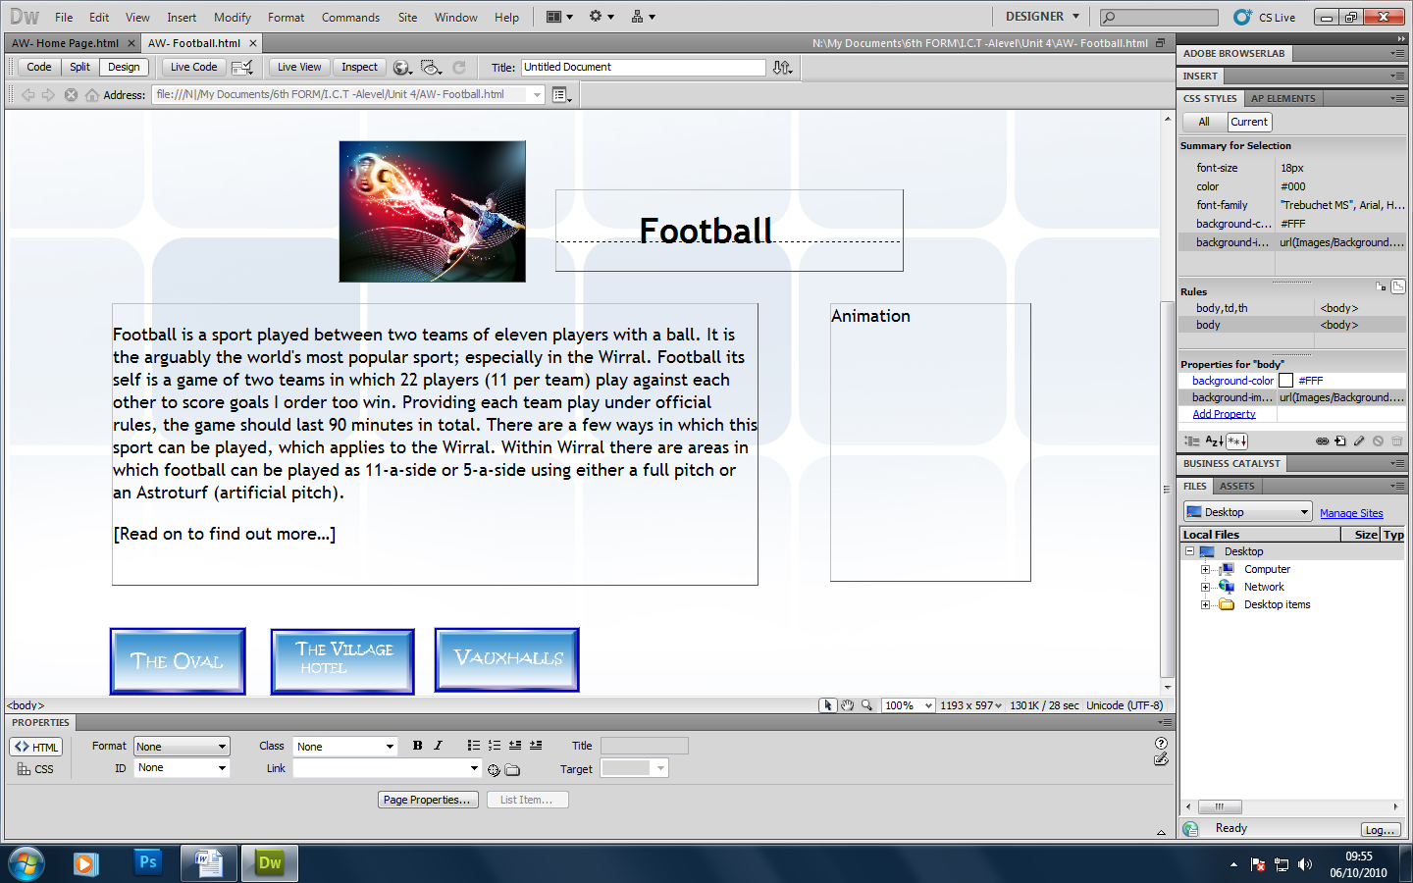

My website is clearly laid out displaying relevant information in a professional way.
A large description providing relevant information.

My website had to follow W3C guidelines when being created so that is accessible and visible for various people such as the disabled or weak sighted. When creating the website, the guidelines they set had to be followed in order for the website to become W3C compliant. I feel that when creating my website I used clear and understandable texts, which were in large fonts so that poor sighted people could clearly see and understand the text and information on the website. I feel that making the website accessible for disabled user by making font sizes bigger and laying out the website out clearer, it not only makes the website more professional; but generally simpler to understand. When I designed the website I really had to consider these points so that it would achieve the needs of the users which in turn; will expand the customer market /target audience. From the screen shot provided below you can see that when creating the website, features such as my buttons, banners and layout follow W3C regulations. My banner is clearly displayed in a large font so that it looks professional and easily readable for disabled or poor sighted people. The buttons on my website are visible and large so that they are easy to use and read. Also I feel that the layout of the overall pages throughout the website clearly separate, images, text and media professionally across the page; making the website easy to follow and understand.
A clear banner to display the name of the website and business which is visible for the disabled and poor sighted.
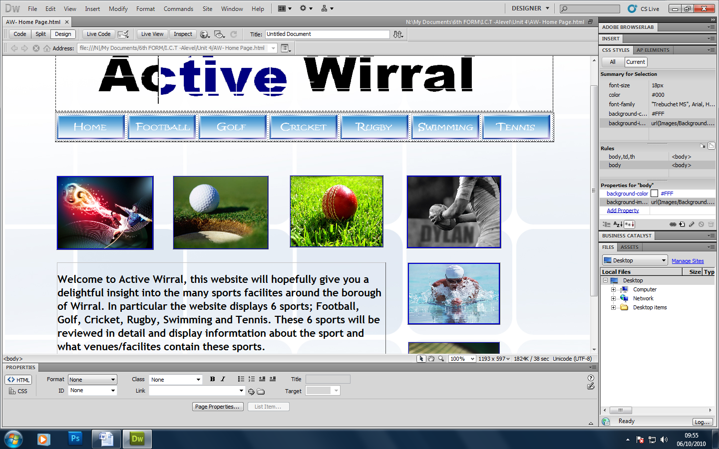

A spacious website which is easy to follow.
Large buttons which are clearly visible and easy to follow.

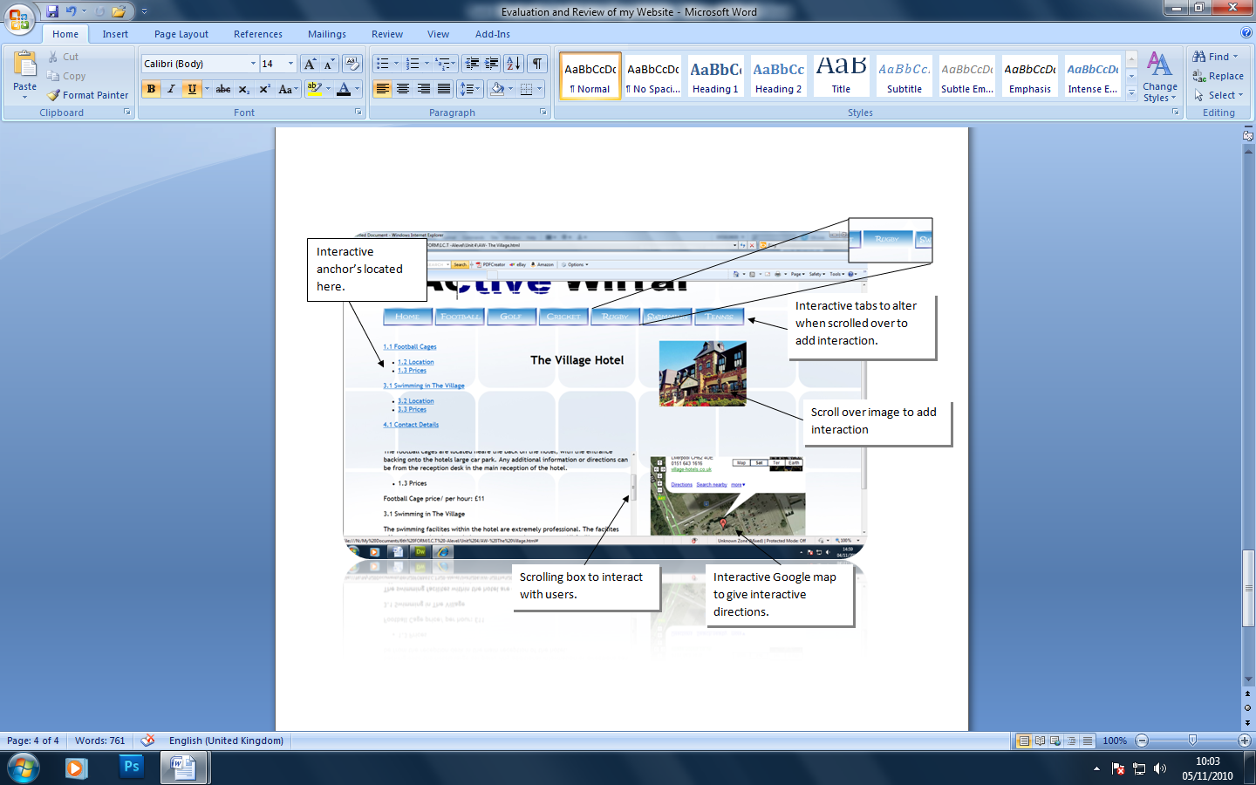
Within my website, I had to include relevant and professional interactions which the users of my website can interact with. The interactions i added to my business were that I used rollovers on images and tabs to seem as if they interact when the mouse rolls over them. This adds dimension and imagination to your website by creating a moving motion between two images. Another interaction between my website and the users of my website is that on each page, I managed to include an anchor. Like the information website www.wikipedia.com my website mirrors its anchor system by clicking a referenced link, E.G 2.3 prices. To then automatically lower the page to the information with a scrolling box. In addition another interaction which interacts with the users of the website through anchors or direct contact by the users is a scrolling system. This system adds an interactive scrolling bar which allows the users to filter up and down the information box using the slider. Finally the last interaction between my website and its users is the interactive Google map. This displays with a pin, directly where the location of the facility is.
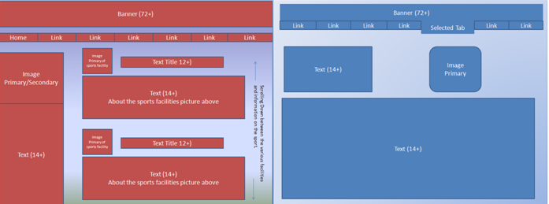
To create my website and all the features on it, I browsed other websites for hints and tips into how they structure their successful websites. The inspiration I received to create my website came from www.wikipedia.com. I feel the way in which they cleverly display information through anchors and references to text, is clever. I followed this idea and structured my website like Wikipedia, by using anchors to reference text to headings. In doing this I created many plans displaying features my website would have as well as the way in which I would display my information. I feel following the task sheet, I managed to create to designs in which I would present to my client so they had a choice in what website they chose and how it was laid out.
Design 1 Design 2
From these web layouts, you can see the two designs I chose in order to present to my client. I feel that after a tough choice, they chose design two, due to its simplicity. I feel this style of design mimics that of Wikipedia and would be the perfect layout for this particular website. I feel its plain design adds to its professional look and overall Wikipedia theme.
After creating my whole website I feel that overall the website was a success. From creating my designs, choosing the right on to finally creating the website, adding interactions and features; overall it went well. I feel the actually highlights of my website is how it mimics the no1 information website; Wikipedia. The way I have designed my website through clever interactions and features makes my website dynamic and user friendly. The website is easy to follow and will largely appeal to my target audience of sporting and active people of any age around the Wirral. If I had an opportunity to alter anything within my website I feel the negative features of my website would be changed. Features such as a possible interactive or moving banner would attract and add more features and depth to my website. Creating my banner in a different computer application such as flash would add more interaction between the users of my website and the website it’s self. In addition I feel that another point I would like to alter within the website next time is that the layout page to page is identically similar throughout out. Although my website has a theme which adds a professional feel to the site, a handful of pages are laid out slightly different. Although this is caused through large text poxes through more information needed to be added, I feel that the same theme could still possibly apply if I had the time to carry on.

