Screenshot of Created Website in Dreamweaver

This is the design view of my created website in Dreamweaver. Individual pages are divided and linked with button links.
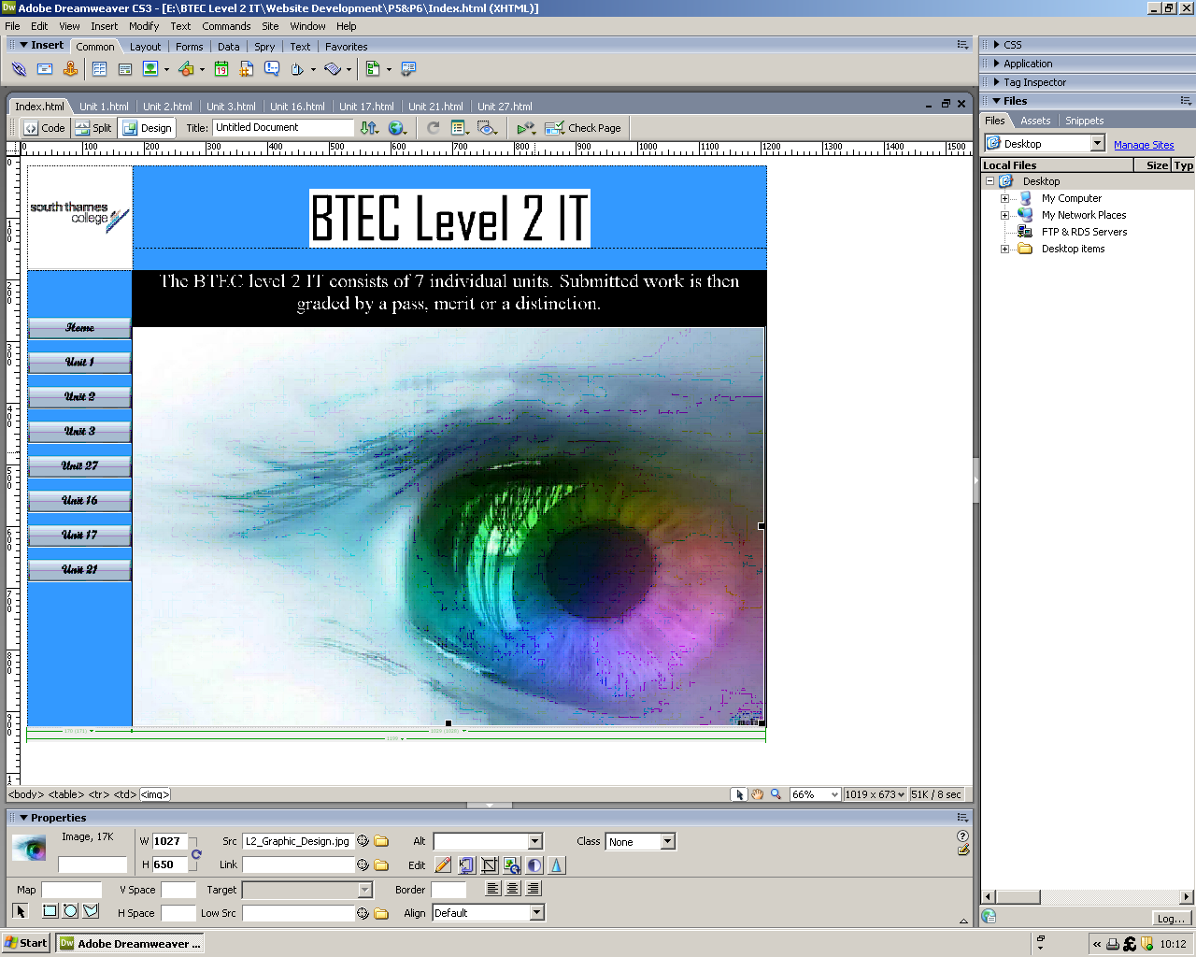
This is the code view of my created website in Dreamweaver.
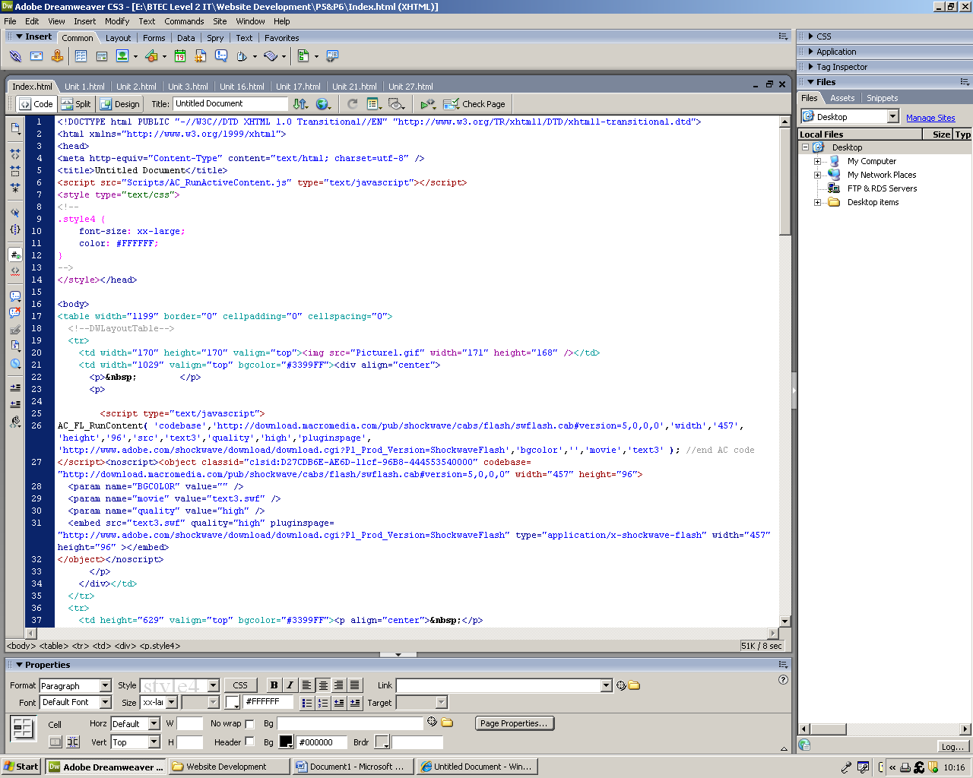
This is the home page of my website uploaded onto geocities.ws.
http://www.geocities.ws/14life /Index.html

